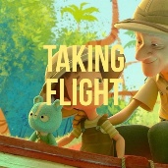
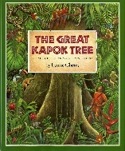
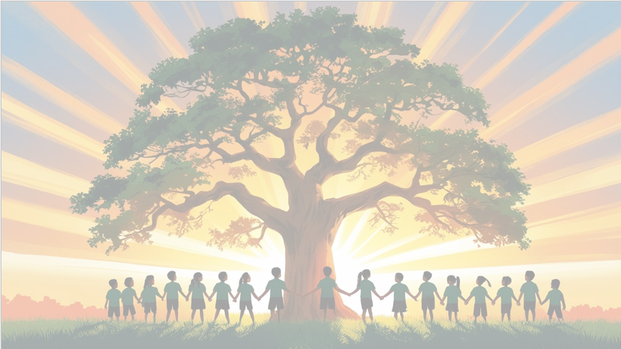
‘’Shine brightly in learning and life’
English
We will be using the text The Great Kapok Tree as our focus book. We will be writing in full sentences, using expanded noun phrases and fronted adverbials. Our final outcome will be a detailed setting description of the rainforest inspired by The Great Kapok Tree.
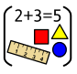
Maths
We will be focusing on place value, exploring the value of digits in numbers up to 10,000. We will practice ordering, comparing, and rounding numbers, and looking for patterns in number sequences.
We will also focus on learning our 6 and 8 times tables, understanding multiplication facts and making connections to arrays, groups, and repeated addition.

PSHE: Healthy Me
In our puzzle piece this term, we will focus on ‘Being Me in My World’. We will be thinking about how to be a positive member of our school community.



RE
Our BIG question this term is: How does believing Jesus is their saviour inspire Christians to save and serve others?

PE
In PE, Year 4 will be focusing on multi skills and fitness with our PE coach, Mr Kyd.

Art
Movement: Cubism​
Art area: Drawing​
Artist: Picasso​
As part of our final outcome, we will be creating self-portraits in the style of Picasso

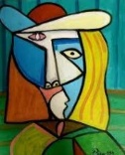
Year 4 Curriculum Overview
Term 1
2026-27

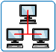
Computing
We will learn how the internet works as a network of networks and explore the World Wide Web to understand ownership and content creation. The children will also evaluate online information to judge its honesty, accuracy, and reliability.

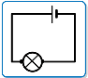

Science: Electricity
We will be learning about electricity, exploring different appliances that use electricity, how to create simple circuits, and the roles of conductors and insulators. We will also investigate how to make circuits work safely and experiment with switches and bulbs.
Geography
In Geography this term, we will be learning about Brazil, exploring its climate, culture, and key geographical features. We’ll compare similarities and differences between Brazil and the UK, focusing on both human and physical features.

Music
This term in Music, we will sing, play, improvise, and compose using ABBA’s Mamma Mia, while listening to and appraising other ABBA songs to develop our musical skills.


