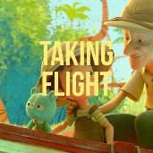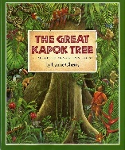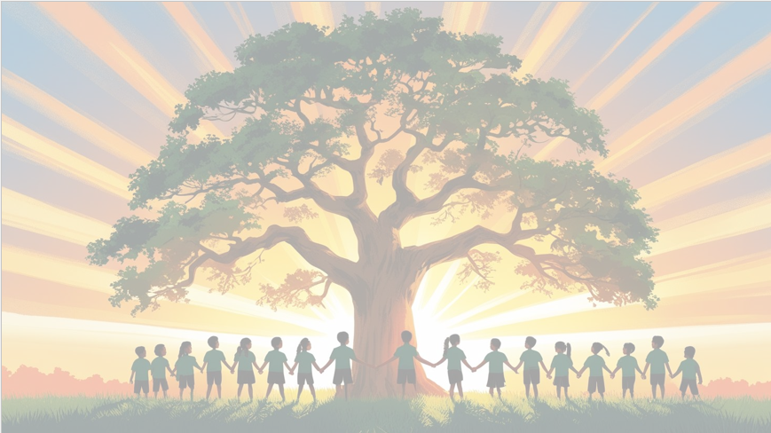‘’Shine brightly in learning and life’

**English**

We will be using the text The Great Kapok Tree as our focus book. We will be writing in full sentences, using expanded noun phrases and fronted adverbials. Our final outcome will be a detailed setting description of the rainforest inspired by The Great Kapok Tree.

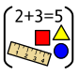

**Maths**

We will be focusing on place value, exploring the value of digits in numbers up to 10,000. We will practice ordering, comparing, and rounding numbers, and looking for patterns in number sequences.

We will also focus on learning our 6 and 8 times tables, understanding multiplication facts and making connections to arrays, groups, and repeated addition.

**PSHE: Healthy Me**

In our puzzle piece this term, we will focus on ‘Being Me in My World’. We will be thinking about how to be a positive member of our school community.

**RE**

Our BIG question this term is: ‘What do Christians mean when they talk about the Kingdom of God?

**PE**

In PE, the children will be swimming, developing their technique, confidence, and water safety skills.

**DT**

In DT this term, we will be designing, baking and evaluating our own biscuits before creating eye-catching packaging to showcase them.

**Year 4 Curriculum Overview**

**Term 1**

**2025/2026**

**Computing**

We will learn how the internet works as a network of networks and explore the World Wide Web to understand ownership and content creation. The children will also evaluate online information to judge its honesty, accuracy, and reliability.

**Science: Electricity**

We will be learning about electricity, exploring different appliances that use electricity, how to create simple circuits, and the roles of conductors and insulators. We will also investigate how to make circuits work safely and experiment with switches and bulbs.

**Geography**

In Geography this term, we will be learning about Brazil, exploring its climate, culture, and key geographical features. We’ll compare similarities and differences between Brazil and the UK, focusing on both human and physical features.

**Music**

This term in Music, we will sing, play, improvise, and compose using ABBA’s Mamma Mia, while listening to and appraising other ABBA songs to develop our musical skills.

