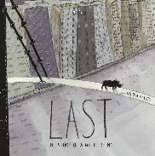
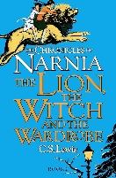
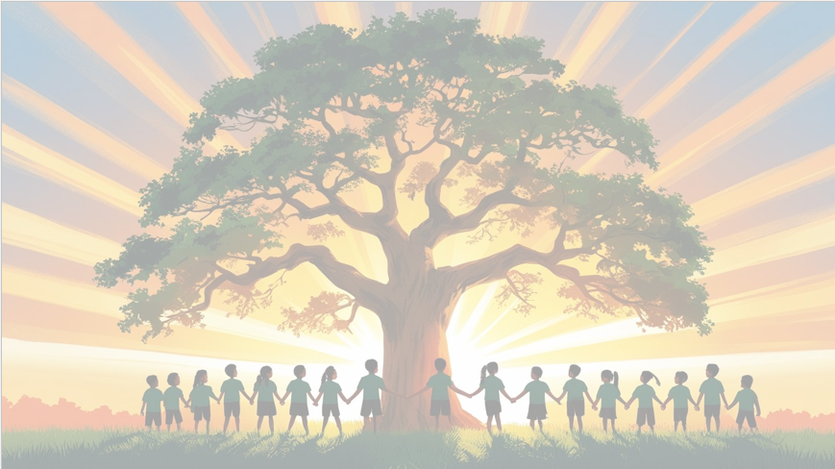
‘’Shine brightly in learning and life’
English
We will be using the focus texts The Lion, The Witch and the Wardrobe and The Last Diary where we will be looking at the effectiveness of descriptions in the text and looking at key features to include in our own writing. Our end pieces will be a setting description and recount in the form of a diary entry.
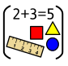
Maths
We will be focusing on place value, exploring the value of digits in numbers up to 100,000. We will practice ordering, comparing, and rounding numbers, and looking for patterns in number sequences. We will also be using decimals in different contexts, such as money and measures as well as revising and practicing a range of methods for addition, subtraction, multiplication and division.

PSHE: Healthy Me
In our puzzle piece this term, we will focus on ‘Being Me in My World’. We will be thinking about how to be a positive member of our school community.



RE
Our BIG question this term is: How do Christians show their belief that Jesus is God incarnate?

PE
In PE, Year 5 will be focusing on fitness and rounders with our PE coach, Mr Kyd.

Art
Movement: Pop art​
Art area: Drawing​
Artist: Warhol​
We will be creating self-portraits in the Pop Art Style

Year 5 Curriculum Overview
Term 1
2026-27

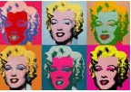

Computing
We will learn how the internet works as a network of networks and explore the World Wide Web to understand ownership and content creation. The children will also evaluate online information to judge its honesty, accuracy, and reliability.

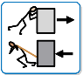
History
This term in History, Year 5 will be learning about World War I. The children will explore the causes, key events, and impact of the war, developing their understanding of this important period in history.
Science: Forces
This term in Science, Year 5 will be exploring forces. The children will learn about different types of forces, how they affect the world around us, and will have the opportunity to carry out experiments to see these forces in action.

Music
This term in Music, we will sing, play, improvise, and compose using Bon Jovi’s Livin' On A Prayer, while listening to and appraising other songs to develop our musical skills.


