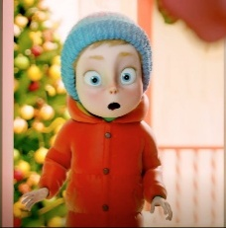
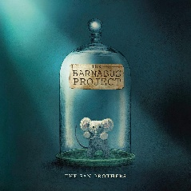
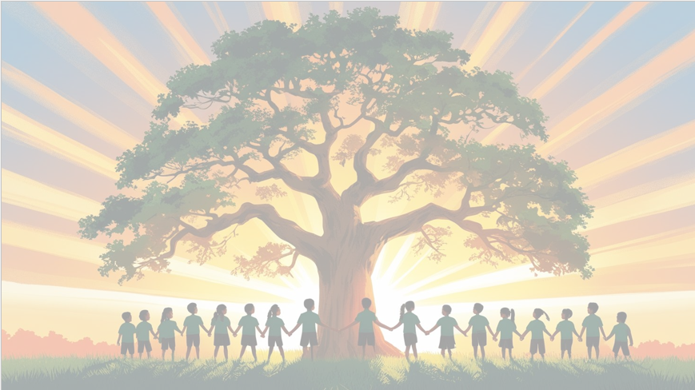
‘’Shine brightly in learning and life’
English
We will be using The Barnabus Project and The Gift as our focus books and clips. We will be writing in full sentences, using expanded noun phrases and fronted adverbials. Our final outcomes will be a detailed character description and a persuasive letter inspired by the stories.
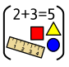
Maths
We will be focusing on multiplication and division, including learning and practicing our times table facts up to 12×12. The children will solve problems using arrays, groups, and repeated addition, and will develop their mental addition and subtraction skills to calculate quickly and confidently. We will also explore how multiplication and division relate to each other and use these skills to tackle real-life word problems.

PSHE
In our puzzle piece this term, we will focus on ‘Celebrating Difference’. We will be thinking about what makes us different and what makes us special.


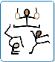
RE
Our BIG question this term is:
How does a
Muslim show their submission and obedience to Allah?

PE
In PE, we’ll develop our balance, control, and creativity through fun gymnastics and dance routines.

Art
In this unit, we will explore artists’ work and create sequenced images to tell a story, culminating in a front cover and accordion book.

Year 4 Curriculum Overview
Term 2
2025/2026

Computing
We will be creating our own podcasts! The children will record, edit, and add sounds to make their podcasts clear, interesting, and fun to listen to.
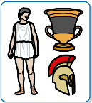
History

In this unit, we will explore Ancient Greece, learning about daily life, key events, the Olympics, and the Battle of Marathon, while investigating historical evidence and developing our understanding of chronology.
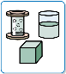
Science: States of Matter
This term, we’ll be exploring states of matter! We’ll discover what makes solids, liquids, and gases different, and investigate how some materials can change from one state to another. We’ll also find out about evaporation and condensation


Music
We will continue exploring music through the glockenspiel or recorder, building on previous skills and learning new tunes while discovering the language of music.

