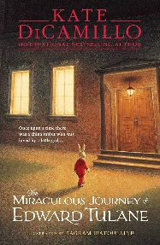
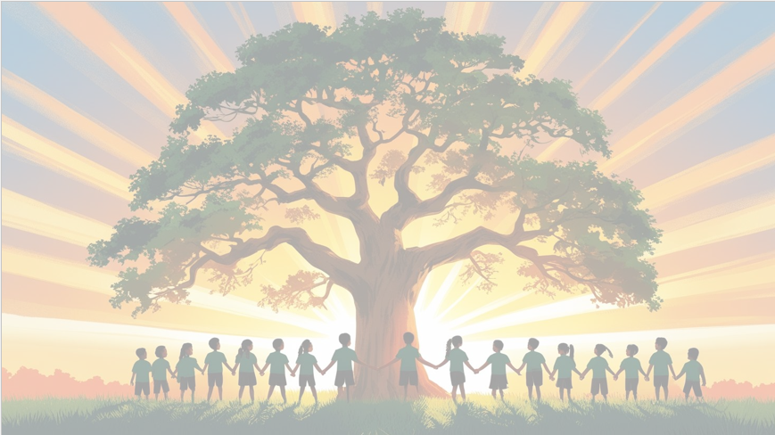
’Shine brightly in learning and life’
English
We will be using Mrs Noah’s Pockets and The Miraculous Journey of Edward Trulane as our key texts. The children will write and retell story and a non-chronological report, using fronted adverbials with commas to show time, place, and manner, and subordinating conjunctions like because, as, and since to explain reasons and link ideas clearly.
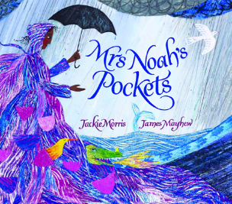
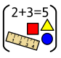
Maths
Children will practise written methods for addition and subtraction and build confidence working with fractions, including halves, thirds, and quarters. They will apply these skills through problem-solving and show their understanding through proficient use of mathematical vocabulary and reasoning in their oral and written responses.

PSHE
In PSHE, we will explore dreams and goals, learning to set targets, overcome obstacles, and set our ambitions high!



RE
Our BIG question this term is:
Why do Hindus want to collect good karma?

PE
In PE, we’ll develop our skills, fitness, and focus through fun hockey and yoga activities.
Art
In this unit, we will be learning how to work with shape and colour

Year 3 Curriculum Overview
Term 3
2025/2026


Computing
In this unit, we will learn how to create sequences in programming using Scratch designing their own programs, as they aim to create a virtual piano.

History
In this unit, children will explore the fascinating world of the ancient Maya. They’ll use artifacts and research to discover how this incredible civilization lived, farmed, and built magnificent cities deep in the rainforest.
Science: Animals Including Humans
In this unit, children will discover how skeletons give our bodies shape, support, and movement. Pupils will also explore what makes a balanced diet by using the healthy eating plate to understand how food choices keep us strong and healthy!

Music
In this unit, we will introduce children to classical music from the Medieval period to the 21st century, featuring works by some of the most famous Western composers. They will learn to play, improvise, and compose while exploring the elements of music.
.
