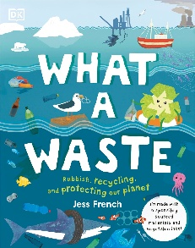
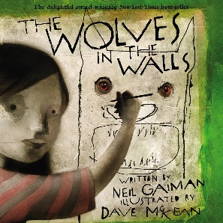
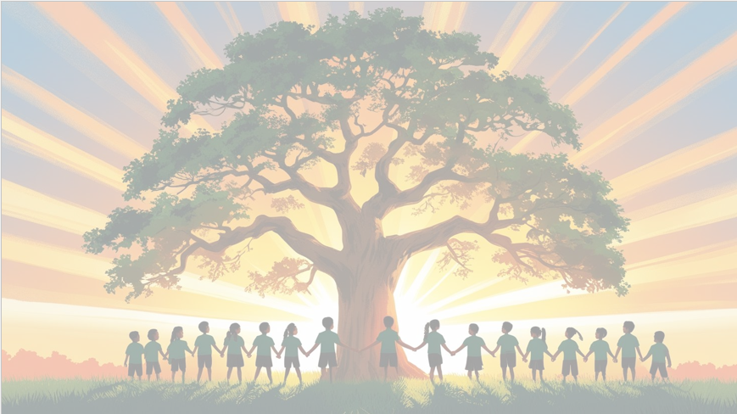
’Shine brightly in learning and life’
English
We will be using Wolves in the Wall and What a Waste as our focus texts. The children will write a retell story and a non-chronological report, using fronted adverbials with commas to show time, place, and manner, and subordinating conjunctions like because, as, and since to explain reasons and link ideas clearly.
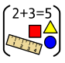
Maths
We will be focusing on multiplication and division, including learning and practicing our times table facts. The children will solve problems using arrays, groups, and repeated addition. We will also focus on written methods for addition and subtraction, developing accuracy and confidence with larger numbers and applying these skills to real-life problems.

PSHE
In PSHE, we will explore dreams and goals, learning to set targets, work together, and celebrate our achievements.



RE
Our BIG question this term is:
Why do Hindus want to collect good karma?
PE
In PE, we’ll develop our skills, fitness, and focus through fun hockey and yoga activities.
DT
In this unit, we will design a torch focusing on features of individual design ideas and electrical circuit.

Year 4 Curriculum Overview
Term 3
2025/2026


Computing
In this unit, we will explore programming with repetition and loops. The children will plan, modify, and test commands to create shapes and patterns using Logo, a text-based programming language.
Geography

In this unit, we will explore mountains around the world. The children will learn how mountains are formed, identify key features, and investigate how they affect the environment and people living nearby.

Science: Animals Including Humans
In this unit, children will learn about the human digestive system and the different types of teeth and their purposes. They will plan and carry out an investigation to see which drink causes the most tooth decay and extend their understanding of food chains, identifying producers, predators, and prey.

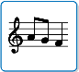
Music
In this unit, we will explore the song Stop! a rap about bullying, learning to sing, play, improvise, and compose while discovering the elements of music.

