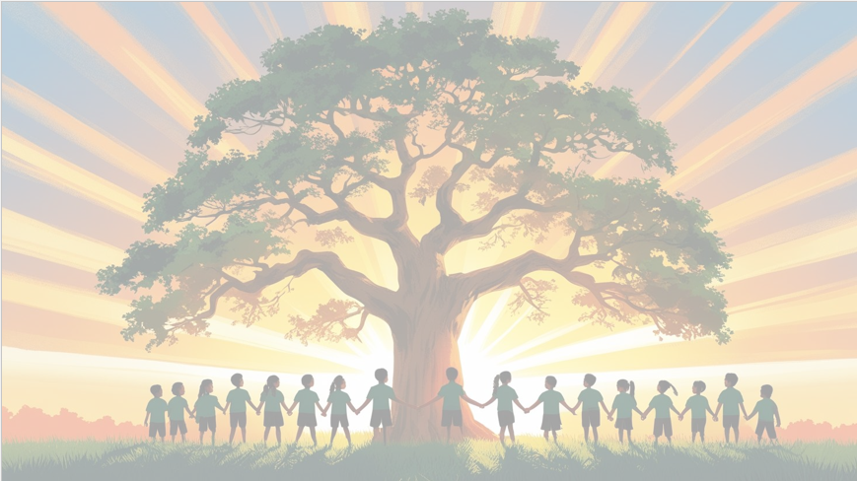

Shine brightly in learning and life’
Maths
We will be focusing on written multiplication including long multiplication and multiplying with decimals before moving onto written division methods for four-digit numbers with and without remainders. Finally, we will look at geometry including symmetry, reflections and translations.

PSHE: Dreams and Goals
In our puzzle piece this term, we will focus on ‘Dreams and Goals’ identifying what jobs would be available to us in the future and the steps we need to take to get there.
English
We will be using the focus text ‘The Man Who Walked Between the Towers’, which is based on true life events of wire walker, Philippe Petit and ‘The Land of Never Believe.’ Our writing units will include a first-person narrative to convey atmosphere and create tension and a non-chronological report.

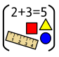


RE
Our BIG question this term is: ‘Why do Hindus want to collect good karma?’

PE
In PE, we will be playing tag rugby, developing their technique, confidence skills. They will also participate lessons based around health and fitness.
Year 5 Curriculum Overview
Term 3
2025/2026
Art 
In Art this term, Year 5 will be focusing on creating mixed media art using found and reclaimed materials and select materials for a purpose.


Science: Properties of Materials
This term in Science, Year 5 will be exploring materials and their properties. The children will compare and group materials together, according to whether they are solids, liquids or gases and based on their properties, including their hardness, solubility, transparency, conductivity (electrical and thermal), and response to magnets.

Computing
We will use physical computing to explore the concept of selection in programming using the Crumble programming environment. We will learn how to connect and program components through the application of our existing programming knowledge.

History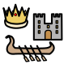
This term in history, Year 5 will be learning about the Romans. After looking at key Roman Empire events, we will discover the power of the Roman army. We will compare Roman and Iron Age settlements and discover certain legacies that have lasted from the Roman age, including baths, mosaics, roads, Hadrian’s wall etc.


Music
As well as learning to sing, play, improvise and compose with the song, ‘Make You Feel My Love’ children will listen and appraise other Pop Ballads.

.

