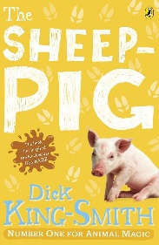
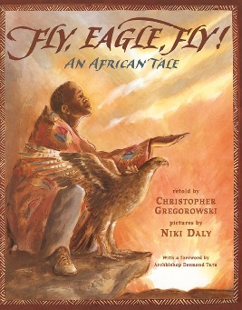
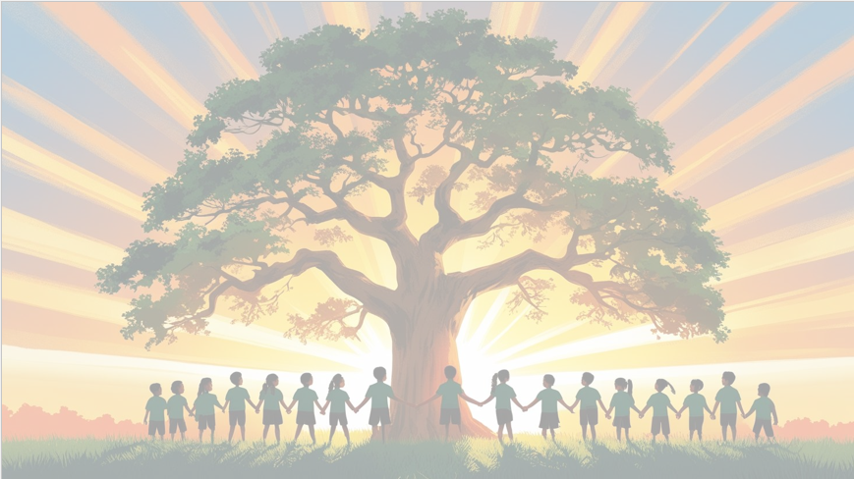
’Shine brightly in learning and life’
English
We will be using Fly, Eagle, Fly and The Sheep-Pig as our key texts for reading and writing this term. The children will explore creating a short story write a persuasive letter as part of our non-fiction focus.
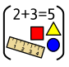
Maths
We will be focusing on Children will practise written methods for multiplication and division. Then we will be building confidence working with shapes and measure. They’ll apply these skills through problem-solving and show their understanding through proficient use of mathematical vocabulary and reasoning in their oral and written responses.

PSHE
In Healthy Me, we will learn about different friendship groups and the roles people have within them, such as leaders and followers.


RE
Is the cross a symbol of love, sacrifice or commitment for Christians?
PE

In PE, we’ll develop our skills, fitness, and focus through fun football and invasion game activities.
DT
In this unit, we will be learning how to cross-stitch and appliqué to decorate and assemble Egyptian collars, which represent the children's unique personalities.

Year 3 Curriculum Overview
Term 4
2025/2026


Computing
In this unit, pupils will consider how and why data is collected over time.

History
In this unit, pupils will be taught about the appearance of the Ancient Egyptians as an early civilisation and how their beliefs about life after death influenced them.
Science: Force and Magnets
In this unit, we will begin to understand how forces can affect the movement of objects. We will also look at how magnets work through poles.

Music
All the learning in this unit is focused around one
song: The Dragon Song. Using our imagination and working together as a class, we will create our own performance of this song.
