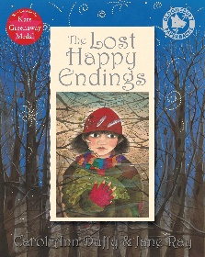
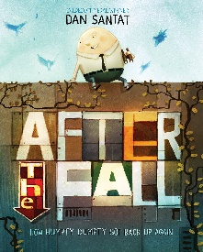
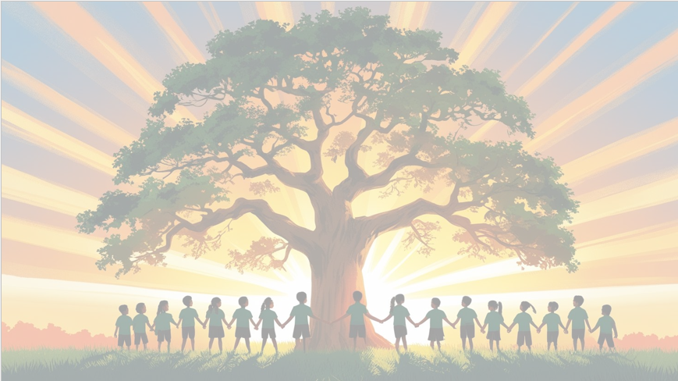
’Shine brightly in learning and life’
English
We will use Lost Happy Endings to retell the story, focusing on key events and characters. We will also use After the Fall as a stimulus for writing a persuasive speech, encouraging Humpty Dumpty to climb the wall again.
Alongside these texts, the children will develop their writing skills by producing a retell and a persuasive piece.
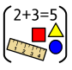
Maths
We will be focusing on multiplication and division, including learning and practicing our times table facts. The children will solve problems using arrays, groups, and repeated addition. We will also learn about shapes and angles, exploring their properties and how to recognise different types of angles.

PSHE
In Healthy Me, we will learn about different friendship groups and the roles people have within them, such as leaders and followers.



Art
In art, you will explore still life, an art style used by artists in the past and today. You will practise observational drawing by closely looking at real objects and then create your own artwork.
RE
Is the cross a symbol of love, sacrifice or commitment for Christians?
PE
In PE, we’ll develop our skills, fitness, and focus through fun football and invasion game activities.

Year 4 Curriculum Overview
Term 4
2025/2026


Computing
In this unit, we will become a data detective, learning how data is collected over time. We will collect and explore data, spot patterns using computers, and use data loggers to answer our own questions.
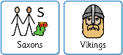
History
Over Terms 4 and 6, we will be exploring the Anglo-Saxons and Vikings. To kick-s tart this exciting history topic, we will be holding a History workshop on 24th February, where children are invited to come dressed up for a fun and immersive day of learning.

Science: Living things and their habitat.
During this unit of work, children will learn to recognise the seven life processes common to all living things. They will learn to sort living things using a variety of criteria and extend their use of scientific vocabulary to describe the features and characteristics of animals and plants.

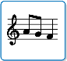
Music
This terms learning is focused around one song: Lean on Me. We will explore pulse, rhythm, pitch, singing and playing instruments.

