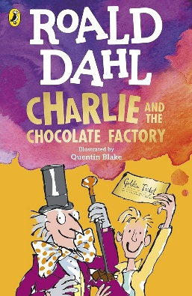
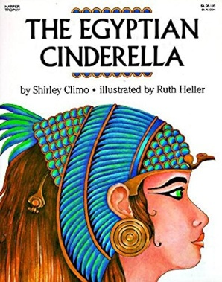
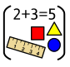
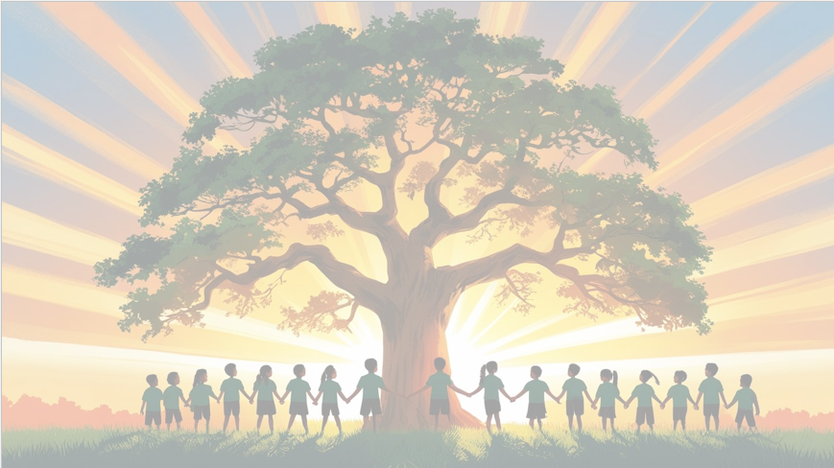
’Shine brightly in learning and life’
Maths
This term, Year 3 will develop their understanding of length, mass and capacity, explore the properties of 2D and 3D shapes, and learn how to collect, present and interpret data. Children will use practical activities and problem-solving to build confidence in their mathematical skills.
English
This term, Year 3 will use The Egyptian Cinderella to write a narrative and a recount, developing their storytelling and non-fiction writing skills. In reading, children will explore Charlie and the Chocolate Factory, focusing on comprehension, vocabulary and discussion of the text.

PSHE
In Relationships we will be exploring ‘Changing Me’

DT
We will design and make a pneumatic toy, exploring how compressed air can be used to create movement. They will develop their design and construction skills while creating a working model.

PE
In PE, we’ll develop our skills of athletics ready for sports day.
RE
Why do Humanists use the golden rule as a basis for morality?

Year 3 Curriculum Overview
Term 6
2025/2026


Geography
In term 6, Year 3 will explore Europe, focusing on Italy and the region of Campania. Children will learn about key human and physical features, including volcanoes and earthquakes, and compare life in Campania with their local area. They will develop their map skills and deepen their understanding of the world's geography.
Computing
This term, Year 3 will learn how computer programs respond to events and actions. Children will create and modify simple programs, using commands that are triggered by clicks, key presses and other inputs. They will develop their understanding of programming while building confidence in testing and debugging their own projects.


Science: Sound
During this unit of work, children will learn about sound and how it is made and travels. They will explore how sounds change in pitch and volume, investigate how vibrations create sound, and use scientific vocabulary to describe and compare different sounds and materials.

Music
Reflect, Rewind and Replay, revisiting musical skills.

