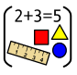
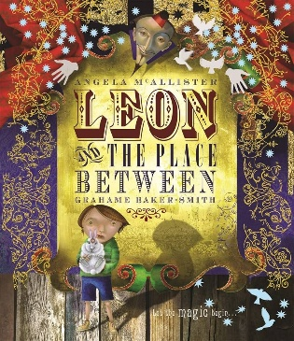
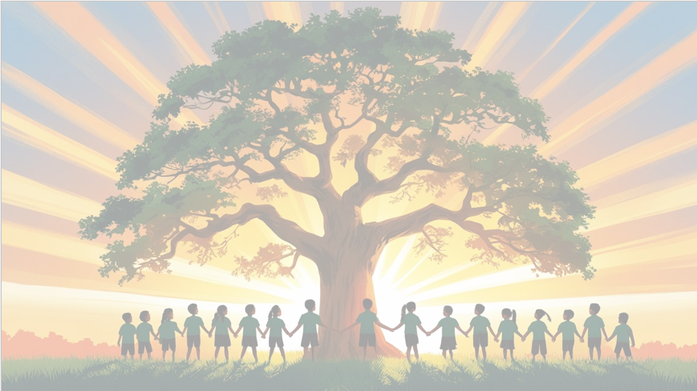
’Shine brightly in learning and life’
Maths
We will be focusing on decimals, time and measure, building confidence and fluency in key mathematical skills. Children will learn to recognise and write tenths as decimals, read, write and convert times on analogue and digital clocks, and solve problems involving length, mass, volume and money. They will use practical resources and visual representations to support their understanding.
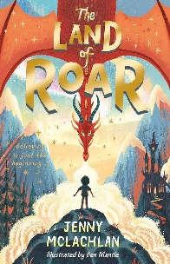
English
We will use Leon and the Place Between to inspire our story writing, exploring character, setting and plot development. Children will learn how to use dialogue effectively to reveal character and move the story forward, before planning and writing their own magical narratives. In Reading, we will study The Land of Roar, using the text to develop comprehension skills, discuss characters’ actions and motivations, and make thoughtful predictions and inferences.

PSHE
In Relationships we will be exploring ‘Changing Me’
Art
In Art, we will be exploring the artist Pablo Picasso. We will be focusing on the Cubism Movement and recreating drawing/portraits in this style.

PE
In PE, we’ll develop our skills of athletics ready for sports day.
RE
Why do Humanists use the golden rule as a basis for morality?

Year 4 Curriculum Overview
Term 6
2025/2026

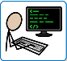
Computing
This term, Year 4 will learn about programming through creating and improving simple games. They will explore how repetition (loops) can make programs more efficient, use sequences of commands, and test and debug their code. Children will develop their problem-solving skills while creating interactive projects.
History
In term 6, we will be exploring the Vikings. We will start by exploring our views of Vikings today and any misconceptions we may have. We will investigate whether they should be remembered as raiders or settlers. They will also explore the Viking legacy that can still be seen in Britain today.

Science: Sound
During this unit of work, children will learn about sound and how it is made and travels. They will explore how sounds change in pitch and volume, investigate how vibrations create sound, and use scientific vocabulary to describe and compare different sounds and materials.

Music
Reflect, Rewind and Replay, revisiting musical skills.

