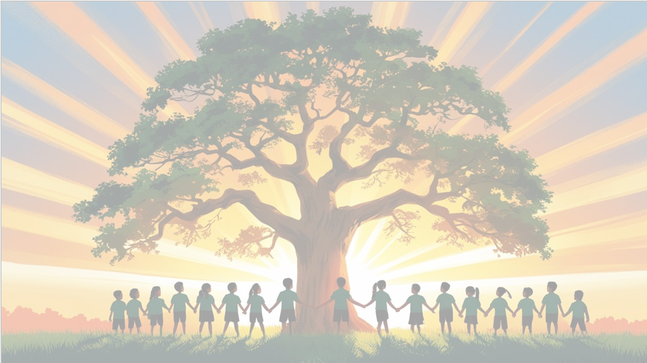

Shine brightly in learning and life’
English
We will be using the focus texts ‘23 degrees 5 minutes’ and ‘Everest’, which describes the events of Edmund Hillary climbing Mount Everest. Our writing units include a retell told in third person and a recount in the form of a letter home.
PSHE: Dreams and Goals
In our puzzle piece this term, we will focus on ‘Changing Me’ which covers body image and media influences, puberty for girls and boys, conception, media literacy around teenage representation, and preparing for transition to the next school year.
Maths
We will be focusing on geometry, measures and statistics. We will learn how to measure angles using protractors, find the area and volume of shapes before moving on to converting units of time and learning how to read and interpret timetables.

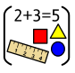


RE
Our BIG question this term is: ‘Why do Christians believe they are people on a mission? ’
PE
In PE, we will be playing rounders, developing our technique, confidence and skills before applying to different games. We will also be preparing for Sports Day.
Year 5 Curriculum Overview
Term 6
2025/2026
DT 
In DT this term, Year 5 will be designing, and making their own pop-up book, focusing on the mechanism of how it works.

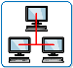
Geography
In Geography we will revise the continents on a World Map and learn the main countries of North America: We will focus on the USA, its wide range of physical geographical features and some significant cities and what these are like. We will also study how the USA influences world culture through media (film, internet, music), sport, technology etc.


Science: Animals including Humans
This term in Science, Year 5 will describe the changes as humans develop to old age. We will understand the physical changes experienced by humans, their consequences and understand the order in which changes happen.

Computing
We will develop our knowledge of selection by revisiting how conditions can be used in programs and then learning how the If… Then… Else structure can be used to select different outcomes depending on whether a condition is true or false.


French
This term we will learn how to tell somebody what they have and do not have in their pencil cases and/or school bag in French.

