
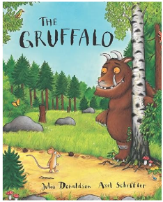

‘Shine brightly in learning and life’
Maths
This term reception children will:
- Orally count in 1’s from a specified number up to and beyond 20, and in 1’s back from 10-0.
- Count out 1–10 objects from a larger set.
- Compare numbers 1-5, independently using sentence stems “__ is greater than/fewer than.”
- Recognise sets of 1-5 dots, however they are arranged.
- Recognise sets of dots on tens frames, including 5 wise arrangements.
- Represent numbers 1-5 in various ways using two hands.
- Add and subtract two single digit numbers (where the total is 5 or less) using resources such as numicon/tens frames and the language of addition/subtraction.
- Partition numbers to 5 using resources such as numicon shapes/pegs, counters, cubes etc…
- Represent patterns within numbers: odd/even/doubles/halves.
- Read numerals 1-10 when out of order independently.

Literacy
Our texts this term are ‘The Gruffalo’ by Julia Donaldson, and ‘Little Red Riding Hood’ by Ladybird First Favourite Tales.
The children will be:
- Using ‘Talk 4 Writing’ to create actions for our focus texts enabling them to orally retell the story.
- Exploring rhymes and poems to accompany these texts to enhance their learning.
- Using our phonics to sound-talk, segment and blend to enable them to write focus words and full sentences relating to our texts.
- Developing letter formation and handwriting skills.
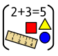

Reception Curriculum Overview
Term 4
2025/2026

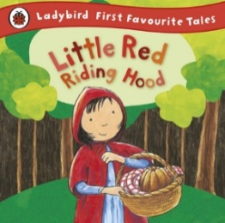
Phonics
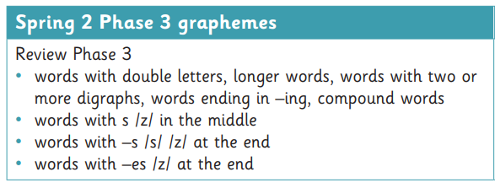




Continuous Provision
UTW - Linking to celebrations – Pancake Day, (Shrove Tuesday), Lent & Easter.
EAD – Gruffalo Activities – Exploring textures (prickles, animal footprints, snakeskin etc…)
Create a Gruffalo wanted poster/Grandma missing poster.
PD – Fine Motor skills – Create the Gruffalo/Wolf using playdough and loose parts.
Construction – Create structures for Gruffalo characters to live in/Create Wolf dens.
Water Play – Explore natural resources in various ways.
Mud Kitchen – Make Gruffalo Crumble/Make a medicinal potion for Grandma


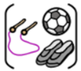
R.E
Our ‘Big Question’ this term is: ‘Why do Christians put a cross in an Easter garden?
P.E
This term the children will be focusing on Gymnastics and Ball skills.

