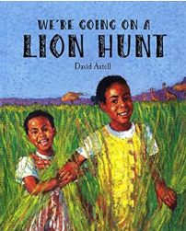


‘Shine brightly in learning and life’
Maths
This term reception children will:
- Orally count in 1’s from a specified number up to 50, and in 1’s back from 20-0.
- Count out 1–10 objects from a larger set.
- Compare numbers 1-5, independently using sentence stems “__ is more (>) than/fewer (<) than.”
- Recognise sets of counters on tens frames, in five-wise arrangements.
- Represent numbers 1-5 in various ways using two hands.
- Add and subtract two single digit numbers (where the total is 5 or less) using resources such as numicon/tens frames and the language of addition/subtraction.
- Partition numbers to 5 using resources such as numicon shapes/pegs, counters, cubes etc…
- Represent patterns within numbers: odd/even/doubles/halves.
- Read numerals 1-10 when out of order independently.

Literacy
Our texts this term are ‘We’re going on a Lion Hunt’ by David Axtell, and ‘Betsy Buglove Saves the Bees’ by Catherine Jacob. The children will be:
- Using ‘Talk 4 Writing’ to create actions for our focus texts enabling them to orally retell the story.
- Exploring rhymes and poems to accompany these texts to enhance their learning.
- Learning new vocabulary specific to our texts this term.
- Using our phonics to sound-talk, segment and blend to enable them to write focus words and full sentences relating to our texts.
- Developing letter formation and handwriting skills.
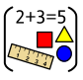

Reception Curriculum Overview
Term 6
2025/2026

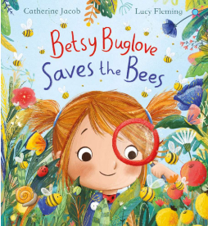

Phonics
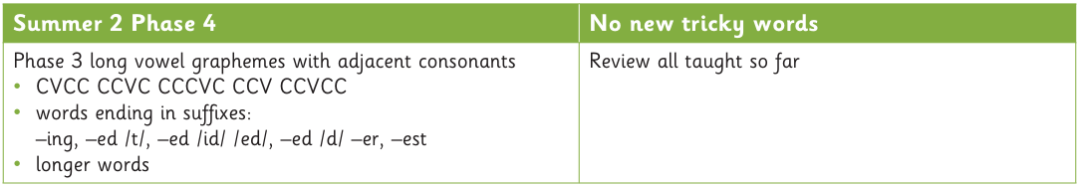

Continuous Provision
UTW - Linking to Festivals/Celebrations: World Cup, Sports Day, Class Transitions
EAD – Flowers/Plants/Garden centre Role-play. Focus Artist: Esther Mahlangu.
PD – Fine Motor skills – Create safari animals and insects out of playdough.
Construction – Construct animal enclosures and large-scale safari trucks.
Water Play – Exploring ways for small-world animals/people to cross a lake/river. Create a pond.
Mud Kitchen – Make ‘Savannah Soup’. Make Bee inspired – ‘Honey Loaf’



R.E
Our ‘Big Question’ this term is: ‘How is our World Wonderful?’
P.E
This term the children will be focusing on multi skills linking to Sports Day.



