
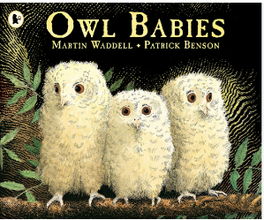

‘Shine brightly in learning and life’
Throughout term 1, we will be focusing on building relationships, following school routines and expectations. We will also be embarking on our new learning journey in our new class.
Literacy
Our texts this term are ‘Owl Babies’ and ‘Little Red Hen’. We will also be learning the nursery rhyme ‘Twinkle Twinkle’.
The children will be:
- Using ‘Talk 4 Writing’ to create actions for our focus texts enabling them to orally retell the story.
- Exploring rhymes and poems to accompany these texts to enhance their learning.
- Developing fine motor skills and making pre handwriting patterns in line with our Little Wandle handwriting program.

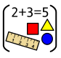
Maths
This term reception children will be:
Instantly recognise dice patterns 1-6 (this is called subitising)
Instantly recognise dots on 5 frame flashcards for amounts up to 5
Make amounts 1-5 on a 5 frame, describing what they can see using the sentence “ I can see …counters and …. spaces.”
Instantly recognise the numicon shapes 1-5.
Be able to make numicon shapes 1-5 with other objects when looking at the numicon shape to refer to.
Count out 1-5 objects from a larger set

Reception Curriculum Overview
Term 1
2026-27

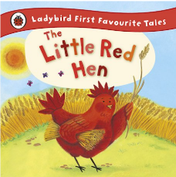
Phonics

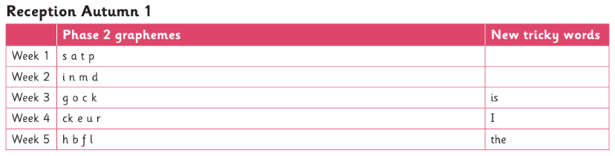


Continuous Provision
Role-Play – Home corner with links to our class texts of Owl Babies and Little Red Hen
EAD – Painting owl portraits, creating owl collages, printing patterns using different objects that we find on our welly walks
Small World – Retelling and recreating our class stories using different resources and props
We will be learning our routines and how to look after our classroom and outside area this term.

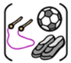

R.E
Our ‘Big Question’ this term is Why is the word ‘God’ so important to Christians?
P.E
This term the children will be focusing on Multi Skills with our PE coach Mr Kyd

