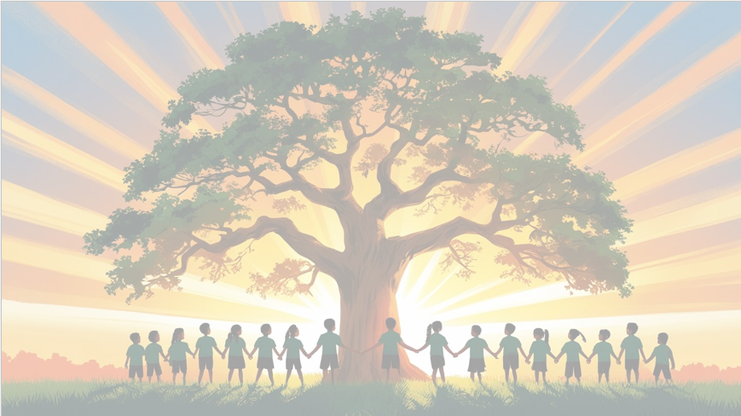
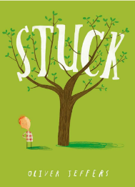
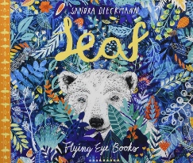
‘’Shine brightly in learning and life’
Maths
In maths, we will be learning:
- Place value to 20
- Sorting and counting objects
- Reading and writing numbers to 10,
- Finding one more and one less
- Ordering numbers up to 20.
- Addition and Subtraction and fact families number bonds to 10
- Taking away and find how many is left
• Place Value to 50
- counting and representing numbers to 50.
- Ordering numbers up to 50.

English
Our texts for the term will be ‘Leaf’ by Sandra Dieckmann and ‘Stuck’ by Oliver Jeffers. We will be learning the stories through role-play and storytelling. We will be focusing on writing labels, recounts and setting descriptions using our phonic knowledge. We will continue practicing our letter formation and handwriting

PSHE: Being me in my World
(Jigsaw)
We will be focusing on our new class, our rights and responsibilities and rewards and consequences.


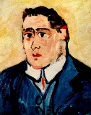
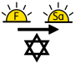
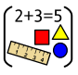
Art:
Movement: Fauvism​
Art area: Drawing​
Artist: Maurice de Vlaminck​
We will be drawing self-portraits in the style of Maurice

RE

Our BIG question this term is: Why do Jewish families talk about repentance at New Year?

PE

In PE the children will be focusing on multi skills and ball skills with our PE coach, Mr Kyd.

Year 1 Curriculum Overview
Term 1
2026-27

Computing – Technology around us
We will be learning what ‘computing is’ and why it is important to us. We will be learning about different technology, how it works and where it can be found. We will be learning how to stay safe online.
Science: Animals including humans (Ourselves)
We will be learning about our bodies by using drawing and labels. We will also be Exploring our senses by asking simple questions and make simple observations.

History – Space Explorers
We will be learning about a significant individual from the past - Neil Armstrong, Tim Peake and Mae Jemison
We will also be learning about the changes in space travel over time.

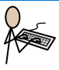

Music
We will be learning about pulse and rhythm.


