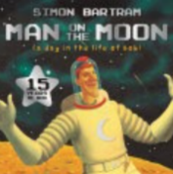
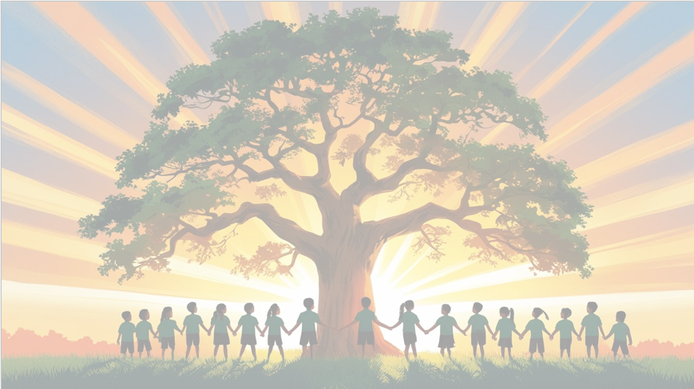
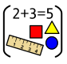
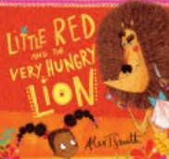
‘’Shine brightly in learning and life’
Maths
We will begin by focusing on place value. Children will learn to represent, compare and order two-digit numbers, developing a solid understanding of tens and ones.
Additionally, we will identify and explore the properties of 2D and 3D shapes.
In our addition work, we will be developing fluency in using number facts of 10 and 20 and learn that addition is commutative (i.e., numbers can be added in any order), and they will use efficient strategies to add two-digit numbers.
Throughout the term we will be applying these skills through problem-solving lessons, encouraging children to reason mathematically and explain their thinking.
English
This term, our texts will be Little Red and the Very Hungry Lion by Alex T. Smith and Man on the Moon: A Day in the Life of Bob by Simon Bartram. Our writing, we will focus on using "and" to join words and phrases, incorporating noun phrases, and properly demarcating sentences with capital letters and full stops. We will also explore the use of the suffix "-ed" for past tense. The end of unit writes will be a setting description and a diary entry.

PSHE: Being me in my world
We will be learning about responsibilities, rewards and consequences. Also, how to talk about our worries.


Music ‘On this Island’
The children will Learn and practice a range of folk songs. With our voices and body percussion, we will create soundscapes of the city, countryside and seaside.
Year 2 Curriculum Overview
Term 1
2026-27

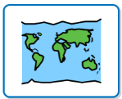
Geography
We will be learning about the oceans and seas of our World and the geographical features of them. We will also learn about the world’s continents and how to use a compass.
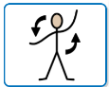
PE
We will be focusing on fitness and ball skills with our PE coach, Mr Kyd

RE
Our BIG question this term is: Why do Jewish families talk about repentance at New Year?

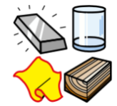
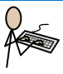
Science: Materials
In Science we will be identifying and comparing a range of common materials and their suitability for different purposes. We will ask simple questions and recognising that they can be answered in different ways.
Art:
Movement: Fauvism​
Art area: Drawing​
Artist: Maurice de Vlaminck​
We will be drawing self portraits in the style of Maurice

Computing – Information and technology around us
We will be identifying IT in school and the wider environment. In addition to learning about some of its benefits, different uses and how to use IT safely.

