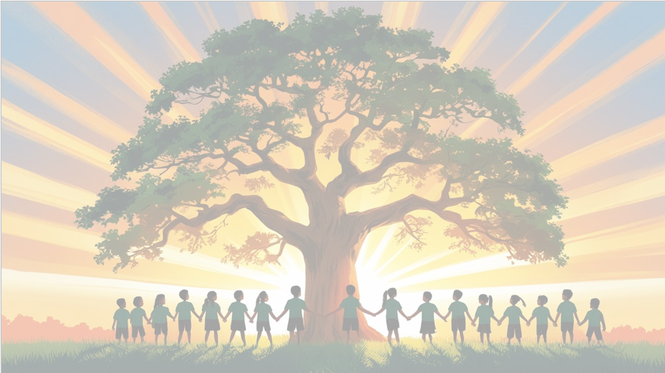
‘’Shine brightly in learning and life’
Maths
We will be focusing on secure our knowledge of number and place value when working with 3-digit numbers comparing and order numbers up to 1,000 and demonstrating that we can identify, represent and estimate numbers using different representations. In geometry, we will draw 2-D shapes and identify different types of lines.
English
This term, the children will be reading ‘The Iron Man’ and writing a setting description where the Iron Man began his journey. The children will then write a diary entry from his perspective for our non-fiction unit.
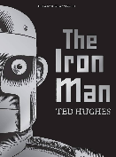

PSHE: Being Me in my world
In our six puzzle pieces this term, we will focus on ‘Understanding myself and others’, exploring emotions and the choices that we make.

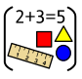


RE

Our BIG question this term is: How does believing Jesus is their saviour inspire Christians to save and serve others?

PE

In PE, Year 3 will be learning multi skills and fitness with our PE coach, Mr Kyd.
Art
Movement: Cubism​
Art area: Drawing​
Artist: Picasso​
As part of our final outcome, we will be creating self-portraits in the style of Picasso

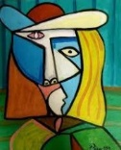
Year 3 Curriculum Overview
Term 1
2026-27


Computing
We will be focusing on understanding how digital networks.

History: Stone Age
In History this term, Year 3 will explore the Stone Age, learning about how people lived, hunted, and adapted during this period.
Science: Scientific method
In Science this term, Year 3 will learn about plants, exploring how they grow, the parts of a plant, and what they need to survive.


Music
We will be learning about … using ‘three little birds’ themed musical tunes.

