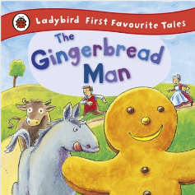
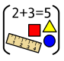


‘Shine brightly in learning and life’
Maths
This term reception children will be:
- Orally counting to and back from10.
- Singing counting songs up to 10.
- Using their fingers to show quantities up to 10.
- Subitising dice patterns 1-6 (recognising number without counting)
- Using 10 frames, using 5 wise to recognise amounts and spaces up to 10.
- Watching clips from the Number blocks Series to support number development.
- Learning to recognise Numicon shapes up to 10 without counting holes.
- Comparing and ordering numbers up to 10 using mathematical language – bigger than, smaller than, more than, fewer than, the same as, and equal to.
- Using talk pictures to discuss and notice different number patterns.
- Learning common 2D and 3D shapes using appropriate mathematical language.
Literacy
Our texts this term are the ‘The Gingerbread Man’ and ‘Stick Man’ by Julia Donaldson.
The children will be:
- Using ‘Talk 4 Writing’ to create actions for our focus texts enabling them to orally retell the story.
- Exploring rhymes and poems to accompany these texts to enhance their learning.
- Using our phonics to sound-talk, segment and blend to enable them to write focus words, relating to our texts.
- Developing letter formation and handwriting skills.

Reception Curriculum Overview
Term 2
2025/2026

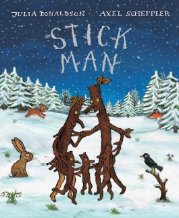
Phonics

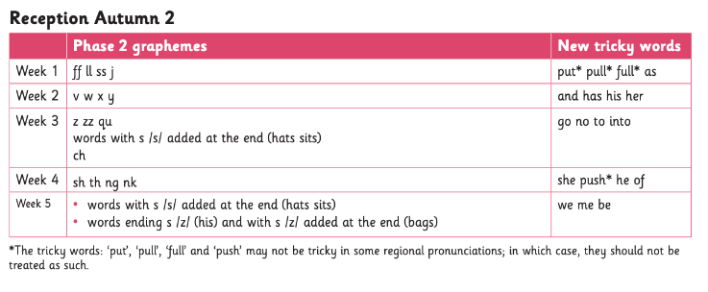



Continuous Provision
Role-Play - Linking to celebrations (Bonfire night, Remembrance & Christmas)
EAD – Autumnal activities: Painting, printing, cutting, Natural resources to create stick people. Etc...
Sand/Water play – Shape, pattern, spatial reasoning & measuring
Sand/Mud kitchen – Exploring seasonal resources: Pumpkins, conkers, leaves etc...

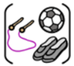

R.E
Our ‘Big Question’ this term is ‘Why do Christians perform nativity plays at Christmas?
P.E
This term the children will be focusing on Gymnastics and Dance.

