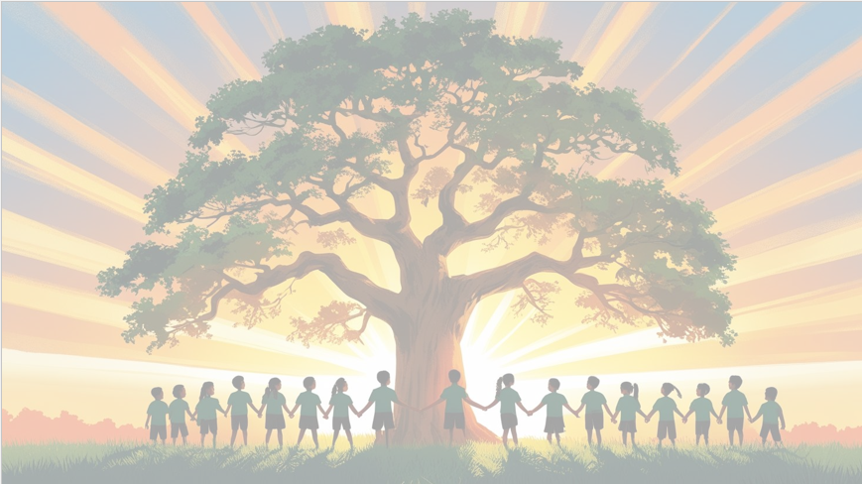
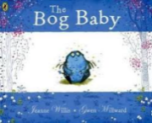
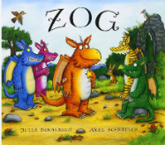
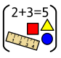
‘’Shine brightly in learning and life’
Maths
In maths, we will be learning:
- Number and place value up to 100
- Representing numbers on a number line
- Finding one more and one less than a number
- Finding and representing all addition and subtraction number facts up to 10
- Recognising and naming 3-d shapes
- Comparing 3-D shapes and explaining how they are similar or different

English
Our texts for the term will be ‘The Bog Baby’ by Jeanne Willis and ‘Zog’ by Julia Donaldson. We will be learning the stories through role-play and storytelling. We will be focusing on writing character descriptions and recounts using our phonic knowledge. We will continue practicing our letter formation and handwriting

PSHE: Celebrating difference
(Jigsaw)
We will be focusing on ways that we are similar and different to other people in our class, and why this makes us all special.

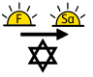
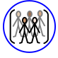
RE
Judaism Mitzvot / tzedakah Why is learning to do good deeds so important to Jewish people?
PE

In PE the children will be learning gymnastics and ball games

DT: Cooking and Nutrition
We will be learning how to safely use a range of cooking tools and equipment to prepare food. We will explore different fruits, learn how to cut them safely, and create our own fruit kebabs. We will also think about making healthy food choices.
Year 1 Curriculum Overview
Term 1
2025/2026

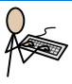
Computing – Creating media
We will be learning how to use technology to create our own digital media. We will explore different tools to make pictures and write. We will learn how to use technology responsibly when creating and presenting our ideas.
Science: Everyday materials
We will be learning about different everyday materials and their properties. We will explore materials such as wood, plastic, metal, and glass, and talk about what they are used for. We will also investigate how materials feel, look, and behave, and use simple tests to find out which materials are best for different purposes.

Geography – United Kingdom
We will be learning about maps and how to use them to find places. We will explore the United Kingdom, looking at the four countries. We will also learn about where we live, our local area, and what makes it special.


Music - Dance, Sing and play
We will be learning that music is made up of long and short sounds called rhythm, and high and low sounds called pitch. We will explore how these sounds work together to make music.

