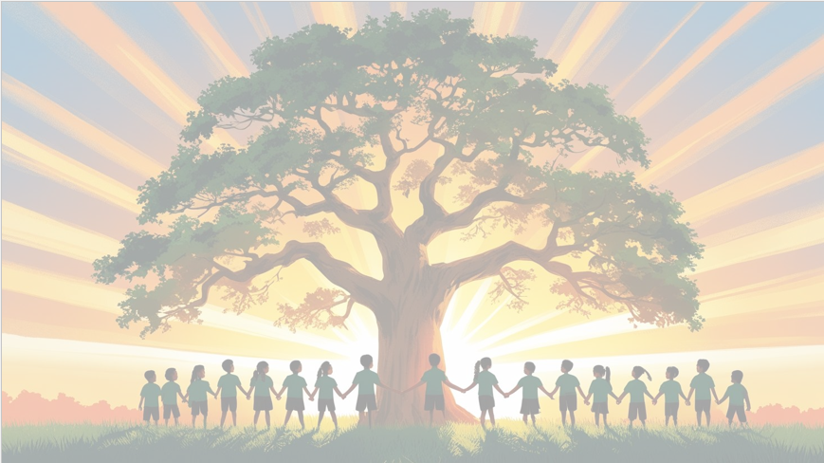
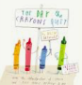
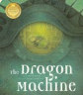
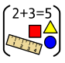
‘’Shine brightly in learning and life’
PSHE: Celebrating Difference
This term, we’ll be learning to celebrate what makes each of us unique. We’ll explore the idea of stereotypes and understand what bullying is and how to respond to it. Alongside this, children will learn positive ways to build new friendships and create a supportive classroom community.
English
This term, we’ll be diving into two exciting texts: The Dragon Machine by Helen Ward and The Day the Crayons Quit by Drew Daywalt. These stories will inspire a range of writing activities including letter writing, character descriptions, narrative writing, and wanted posters.
Each day, children will take part in Bridge to Spelling, reading skills sessions, and Reading Theatre to build fluency and confidence. Grammar and handwriting will be taught explicitly to support clear and accurate writing. By the end of the term, children will have created a variety of written pieces that showcase their growing skills and creativity.

Maths
This term, we’ll be exploring the properties of 3D shapes and learning how to describe them using mathematical language. We’ll also be building confidence in subtraction, working with both single-digit and two-digit numbers. As we move into multiplication and division, children will use arrays and grouping to solve problems, helping them understand how these operations are connected. Throughout, we’ll continue to encourage reasoning and problem-solving to deepen their understanding.


Year 2 Curriculum Overview
Term 2
2025/2026
History
This term, we’ll be learning about the dramatic events of the Great Fire of London and the impact it had on the city. We’ll discover how the fire changed London’s buildings and streets and explore the lives of key figures like Samuel Pepys and Christopher Wren. Through their stories, children will understand why these individuals were so significant and how their actions helped shape the city’s recovery.

RE Judaism Mitzvot / tzedakah Why is learning to do good deeds so important to Jewish people?
PE – Gymnastics and Ball Games
Wednesdays and Fridays

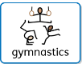
Art
This term, we’ll be exploring the work of different artists through the theme of the environment. Children will develop their drawing skills by making careful observations and experimenting with line, shape, and texture. Through this, they’ll begin to express their ideas and respond creatively to the world around them.
Science: Materials
This term, we’ll continue our exploration of materials by investigating their properties in more depth. Children will test and compare materials for bounciness, elasticity, strength, and rigidity, learning how these characteristics affect their suitability for different uses. Through hands-on experiments and discussions, we’ll encourage curiosity and scientific thinking.
Computing –
Our focus will be on E Safety and digital photography.



