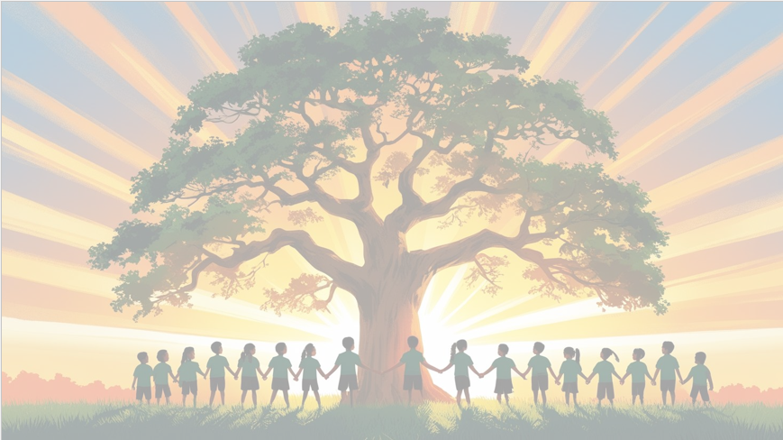
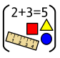
‘’Shine brightly in learning and life’
PSHE: Celebrating Difference
This term, we’ll be learning to celebrate what makes each of us unique. We will be exploring the concepts of acceptance, influence and bullying.

English
This term, we’ll journey through the magical world of The Winter’s Child, using the text to explore characters, settings, and themes. Pupils will develop their comprehension skills by making predictions, asking questions, and diving deeper into the author’s language and meaning.
In writing this term we will continue to dive deeper into the world of diary writing, capturing thoughts and feelings just like real authors. Inspired by our magical class text The Winter’s Child, we’ll also bring characters to life through vivid and imaginative descriptions.

Maths
This term, will focus on building confidence and fluency with multiplication! Pupils will explore the concept of equal groups, use arrays to represent multiplication facts, and begin to understand the relationship between multiplication and division. Year 3 will also develop quick and efficient mental strategies for adding and subtracting. They’ll use number bonds, place value, and rounding to solve problems confidently.

Year 3 Curriculum Overview
Term 2
2025/2026
Geography
This term, Year 3 will dive into the diverse and dramatic coastlines of Europe! Pupils will explore how coasts are formed, the features that make them unique, and the ways people live and work near the sea. Children will compare different coastal environments and learn about erosion, landforms, and the importance of protecting these natural habitats.

RE
This term children will be exploring the big question
How does a Muslim show their submission and obedience to Allah?
PE – Gymnastics and Handball

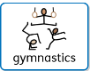
DT - Cooking and nutrition-Eating seasonal
This term, children will create a healthy and nutritious recipe for a savoury tart using seasonal ingredients.
Children will learn how to prepare themselves and a workspace to cook safely in, learning the basic rules to avoid food contamination.
Science: Rocks and Soils
This term, Year 3 will become junior geologists as we explore the fascinating world beneath our feet! Pupils will investigate different types of rocks, learn how they are formed, and discover how fossils are created.
Computing –
Our focus will be on E Safety and Digital Media



