
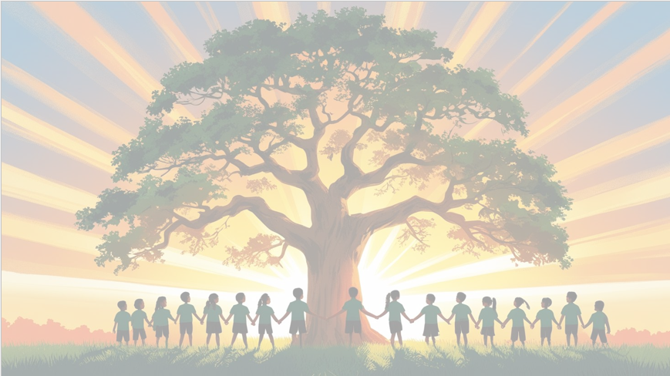
‘’Shine brightly in learning and life’
English
We will be using the focus text ‘The Promise’. Through this thought-provoking story, we will explore moral dilemmas and empathy. Our writing units will include a character description and a persuasive letter, encouraging children to write with emotion, clarity, and purpose.
PSHE: Celebrating Difference
In our puzzle piece this term, we will focus on ‘Celebrating Difference’ recognising how our differences make us special and unique and how we can stand up for others.
Maths
We will be focusing on addition and subtraction, developing our confidence and skills adding and subtraction 5-digit numbers and decimals. We will then move on to multiplying whole numbers and decimals by 10, 100 and 1000.

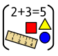


RE
Our BIG question this term is: ‘How does a Muslim show their submission and obedience to Allah?’

PE
In PE, the children will be playing football, developing their technique, confidence skills. They will also participate in yoga and learn its benefits
Year 5 Curriculum Overview
Term 2
2025/2026
Design Technology
In Design Technology this term, Year 5 will be focusing on Cooking and Nutrition. As well learning about food prep and food hygiene, the children will be thinking about making healthy choices and adapting recipes. What could be healthier?





Science: Earth and Space
This term in Science, Year 5 will be exploring the Earth and Space. The children will learn the names of the planets in our Solar System, understand how day and night are created and learn the role and movements of the Earth, Sun and moon.
Geography
This term in Geography, Year 5 will be learning about Cartography. The children will identify the continents and oceans of the world. We will then use 6-figure grid references to find destination and landmarks on maps as well as well as creating our own maps.
Computing
We will learn about Creating Media including identifying what makes a video effective, capturing video using a range of techniques including reshooting and editing.

French

.

