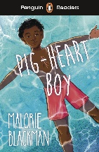
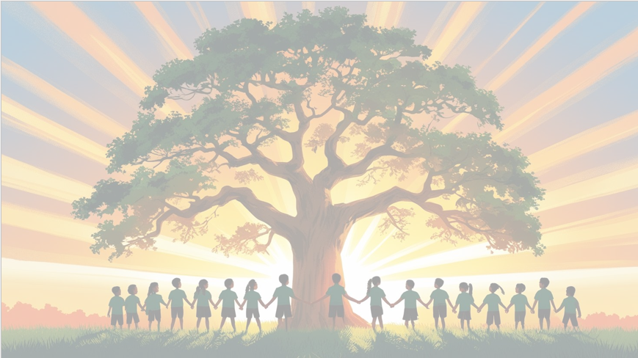
‘’Shine brightly in learning and life’
Maths
This term, we will be focusing on fractions – developing confidence in simplifying, comparing, adding, subtracting, multiplying and dividing them. Later in the term, we will move on to geometry, exploring the properties of shapes and angles, and applying our knowledge to solve problems.
English
We will be using Pig Heart Boy as our focus text this term. Through this thought-provoking story, we will explore moral dilemmas and empathy. Our writing units will include a narrative inspired by the novel and a persuasive letter, encouraging children to write with emotion, clarity, and purpose.

PSHE: Healthy Me
In our six puzzle pieces this term, we will focus on ‘Celebrating Difference’, recognising how our differences make us special and how we can stand up for others.


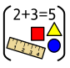

RE

Our BIG question this term is: ‘What does the Qur’an reveal to Muslims about Allah and his guidance?”
PE

In PE the children will be learning Football and Yoga.

Art: Drawing
We will be exploring identity through drawing, developing our observational skills and experimenting with a range of materials and techniques to express who we are and what makes us unique.

Year 6 Curriculum Overview
Term 2
2025/2026

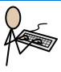

History
In History, we will learn about World War II, focusing on the Battle of Britain. We will explore why it was a significant turning point in British history, consider the experiences of people living through it, and use a range of sources to develop our understanding.
Computing
We will be focusing on the strand Computer Science, learning about computing systems and networks, and how communication and collaboration happen online.
Science: Light
We will be investigating how light travels, how we see objects, and how shadows are formed. Children will explore reflection and refraction through practical investigations.


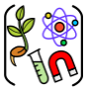

French
We will learn to describe our local area, give directions, and talk about places in town.

