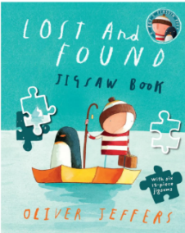
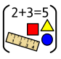

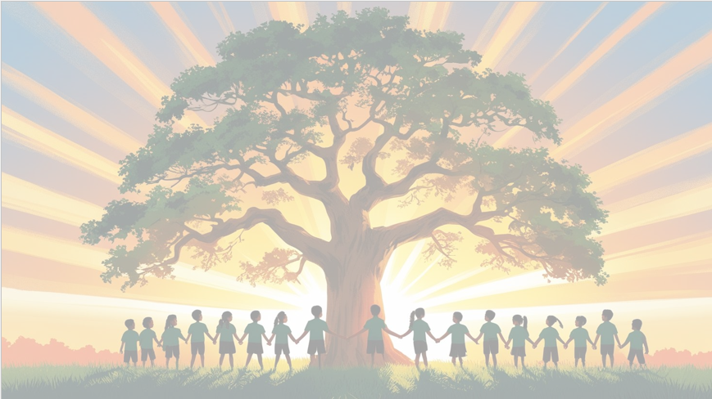
‘Shine brightly in learning and life’
Maths
This term reception children will be:
- Orally counting to and back from20.
- Singing counting songs up to 20.
- Using their fingers to show quantities up to 10.
- Subitising arrangements of 1-6 objects (recognising number without counting)
- Using 10 frames with ‘5-wise’ arrangements to recognise amounts and spaces up to 10.
- Watching clips from the Number blocks Series to support number development.
- Learning to recognise Numicon shapes without counting holes.
- Comparing and ordering quantities up to 10 using Numicon.
- Using talk pictures to discuss and notice different number patterns.
- Learning common 2D and 3D shapes using appropriate mathematical language.
Literacy
Our texts this term are ‘Lost and Found’ by Oliver Jeffers, and ‘Naughty Bus’ by Jan Oke.
The children will be:
- Using ‘Talk 4 Writing’ to create actions for our focus texts enabling them to orally retell the story.
- Exploring rhymes and poems to accompany these texts to enhance their learning.
- Using our phonics to sound-talk, segment and blend to enable them to write focus words, relating to our texts.
- Developing letter formation and handwriting skills.

Reception Curriculum Overview
Term 3
2025/2026

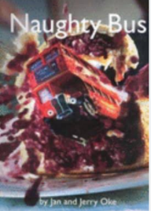
Phonics

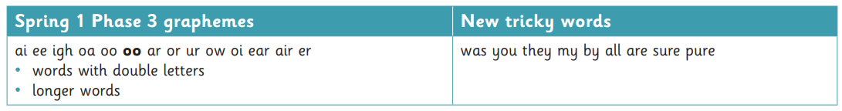





Continuous Provision
Role-Play - Linking to celebrations (New Year, Penguin Awareness Day (20.1.26) and Safer Internet Day (10.2.26)
EAD – Transport activities, create buses, trains, planes, cars. Create cities using blocks.
Sand/Water play – Create scenes for different vehicles. Create boats – investigating floating/sinking.
Sand/Mud kitchen – Create ice lollies – make meals for friends – New Year party.

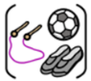

R.E
Our ‘Big Question’ this term is: ‘?
P.E
This term the children will be focusing on multi-skills.

