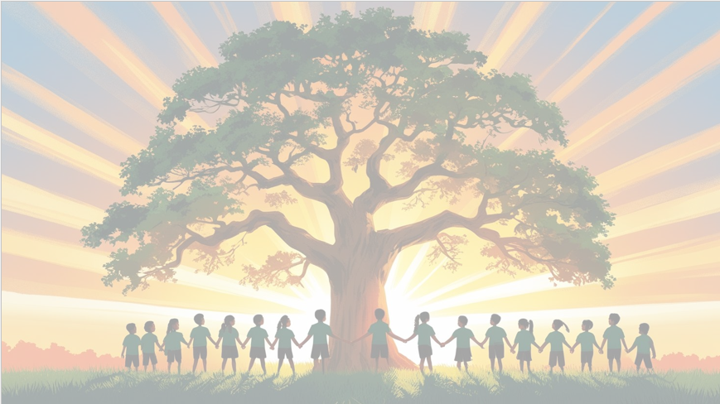
‘’Shine brightly in learning and life’
Maths
This term we will be continuing to learn about the place value of numbers, all the way up to 100.
In addition, and subtraction, we will be focusing on the numbers: 11, 12, 13, 14,15, and 16. We will be partitioning these numbers and writing both addition and subtraction number sentences using them.

PSHE: Dreams and goals
The children will learn how to work effectively in a group, think about the skills they bring and how these complement others, and explore the different roles people play in a team and the feelings that come with them.

Would you like me to make it even warmer and engaging (e.g., “We’re excited to see the children grow as team players and build confidence in their unique strengths!”)?
English
In English this term, we’ll be diving into some exciting stories!
Our core texts this term will be:
Poles Apart and Dear Greenpeace.
We will be continuing to learn about sentence structure (capital letters, full stops, and finger spaces), as well as adjectives and using the connectives “and” and “because” in our writing.
Our end units will be to write a part of a well-known story and to write a non-chronological report.

We’ll make writing active and enjoyable, helping children develop both creativity and accuracy.

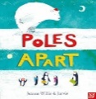

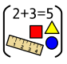
History
This term we will look at toys and how they have changed over time. We will discuss similarities and differences and create a toy timeline.

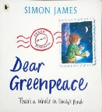
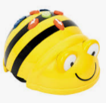
Computing – Programming
This term we will be learning
about programming and using bee-bots.

Year 1 Curriculum Overview
Term 3 2025/2026

RE Christianity
Prayer / worship
Why do Christians pray to God and worship him?

Science: Materials
This term we will continue to learn about materials and be using vocabulary to describe their properties. We will be performing simple tests so we can group materials and answer posed scientific questions
Phonics
This term, we will be continuing to learn our phase 5 sounds and practice applying them through reading and writing.

Art - Painting
This term we will be exploring a variety of painting skills.
PE – Health and fitness and Dance
Our PE days are Tuesdays and Wednesdays.


