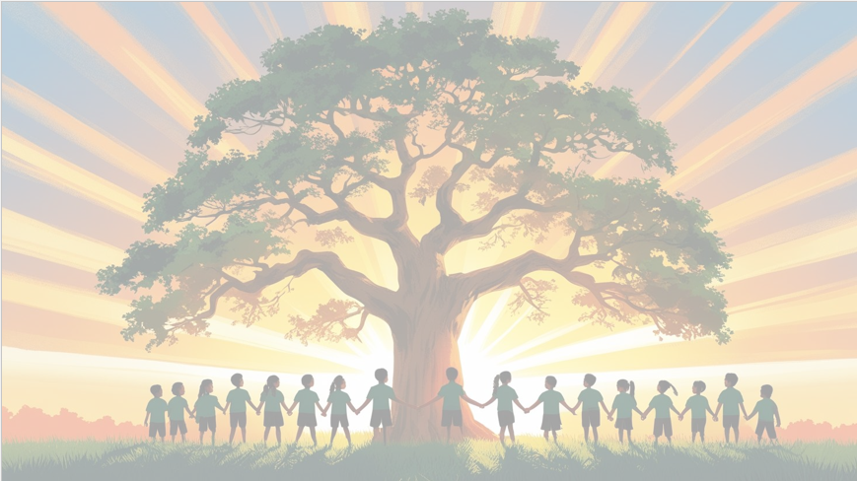
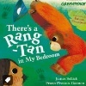
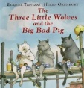
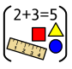
‘’Shine brightly in learning and life’
English
In English this term, we’ll be diving into some exciting stories!
Our main texts will be The Three Little Wolves and the Big Bad Pig and There’s a Rang-Tan in My Bedroom. Through these, children will:
Write creative pieces like character descriptions, retelling stories and creating wanted posters along with diary entries.
The skills that we will be focusing on are using subordinating conjunctions, adverbials for time, including exclamation sentences and developing our editing and revising skills.

We’ll make writing active and enjoyable, helping children develop both creativity and accuracy.
PSHE: Dreams and goals
The children will learn how to work effectively in a group, think about the skills they bring and how these complement others, and explore the different roles people play in a team and the feelings that come with them.

Would you like me to make it even warmer and engaging (e.g., “We’re excited to see the children grow as team players and build confidence in their unique strengths!”)?
Maths
This term, we’ll be getting confident with times tables – we’ll practise the 2, 5 and 10 times tables so children can recall them quickly and use them in different situations.
Additionally, we will Exploring division – using what we know about multiplication to solve division problems with the same tables.
Measuring weight – children will learn how to measure the mass of objects in kilograms and grams.
Comparing weights – we’ll use symbols like >, < and = to compare which objects are heavier or lighter.
Measuring length – using metres and centimetres to measure everyday items.
Estimating heights – making sensible guesses about how tall things are in centimetres before checking with a ruler.• Estimate heights (cm)

Geography
We will learn about different places around the World with a focus on homes and weather.

Year 2 Curriculum Overview
Term 3
2025/2026

RE Christianity
Prayer / worship
Why do Christians pray to God and worship him?

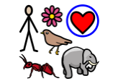
Science: Living things and their habitats
In Science this term, we’ll start by thinking about what makes something living and how that’s different from things that are non-living. Then, we’ll explore habitats – from tiny microhabitats to larger environments – and learn about the creatures that live there. The children will also investigate food chains, finding out how plants and animals depend on each other. Finally, we’ll look at how and why animals adapt to survive in their habitats, which is always a fascinating unit!
DT - Sewing
This term we will be making and decorating money pouches using a running stitch.
PE – Health and fitness and Dance
Our PE days are Wednesdays and Fridays.

Computing – Programming
Our focus will be on E Safety and using clear instructions to create algorithms.

