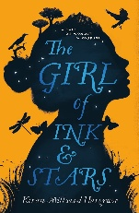
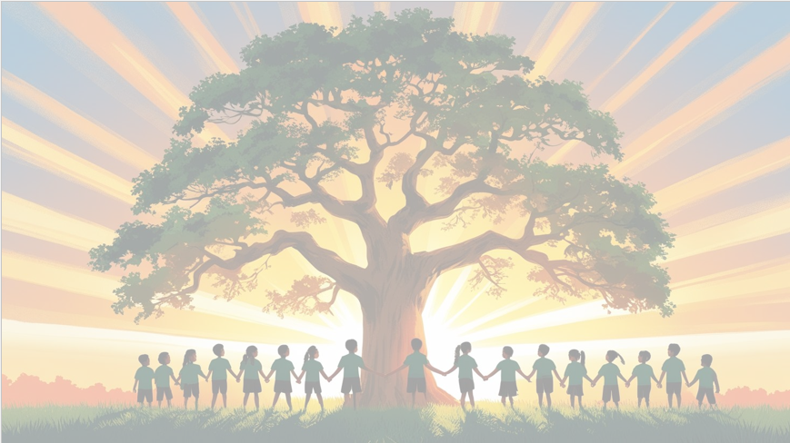
‘’Shine brightly in learning and life’
Maths
This term, Year 6 will be developing fluency and confidence in a range of key areas:
- Multiplying and dividing fractions
- Ratio and proportion
- Percentages of amounts
- Measurement, including converting between units
Children will apply these skills to multi-step problems, deepening their reasoning and arithmetic accuracy.

English
Our focus text this term is The Girl of Ink and Stars. We will explore themes of myth, adventure and bravery. Children will be writing their own myth, inspired by the world of the story, and producing a non-chronological report linked to the text’s setting and creatures.

PSHE: Dreams and Goals
In our six puzzle pieces this term, we will focus on ‘’Dreams and Goals’. We will reflect on their aspirations, strengths and next steps.
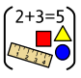


DT: Structures – Bridges
We will investigate how different bridge types are constructed, looking at strength, stability and purpose. Children will design and build their own bridge structure, testing materials and applying engineering principles.
RE
Our BIG question this term is: ‘What spiritual
pathways to
moksha are written
about in Hindu
scriptures?
PE

In PE the children will be learning Tag Rugby and Health & Fitness.

Year 6 Curriculum Overview
Term 3
2025/2026



Geography
In Geography, we will be learning about key regions across the globe. Children will deepen their understanding of continents, climate zones, biomes, and significant world locations, using maps, atlases, and digital tools to explore human and physical geography.
Computing
We will be focusing on the strand Computer Science, learning. This unit will introduce children to the use of variables within programming using Scratch.

Understand what variables are and what they do

Create and manipulate variables within a game

Use variables to store scores, timers or player lives
Science: Living Things and Their Habitats
We will be classifying living things using detailed classification systems, exploring microorganisms and recognising how scientists use characteristics to group and compare life forms.


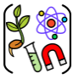
Music
We will learn to describe our local area, give directions, and talk about places in town.


