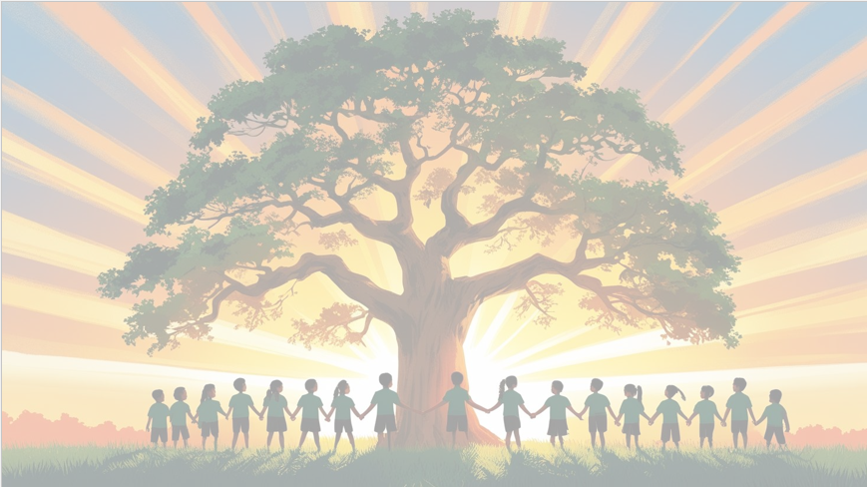
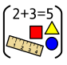
‘’Shine brightly in learning and life’
Maths
This term, we’ll be looking at 2 units; fractions and time.
Fractions – We will be finding 1/3, 2/4 and ¾ of shapes, objects and numbers.
Time – Knowing units of time, telling the time to the hour, half past, quarter past and quarter to. Drawing the hands on a clock face to show time. Sequencing intervals of time.

English
English: Our text for the term will be ‘The Lighthouse Keeper’s Lunch’ by Ronda & David Armitage
• Daily spelling sessions
• Reading skills taught daily
• Role play
• Grammar rules taught explicitly
• Newspaper report
• Fairy tale writing
• Sequel narrative to the Lighthouse Keeper’s Lunch
• Diary entry
• Instructions
We’ll make writing active and enjoyable, helping children develop both creativity and accuracy.
PSHE: Healthy Me
We will be learning about being healthy, how to be relaxed, medicine safety and healthy eating.
Would you like me to make it even warmer and engaging (e.g., “We’re excited to see the children grow as team players and build confidence in their unique strengths!”)?

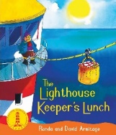

History
We will be learning about the seaside during the Victorian era and comparing it to the seaside today.
Year 2 Curriculum Overview
Term 4
2025/2026

RE Judaism
Tefillah/ blessings
Why do Jewish families say so many prayers and blessings?


Science: Animals, including humans
• Notice that animals, including humans, have offspring which grow into adults.
• Find out about and describe the basic needs of animals, including humans, for survival (water, food and air)
• Describe the importance for humans of exercise, eating the right amounts of different types of food, and hygiene.
ART – Exploring the World through Monoprint
Artist- Xgaoc'o X’are
PE – Invasion games and multi skills
Our PE days are Wednesdays and Fridays.

Computing – ICT Skills
•E-safety
•Data and information- Pictograms

