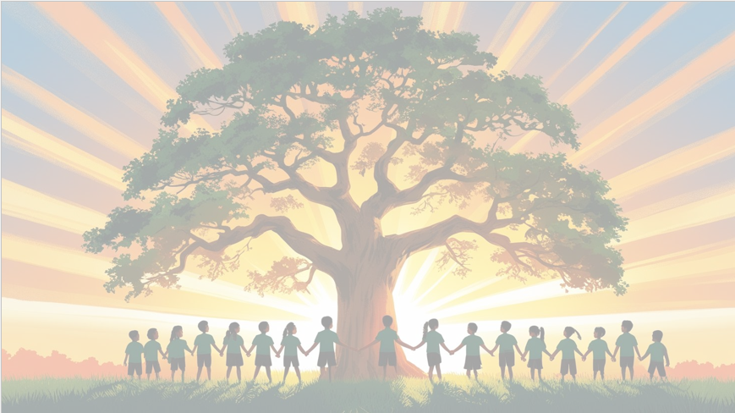

Shine brightly in learning and life’
PSHE: Dreams and Goals
In our puzzle piece this term, we will focus on ‘Healthy Me’ identifying the importance of a healthy lifestyle including the effects of smoking and alcohol as well as body image and our relationship with food.
Maths
We will be focusing on fractions, decimals and percentages, looking at the relationship between them and converting amounts between all 3. We will move on to look at measurements (length, mass and capacity) including perimeter and suing decimal notation.

English
We will be using the focus text ‘Wonder’, which is based around a boy with Treacher Collins syndrome, and ‘The Greatest Show/Little Freak.’ Our writing units include creating our own short stories based on characters overcoming adversity and writing a persuasive speech.

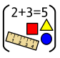
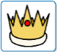

RE
Our BIG question this term is: ‘How does the triple Refuge help Buddhists in their journey through life?’
PE
In PE, we will be playing cricket and hockey, developing our technique, confidence and skills before applying to different games.
Year 5 Curriculum Overview
Term 4
2025/2026
DT 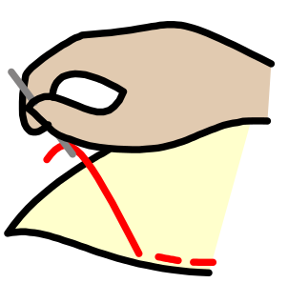
In Art this term, Year 5 will be designing, sewing and decorating their own cuddly toy.

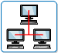
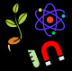
Science: Living Things and Their Habitats
This term in Science, Year 5 will describe the differences in the life cycles of a mammal, an amphibian, an insect and a bird. We will also describe the life process of reproduction in some plants and animals.

Geography
In Geography we will study the similarities and differences between our environment in the UK and an ‘extreme’ environment in a different country. We will also look at what causes an environment to be ‘extreme’ environment and what it is like to live in one.

Computing
We will start to create vector drawings by using different drawing tools to help create images. We will recognise that images in vector drawings are created using shapes and lines and begin grouping and duplicating them to support the creation of more complex pieces of work.


French
This term we will learn how to tell somebody if they have or do not have a pet, ask somebody else if they have a pet and tell somebody the name of their pet.
.

