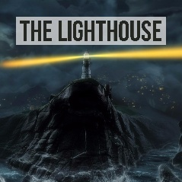
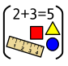
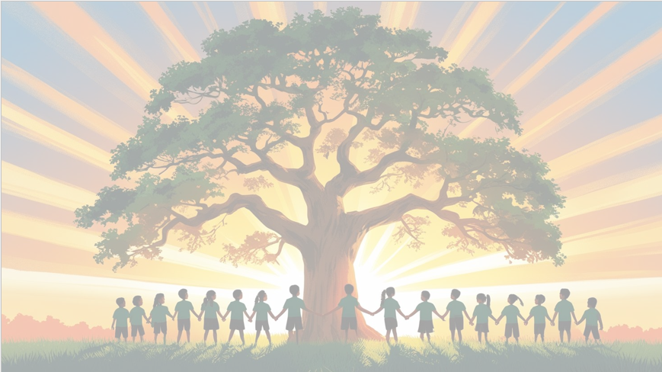
‘’Shine brightly in learning and life’
Maths
This term, Year 6 will focus on:
- Statistics
- Algebra
- Geometry (Position and Direction).
Children will learn to develop their skills in interpreting data, solving simple algebraic problems, and describing movement and position on a grid.

English
Our focus text this term is The Lighthouse. Children will retell the narrative, developing their use of dialogue. They will also use the text Can We Save the Tiger? to write a persuasive argument using emotive language and facts.

PSHE: Healthy Me
In our six puzzle pieces this term, we will focus on Healthy Me, children will learn how to take responsibility for their physical and emotional health and how to stay safe and manage stress.



Art: Painting
This term focuses on painting as a form of activism, with children exploring how artists use images to express messages about important issues. Children will create our own artwork about a cause they care about.
RE
Our BIG question this term is: ‘How does the Triple Refuge help Buddhists in their journey through life?’
PE

In PE the children will be learning Cricket and Hockey.

Year 6 Curriculum Overview
Term 4
2025/2026



History
This term, we will explore the Victorian era, focusing on inventions, and industrial developments. We will learn about town and country life, major industries such as factories, mills, and mines. They will examine how schools, work, and society changed during this period and the legacy of Queen Victoria.
Computing
We will be focusing on the strand Information Technology. This unit introduces the learners to spreadsheets. They will be supported in organising data into columns and rows.

Understand what variables are and what they do

Create and manipulate variables within a game

Use variables to store scores, timers or player lives
Science: Evolution and Inheritance
We will explore how living things inherit characteristics from their parents and how species change over time. Children will learn about inherited and acquired traits, adaptation, natural selection, and evolution.

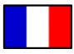
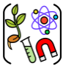
French
We will learn to describe our clothes and what we wear.


