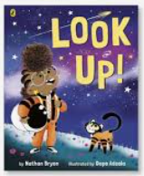
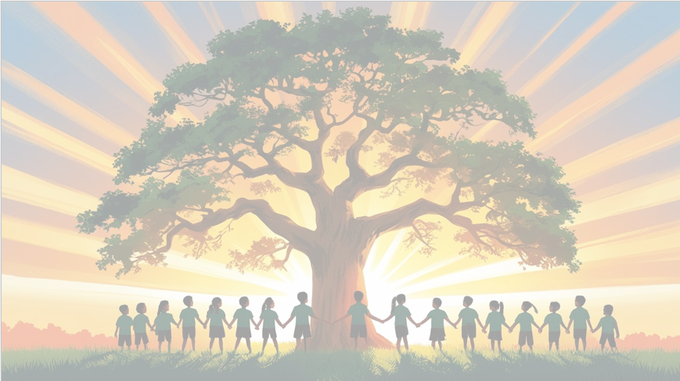
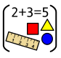
‘’S h ine brightly in learning and life’
English

We will be using the texts ‘Look Up!’ and ‘Dragon Post’ as our focus books. We will be writing in full sentences, using exclamation marks, question marks, adjectives and recapping on all of the suffixes we have learnt throughout Year 1 to write retells and letters.

Maths: Measurement
We will be focusing on the different aspects of measurement, including time, money, mass and capacity. We will be learning how to tell the time using o’clock and half past, as well as sequencing events. We will be looking at coins and notes, before describing and comparing them, and their value. We will also learn about how to compare and measure the mass and capacity of different objects.

PSHE: ‘Changing me’
In our sixth puzzle pieces, we will focus on ‘Changing Me and learning about how we have changed and will change, and the difference between boys and girls.
too.

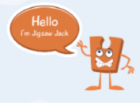


Year 1 Curriculum Overview
Term 6
2025/2026
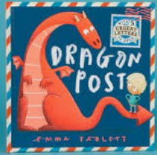
Geography
We will be learning about ‘Forests and Woodlands’ as well as human and physical features. We will be using maps and aerial photographs to support our learning, before making maps of our local area and school grounds.

Science: Trees and Plants
We will be learning about evergreen and deciduous trees and their leaves, before focusing on both wild and common plants. We will learn about their structures and what they need to help them grow.

RE: Christianity
Baptism / church
Why is belonging to God and the church family important to Christians?
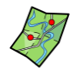
Computing
We will be focusing on the strand programming and be using ‘Scratch Junior’ to create our own programmed animations and algorithms.



DT: Mechanisms
We will be learning about wheels and axles to create a pull-along toy. Throughout the unit we will be testing and comparing different wheels, designing our very own cars, before making them and evaluating.

Value of the term:
Creativity/Creation

PE – Preparation for Sports Day

