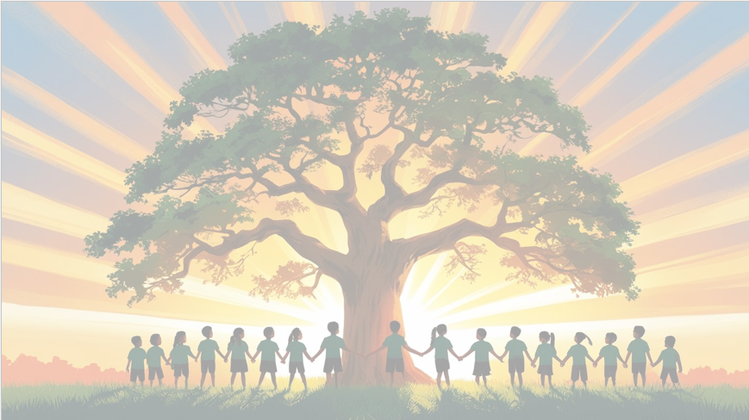
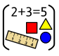
‘’S h ine brightly in learning and life’
PSHE: ‘Changing me’
We will be understanding the changes that are taking place around us, learning about the parts of the body and learning about privacy.
We will be doing lots of work on the transition to Year 3 in our PSHE lessons too.
Maths
- Position and direction- describing positions, turns and the use of right angles.
- The remainder of the term will be revision of the Year 2 Maths curriculum to ensure it’s embedded before the children move up to Year 3.
- We will also be learning about different problem-solving skills and exploring these in different contexts.

English
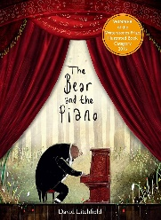

English: Our texts for the term will be ‘The Bear and the Piano’ by David Litchfield and ‘The Wonder’ by Faye Hanson.
• Reading skills taught daily
• Handwriting taught explicitly
• Grammar rules taught explicitly
• Innovated narrative
• Setting description
• Writing Recounts

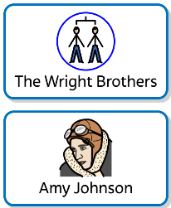
Year 2 Curriculum Overview
Term 6
2025/2026
History

- We will be learning about the development of flight (within and beyond living memory), famous pilots, such as: The Wright Brothers and Amy Johnson.

RE: Christianity
Baptism / church
Why is belonging to God and the church family important to Christians?
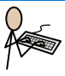
Science: Plants
• In Science we will be continuing our Plants focus. This term we will be exploring:
• What plants need to grow
• The lifecycle of plants
• The different ways to grow our own plants
Computing – Multimedia Skills
• Online safety
• Programming

Art: Expressive Painting
We will be learning about artists who use expressive painting. We will also be exploring a variety of mark making techniques.

PE – Preparation for Sports Day and
Handball
PE days are Wednesdays and Fridays.

