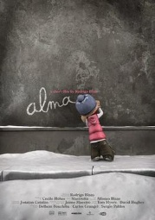
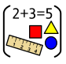
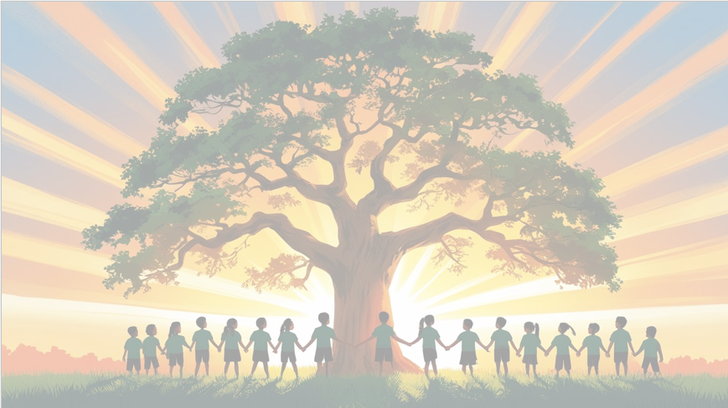
‘’Shine brightly in learning and life’
Maths
This term, we will focus on:
‘Moving On Up’.

Children will begin by revisiting key learning in preparation for secondary school. Following this, they will continue to develop their problem-solving skills.
English
Our focus text this term is the animation ‘Alma’. Children will a set of instructions.
They will also use other texts such as ‘Wing’ to write a narrative.

PSHE: Relationships
In our six puzzle pieces this term, we will focus on Changing Me. Children will learn about puberty, boyfriends and girlfriends and self-esteem.



Art
We will explore sculpture through our topic Take a Seat. Children will investigate how artists design and create chairs, thinking about both form and function. They will experiment with a range of materials and techniques.
RE
Our BIG question this term is: Why do Christians think being a pilgrim is a good analogy for life itself?
PE

In PE the children will be learning rounders and athletics

Year 6 Curriculum Overview
Term 5
2025/2026


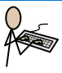
History
This term, we will explore the Tudor Monarchy. Children will learn about key Tudor monarchs such as Henry VIII and Elizabeth I, and discover how their reigns shaped England’s history. They will investigate important events including changes in religion, the impact of the Tudor court, and England’s growing role.
Computing
We will be exploring how to design and create 3D models using digital software. They will learn to build, modify and combine shapes to produce their own designs and developing creativity.
Use variables to store scores, timers or player lives
Science: Working Scientifically
We will develop our skills in Working Scientifically through a range of practical experiments. Children will learn how to plan and carry out fair tests, make careful observations, and take accurate measurements.


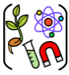
French
We will be focusing on the topic ‘In My Classroom’


