Pupil premium strategy statement 2023 – 2024

This statement details our school’s use of pupil premium (and recovery premium for the 2023 to 2024 academic year) funding to help improve the attainment of our disadvantaged pupils.

It outlines our pupil premium strategy, how we intend to spend the funding in this academic year and the effect that last year’s spending of pupil premium had within our school.

School overview
Detail | Data
School name | Shaw CE Primary
Number of pupils in school | 206
Proportion (%) of pupil premium eligible pupils | 17% (36)
Academic year/years that our current pupil premium strategy plan covers (3 year plans are recommended) | 2022 – 2025  Current Year 2023-2024
Date this statement was published | January 2023
Date on which it will be reviewed | September 2025  (reviewed Sept 2024)
Statement authorised by | Thomas Brewer
Pupil premium lead | Natalie Burke
Governor / Trustee lead | Mark Burrett  (from Sept 2024 Nigel Watson)
Funding overview
Detail | Amount
Pupil premium funding allocation this academic year | £33,775
Recovery premium funding allocation this academic year | £3,770
Pupil premium funding carried forward from previous years (enter £0 if not applicable) | £0
Total budget for this academic year  If your school is an academy in a trust that pools this funding, state the amount available to your school this academic year | £37,545

Part A: Pupil premium strategy plan

Statement of intent
At Shaw C of E Primary School, we believe that every child is unique and special. All members of staff, including governors and teaching assistants, accept responsibility for ‘socially disadvantaged’ pupils and are committed to meeting their pastoral, social and academic needs within a nurturing, C of E environment. We intend that each child will develop a love for learning and acquire skills and abilities to support them in reaching their full potential and to be successful in life. We engage children in a theologically grounded and spiritual ethos that promotes “Let your light shine” (Matthew 5). We strive for children to demonstrate their individual talents and to let their sense of self shine through whatever they’re background and advantage/disadvantage.
Quality First Teaching is at the core of our approach. This is proven to have the greatest impact on progress for disadvantaged learners and closing the attainment gap, whilst also benefitting the progress and attainment of all children.
We believe that it is our duty to ensure that disadvantaged students perform as well as their peers and so we plan to work tirelessly to ensure that the funding is used as effectively as possible to improve the achievement of students for whom it is intended. At Shaw we pride ourselves on knowing our students and parents well and recognise that not all of our students who are socially disadvantaged are registered for or qualify for free school meals. Therefore, we target our Pupil Premium funding to all students who may be disadvantaged so that they too are supported to thrive with a determination to achieve well.
Almost 20% of our pupils in receipt of pupil premium have identified special educational needs. In all cases we strive to ensure all our pupils make excellent progress. We believe that all our pupils benefit from high quality teaching every day and we ensure our strategy provides for this with further additional intervention through one to one and small group teaching. We have accessed this using our current staff in school but also accessing the National Tutoring Programme.
We run bespoke targeted interventions to support all our pupils who have additional needs and our disadvantaged pupil’s access all of these interventions and groups regardless.
Our objectives are to:
- Improve attitudes to learning of disadvantaged learners
- Ensure our school environment is as suitable as possible to accommodate all types of learners
- Narrow the attainment gap between Pupil Premium children and their non-Pupil Premium peers
- Ensure all pupils are able to read fluently and with good understanding
- Enable all pupils to communicate confidently and effectively
- To support all Pupil Premium children in reaching Age Related Expectations at the end of Year 6 in reading, writing and maths.
- Pupils to be happy, confident individuals who are ready for the next stage of their schooling

Challenges

This details the key challenges to achievement that we have identified among our disadvantaged pupils.
Challenge number | Detail of challenge
1 | Communication/SEMH/Behaviour  Our assessments, observations and discussions with pupils show that disadvantaged pupils generally have greater challenges around communicating and expressing their needs than their peers, in the context of SEMH needs.
2 | Well Being/Self Esteem  Significant special educational needs within some groups of disadvantaged  learners, this includes low self-esteem amongst this group of pupils.
3 | Limited Cultural Capital  Through observations and conversations with pupils and their families, we find that disadvantaged pupils generally have fewer opportunities to develop cultural capital outside of school.
4 | Difficulties with reading fluency  Low literacy, particularly reading comprehension and limited vocabulary has an impact on students’ ability to fully access the curriculum. Parental engagement with this.
5 | Prior Attainment  Low prior attainment means that some students have significant gaps in their knowledge when joining the school. If these gaps are not addressed early, the gaps can widen as students’ progress through school.
6 | Attendance  Across the year groups disadvantaged learners’ attendance is lower than their peers.

Intended outcomes
This explains the outcomes we are aiming for by the end of our current strategy plan, and how we will measure whether they have been achieved.
 | Intended outcome | Success criteria
1 | Improve the behaviour of our disadvantaged students, especially those with sensory needs. | The school have systems, processes, and routines in place so that quality first teaching is delivered daily and lesson disruption is minimum.  Individual pupils with SEMH needs have inclusive plans that enable and/or support self-regulation – this will include places in the school dedicated to supporting these types of pupils many of whom are already disadvantaged pupils.
2 | To ensure the well-being needs of all pupils in receipt of pupil premium funding are met to ensure they are ready for learning. Including mental health. | Our children’s well-being needs are met and supported to ensure they are attending school more regularly and able to access high quality teaching and targeted interventions where needed to support them in making progress.
3 | To provide a range of enrichment opportunities for pupils in school time and after school | WWT – Wiltshire Wildlife Trust to begin forest school activities with our most SEMH class in the school YR 6.  Up and Under Sports to deliver bespoke learning to KS2 classes in particular Year 4+6 as identified classes with SEMH needs and disadvantaged learners  - Lunchtime football club once a week  - After school sports clubs  Ensure that learning is done by the following;  - Regular feedback  - Monitoring  - Pupil feedback  - Quantifiable data  - Behaviour reports
4 | Increase engagement with parents to support home reading. Provide increased opportunities in school to support and enthuse a love of reading. | By the end of the academic year, attainment in reading for all pupils improves across the whole school compared to standardised assessment in summer 2021.  Established systems in place to signpost support for families who maybe be struggling with supporting their child (including ensuring children are prepared for learning)  • Established systems in place to support children who may ready to come to school ready to learn i.e. access to free breakfast clubs; Rest and Recovery club at lunchtime; access to ELSA groups.  The school have a high quality Systematic Synthetic Phonics (SSP) programme in place and it is being delivered consistently across EYFS and KS1.  • The school has a rigorous and robust assessment process which quickly identifies children who are unable to read fluently.  • Disadvantaged Pupils have access to a range of High Quality (age appropriate) Texts and have opportunities to develop a love of reading  • EYFS teachers report improved comprehension and oral language skills in Disadvantaged pupils and improvements in Reading Age scores  • Pupils in Reception and Year 1 have a developing grasp of phonics to support the segmenting/blending (decoding) of unknown words.  • The number of Disadvantaged pupils leaving Year 2 having passed the Phonics Screener check is broadly in line with National Expectations (90%).  • An increase in the attainment of Disadvantaged pupils in Reading (Both On-Track and Greater Depth) at the end of each Key Stage.  • Disadvantaged Pupils have developed a love for reading and read more frequently at home
5 | To ensure the outcomes for pupils in receipt of pupil premium are at least in line with those of peers in school across the curriculum through ensuring high quality teaching is effectively in place, alongside targeted interventions. | Disadvantaged pupils perform in line with their peers in reading, writing and maths and SPAG  High quality teaching and learning is observed in lessons and in learning walks  Targeted interventions are bespoke, rapid and effective and carefully monitored by the SENDCO and class teachers for effectiveness.
6 | To ensure the attendance of pupils in receipt of pupil premium is in line with those of peers, reducing the proportion classed as persistent absentees | To close the increasing gap between whole school attendance and pupils in receipt of pupil premium funding.  Monitor attendance weekly and raise profile within the school community of the importance of attending school regularly.  Ensure families and pupils are supported effectively

Activity in this academic year
This details how we intend to spend our pupil premium (and recovery premium funding) this academic year to address the challenges listed above.

Teaching (for example, CPD, recruitment and retention)
Budgeted cost: £12,000
Activity | Evidence that supports this approach | Challenge number(s) addressed
Continued improvements in whole school early reading provision through access to a high-quality systematic synthetic phonics (SSP) programme to the Little Wandle SSP. This ensures;  • All children have a solid base upon which to build as they progress through school;  • Enable children to develop the habit of reading widely and often, for both pleasure and information This will be done through;  • Access to ongoing, high-quality staff training.  • Access to well-mapped and sequenced lesson plans  • Matched phonetically decodable books  • Learning environments which are conducive to high-quality | EEF Key finding;  “Phonics has a positive impact overall (+5 months) with very extensive evidence and is an important component in the development of early reading skills, particularly for children from disadvantaged backgrounds. “The teaching of phonics should be explicit and systematic to support children in making connections between the sound patterns they hear in words and the way that these words are written.” “Studies in England have shown that pupils eligible for free school meals typically receive similar or slightly greater benefit from phonics interventions and approaches. This is likely to be due to the explicit nature of the instruction and the intensive support provided. It is possible that some disadvantaged pupils may not develop phonological awareness at the same rate as other pupils, having been exposed to fewer words spoken and books read in the home. Targeted phonics interventions may therefore improve decoding skills more quickly for pupils who have experienced these barriers to learning.” | 4
Continued subscription to a DfE validated Systematic Synthetic Phonics programme (Little Wandle) Enable and maintain strong and secure phonics teaching for all pupils. | Phonics approaches have a strong evidence base that indicates a positive impact on the accuracy of word reading (though not necessarily comprehension), particularly for disadvantaged pupils:  https://educationendowmentfoundation.org.uk/evidence-summaries/teaching-learning-toolkit/phonics/ | 3
All staff to access training in working with children with sensory regulation difficulty. | Evidence from the EEF suggests that there are some indications that children from disadvantaged backgrounds are more likely to begin nursery or reception with weaker self-regulation skills than their peers. As a result, embedding self-regulation strategies into early years teaching is likely to be particularly beneficial for children from disadvantaged backgrounds. | 2,3
Improve the quality of social and emotional (SEL) learning. SEL approaches will be embedded into routine educational practices and supported by professional development and training for staff. Training for all staff (including support staff) to ensure SEL is delivered consistently across the school | There is extensive evidence associating childhood social and emotional skills with improved outcomes at school and in later life (e.g., improved academic performance, attitudes, behaviour and relationships with peers):  https://educationendownmentfoundtion.org.uk | 2,3
Attendance monitoring clear and effective in supporting families and pupils. |  | 6

Targeted academic support (for example, tutoring, one-to-one support structured interventions)
Budgeted cost: £14,000
Activity | Evidence that supports this approach | Challenge number(s) addressed
Establish small group maths/writing intervention for disadvantaged pupils falling behind age-related expectations  Investigate using Third Space Learning /School Led Tutoring for ‘bespoke’ individual / small group intervention. | EEF Toolkit guidance: https://educationendowmentfoundation.or g.uk/support-for-schools/school improvement-planning/2-targeted academic-support ‘Some pupils may require additional support alongside high-quality teaching in order to make good progress. The evidence indicates that small group and one to one interventions can be a powerful tool for supporting these pupils when they are used carefully.’ | 5
Effective deployment of staff, Teaching Assistants to support key children and year groups. Targeted Interventions led by member of SLT in Year 6. Teaching Assistant timetable re-evaluated to deliver pastoral groups, positive play at playtimes, out-door learning, settling child into school in the morning. | EEF research guidance:  www.educationendowmentfoundation.org.uk  ‘Research on Tas delivering targeted interventions in one-to-one or small group settings shows a consistent impact on attainment of approximately three to four additional months’ progress (effect size 0.2 – 0.3). Crucially, these positive effects are only observed when Tas work in structured settings with high quality support and training. When Tas are deployed in more informal, unsupported instructional roles, they can impact negatively on pupils’ learning outcomes. | 5
To analyse summative assessment data and identify the children who require catch up and more targeted intervention. Closely monitored by Deputy Head Teacher and PP Lead Pupil progress meetings termly Regular monitoring of targeted interventions | EEF Toolkit guidance:  https://educationendowmentfoundation.org.uk/support-for-schools/school-improvement-planning/2-targeted-academic-support  ‘These interventions should be targeted at specific pupils using information gathered from assessments and their effectiveness and intensity should be continually monitored. Some pupils may have made quick gains once they returned to school full time, so assessment needs to ongoing, but manageable.’ | 5
To use music therapy and imagery to support pupils with emotional needs. | The school have employed a Music Therapist to work with selected classes in the school for periods of time and individual PP children.  We also had staff training around the work done by Dan Nicholls Dan Nicholls | @DrDanNicholls | educational leadership | inspiring change | releasing potential (dannicholls1.com) | 1+2

Wider strategies (for example, related to attendance, behaviour, wellbeing)
Budgeted cost: £4,500
Activity | Evidence that supports this approach | Challenge number(s) addressed
Pastoral support from Pastoral Lead for vulnerable children and families key support needed to ensure attendance is maintained and readiness to learn. | EEF Guidance about Wider strategies focusing on : SEL, Well-being and Mental Health.  https://educationendowmentfoundation.org.uk/support-for-schools/school-improvement-planning/3-wider-strategies | 2,3,4
Lunchtime and after school clubs with outside providers | EEF Teaching and Learning toolkit- Physical Activity | 1, 2, 6
Use of outdoor learning to support key groups of pupils Ensuring sustainability of Forest Schools approach by adopting an outdoor learning model so more pupils can access and staff feel confident to deliver. Staff Training to increase access for all pupils to outdoor learning opportunities. | Year 6 pupils to begin with but in readiness to extend to the whole school in September 2023  https://www.forestresearch.gov.uk/research/forest-schools-impact-on-young-children-in-england-and-wales/  The evaluation suggests Forest Schools make a difference in the following ways:  • Confidence: children had the freedom, time and space to learn and demonstrate independence  • Social skills: children gained increased awareness of the consequences of their actions on peers through team activities such as sharing tools and participating in play  • Communication: language development was prompted by the children’s sensory experiences  • Motivation: the woodland tended to fascinate the children and they developed a keenness to participate and the ability to concentrate over longer periods of time  • Physical skills: these improvements were characterised by the development of physical stamina and gross and fine motor skills  • Knowledge and understanding: the children developed an interest in the natural surroundings and respect for the environment | 2,3,4
Subsidised free access to the school’s breakfast club to improve attendance and readiness to learn.  • Employment of 2 x Breakfast club playleaders.  • Subsidies for food items  • Access to high-quality games and resources. | www.assests.publishing.service.gov.uk/disadvanatged  DfE/NfER 2015 “Schools’ typical pathways to improvement take around three to five years. Beginning with a focus on attendance and behaviour alongside quality teaching, schools can embed their support for disadvantaged pupils, and the most successful are able to continue to system improvement. | 2,3,
All PP children to be able to access extra-curricular activities in line with their peers. | School cultures and practices: supporting the attainment of disadvantaged pupils (publishing.service.gov.uk)  C:\Users\nburke\AppData\Local\Temp\MicrosoftEdgeDownloads\12c48ca7-a4aa-4a9e-a638-b5f21914367f\Extra Curriculuar | 1, 2, 6

Total budgeted cost: £37,545

Part B: Review of outcomes in the previous academic year

Outcomes for disadvantaged pupils
This details the impact that our pupil premium activity had on pupils in the 2023 to 2024 academic year.
Communication/SEMH/Behaviour
We have significantly reduced the number of incidents in which children have become dysregulated or not managed to control their behaviours. The school have systems, processes, and routines in place so that quality first teaching is delivered daily and lesson disruption is minimum. Teaching assistants are deployed effectively and all staff use the embedded behaviour policy to address low level behaviour/disruption so that lessons can be delivered without interruption.
Well Being/Self Esteem
We have provided a ‘soft start’ space for those children who struggle to positively start their school day. We have provided separate spaces so that children can regulate at playtimes supervised by adults to minimise incidents and ensure that children can remain regulated throughout the school day. We have employed a sports mentor to work with children who need support with regulation and well-being/self-esteem.
Limited Cultural Capital
We have provided enriching/extra-curricular experiences for children and provided financial support for families who can’t afford the full cost of the residentials. Children have attended Braeside Education Centre and Pencelli outdoor education centre. Children have visited Sevington Victorian school and The Living Rainforest. During the school week, children are involved in The Wiltshire Wildlife Trust Forest School project and we employ Up and Under sports coaches to provide high quality PE sessions.
Difficulties with reading fluency
Embedding of Little Wandle SSP (systematic synthetic phonics) has built the foundations for sustained and improved reading outcomes as children move up through the school. We continue to provide targeted interventions for those children who are struggling with reading. A poetry week (sept 24) engaged children in high quality texts and inspired a love of literature and art.
Prior Attainment
With the weekly use of the RAG data assessment (TWHF) we are able to closely monitor children’s progress in core subjects. Weekly SLT reviews allow forensic investigation into children who may be underperforming and professional conversations held with class teachers and Senco allow us to apply effective and timely interventions.
Attendance
Attendance is closely monitored and SAM meetings are held to remind families of the importance of high attendance rates and the impact on children’s educational progress.
Whole school attendance has ranged from highest 97.77% (Nov 2023) to 89.92% (July 2024)
End of KS2 data 2023-2024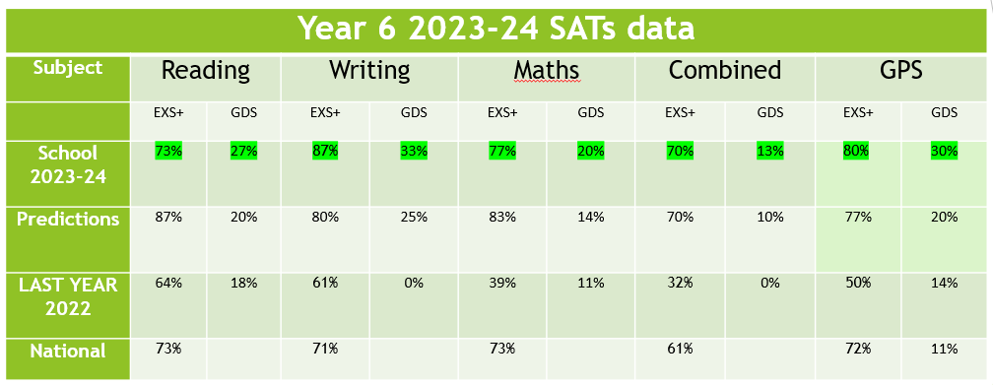
17% of this cohort were pupil premium children – 40% of whom achieved combined EXS in Reading, writing and Maths.
The success of the cohort and significant improvement in comparison with the previous cohort can be attributed to a number of factors:
- Quality first teaching
- Targeted interventions led by SLT
- SATS booster groups run from April 15th to May 6th
- Third space learning intervention
- Pastoral support
- Senco support
- Access arrangements carefully defined and monitored
EYFS data (no children were in receipt of PP when this data was achieved)
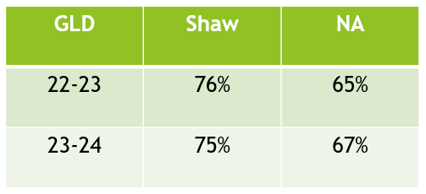
Year 1
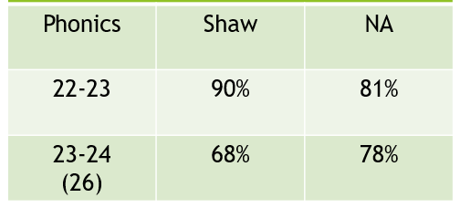It should be noted that out of 8 children who underperformed, only 1 of these children was pupil premium.
Year 2 Optional SATS
6 children in receipt of pupil premium –
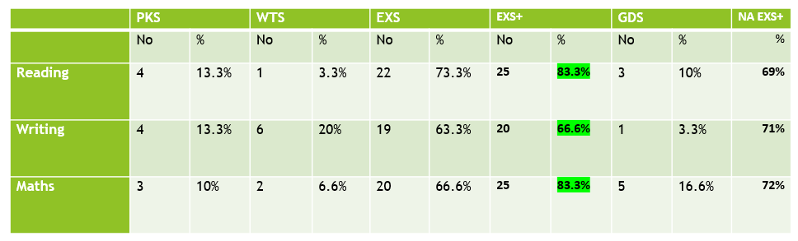
MTC – Year 4
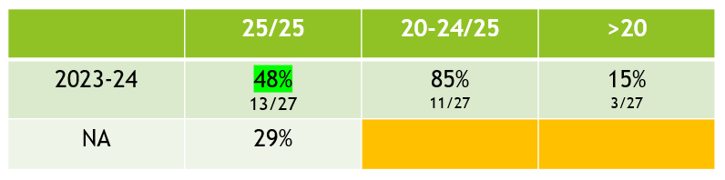
5 children in receipt of PP.

Externally provided programmes
Please include the names of any non-DfE programmes that you purchased in the previous academic year. This will help the Department for Education identify which ones are popular in England
Programme | Provider
Forest school/outdoor learning | Wiltshire Wildlife Trust
Bespoke sports activities in school time and during lunch time and after school clubs | Up and Under Sports
Lacrosse taster for pupils to experience sport | England Lacrosse
Can Do Maths | Buzzard Publishing
Discovery RE | Discovery RE
Little Wandle | Collins
Primary PE Planning | PPP
Teach Computing | NCCE
Basketball Mentoring | Matts Basketball

