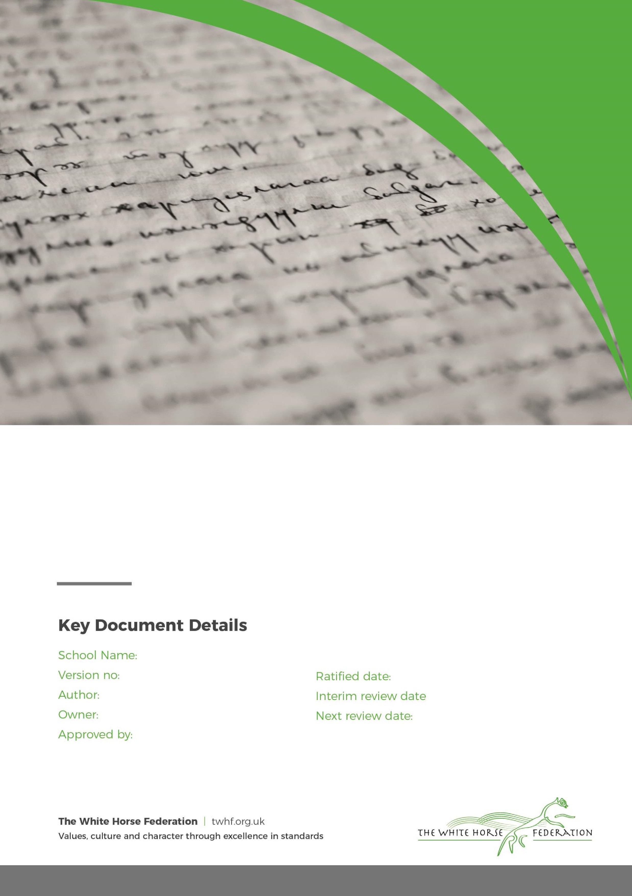

Special Education Needs (SEN)
Information Report

1

Tim James

Tim James

September 2025

September/2026

Shaw Primary School

Approver

Dear Parents and Carers,

The aim of this information report is to explain how we implement our SEND policy. In other words, we want to show you how SEND support works in our school.
If you want to know more about our arrangements for SEND, read our SEND policy.
You can find it on our website https://shaw.wilts.sch.uk
Note: If there are any terms we’ve used in this information report that you’re unsure of, you can look them up in the Glossary at the end of the report.

1. What types of SEN does the school provide for?
Our school provides for pupils with the following needs:

Area of need | Condition
Communication and interaction | Autism spectrum disorder
Communication and interaction | Speech and language difficulties
Cognition and learning | Specific learning difficulties, including dyslexia, dyspraxia, dyscalculia
Cognition and learning | Moderate learning difficulties
Cognition and learning | Severe learning difficulties
Social, emotional and mental health | Attention deficit hyperactive disorder (ADHD)
Social, emotional and mental health | Attention deficit disorder (ADD)
Sensory and/or physical | Hearing impairments
Sensory and/or physical | Visual impairment
Sensory and/or physical | Multi-sensory impairment
Sensory and/or physical | Physical impairment

2. Which staff will support my child, and what training have they had?
The school has many options to enable your child to access mainstream learning, these include the following:
  - An Individual Pupil Profile for all SEN children that states how and when a child is supported with what resources are required to enable successful delivering of the support.
  - An individual pupil passport detailing needs of a child and what supports them in their learning.
Specialists TAs that are specifically trained in supporting specific and high needs children.
  - Qualified and trained teaching staff including the SENCO who can advise on strategies to support and help your child to progress
  - Access to other professionals for advice
Our special educational needs co-ordinator:
Our SENCO, Mrs Duck. WHF expectations are that all teachers are responsible and teachers of SEN and have the support of the SENCO to ensure good progress and attainment of all children. All teachers are expected and committed to having a good understanding and awareness of SEND. This is achieved through on-going CPD. Our SENCO joined us at Shaw Primary in September 2025. She is allocated full time at Shaw Primary School.

Our class teachers:

All of our teachers receive in-house SEN training, and are supported by the SENCO to meet the needs of pupils who have SEN.

Training programme | When / Time | Who
Precision Teaching | 2018-19  2 hours theory and strategies | All staff
Working Memory | 2018-19  2 hours theory and strategies | All staff
CP training and Safeguarding | Yearly updates  2 hours | All staff
Medical training | Yearly updates  1 hour | All staff
First Aid | Yearly updates of basic training 3 year reviews for fully trained  staff | Some teaching and support staff
Team Teach positive handling and de-escalation strategies | Reviewed every 2 years  6 or 12 hour course dependent  on level | Some teaching and TA staff
ASD Training | 2020-21  3 hours | Some teaching and TA staff
Dyslexia Training | 2020-21  6 hours | Trainee SENCO, Specialist TA All Teaching Assistants have  basic awareness training
ELSA (Emotional Literacy  Support Assistant) | 2019  6 whole days | 2 TAs
Letters and Sounds – training to  support in the classroom | 2018-2019 | Some teaching and TA staff
Supporting Neurodiversity in Schools | November 2023 | SENCO
Domestic Abuse Training | November 2023 | SENCo and Learning Support Mentor
Advisory Teachers of social, emotional and mental health | October 2023 | All staff
Individual pupil profiles | December 2023 | Teaching staff and TAs
Introduction of learning journeys for SEND | January 2024 | Teaching staff and 1:1 TAs
Implementation of working memory in the classroom as a support strategy | February 2024 | All staff
SEND law training | June 2024 | SENCo
Advisory Teachers of Cognition and Learning- working memory | July 2024 | All staff
Individual pupil profiles | September 2025 | Teaching Staff
SEND scaffolding and working walls | October 2025 | Teaching Staff
Individual pupil profiles continued | December 2025 | Teaching Staff
Precision Teaching | February 2026 | Teaching Staff and TAs

Teaching assistants (TAs)
We have a team of 7 TAs who are trained to deliver SEN provision.
We have teaching assistants who are trained to deliver interventions such as ELSA, Colourful Semantics, Phonics, Mathematics, Intensive interactions, Play therapy, morning readers to name a few.
In the last academic year, TAs have been trained in Precision Teaching, Welcomm and delivering high quality phonic interventions.
External agencies and experts
Sometimes we need extra help to offer our pupils the support that they need. Whenever necessary we will work with external support services to meet the needs of our pupils with SEN and to support their families. These include:
- Educational Psychologists
- Speech and Language Therapists
- Occupational Therapist
- Early Years Consultant
- Early Years Drop-In sessions
- Fair Access Panel
- Advisory Teachers for Cognition and Learning (CLASS)
- Autism Resource Centre (ARC)
- All Abroad Nursery
- School Nurse
- Neurodevelopmental Pathways
- SpLD Advisory Service
- ASD Advisory Service, (ARC)
- Visual Impairment Advisory Services
- Hearing Impairment Advisory Services
- Assistive Technology Service
- Advisory Teacher for Physical Disabilities
- Health Care Professionals (School Nurse, Community Pediatrician and Physiotherapists)
- Swindon Information, Advice and Support (SIASS- formerly Parent Partnership)
- MASH (Multi Agency Safeguarding Hub)
- Virtual School (for Looked After Children)
- Special Educational Needs Assessment Team (SENAT)
- Education Welfare Officer
- Social Emotional and Mental Health (SEMH) Support Team
- Young Carers

What should I do if I think my child has SEN?
- Once your child has settled into school, it may seem to the teacher that s/he needs extra help. This may be clear to them from observation, or they may do some assessments. It maybe that later on s/he does not make the progress expected.
- If your child has been to a preschool, nursery or another school, they will pass on information.
- If you have concerns yourself, please talk to your child’s class teacher. We have an open door policy at Shaw Primary School and you are welcome to express your concerns to the class teacher at any time however avoiding teaching time. After school is better than in the morning, if this is not possible please phone the school to make an appointment.
- If we in school identify any special educational needs we will talk to you about it and tell you what support will be put in place. We may or may not ask your permission to involve one or more of the Partnership Agencies.
- If you are concerned about your child’s needs at the first instance, please contact Mrs Bridge via the school office on 01225 702544 or email administrator@Shaw.wilts.sch.uk.

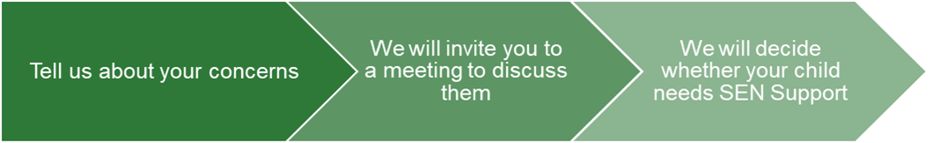
If you think your child might have SEN, the first person you should tell is your child’s teacher.  They will pass the message on to our SENCO, Annie Costello, who will be in touch to discuss your concerns.  You can also contact the SENCO directly on senco@Shaw.wilts.sch.uk or call the main school office on 01225 702544 | We will meet with you to discuss your concerns and try to get a better understanding of what your child’s strengths and difficulties are.  Together we will decide what outcomes to seek for your child and agree on next steps.  We will make a note of what’s been discussed and add this to your child’s record. You will also be given a copy of this. | If we decide that your child needs SEN support, we will formally notify you in writing and your child will be added to the school’s SEND register.

4. How will the school know if my child needs SEN support?

All our class teachers are aware of SEN and are on the lookout for any pupils who aren’t making the expected level of progress in their schoolwork or socially.
If the teacher notices that a pupil is falling behind, they try to find out if the pupil has any gaps in their learning. If they can find a gap, they will give the pupil extra tuition to try to fill it. Pupils who don’t have SEN usually make progress quickly once the gap in their learning has been filled.
If the pupil is still struggling to make the expected progress, the teacher will talk to the SENCO, and will contact you to discuss the possibility that your child has SEN.
The SENCO will observe the pupil in the classroom and in the playground to see what their strengths and difficulties are. They will have discussions with your child’s teacher/s, to see if there have been any issues with, or changes in, their progress, attainment or behaviour. They will also compare your child's progress and development with their peers and available national data.
The SENCO will ask for your opinion and speak to your child to get their input as well. They may also, where appropriate, ask for the opinion of external experts such as a speech and language therapist, an educational psychologist, or a paediatrician.
Based on all of this information, the SENCO will decide whether your child needs SEN support. You will be told the outcome of the decision in writing.
If your child does need SEN support, their name will be added to the school’s SEN register, and the SENCO will work with you to create a SEN support plan for them.
Please refer to our SEND flow chart of support for more information.

5. How will the school measure my child’s progress?
We will follow the ‘graduated approach’ to meeting your child’s SEN needs.
The graduated approach is a 4-part cycle of assess, plan, do, review.
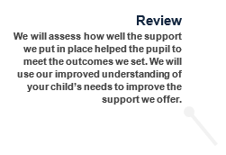

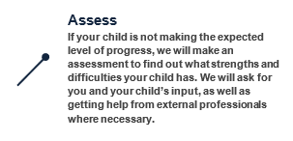

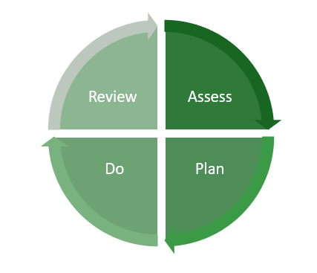

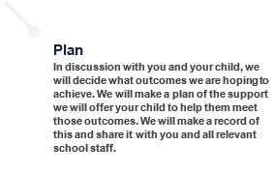
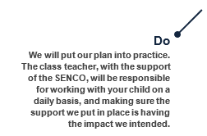

As a part of the planning stage of the graduated approach, we will set outcomes that we want to see your child achieve.
Whenever we run an intervention with your child, we will assess them before the intervention begins. This is known as a ‘baseline assessment’. We do this so we can see how much impact the intervention has on your child’s progress.
We will track your child’s progress towards the outcomes we set over time and improve our offer as we learn what your child responds to best.
This process will be continual. If the review shows a pupil has made progress, they may no longer need the additional provision made through SEN support. For others, the cycle will continue and the school's targets, strategies and provisions will be revisited and refined.

6. How will I be involved in decisions made about my child’s education?
We will provide an annual report. Reports on your child's progress will also include two parents evening throughout the year and EHCP meetings for those children who hold an Education and Health Care Plan or they are open to an early help record for SEN with Mrs Cuming and your child’s class teacher.
Your child’s class/form teacher will meet you to:
- Set clear outcomes for your child’s progress
- Review progress towards those outcomes
- Discuss the support we will put in place to help your child make that progress
- Identify what we will do, what we will ask you to do, and what we will ask your child to do
The SENCO may also attend these meetings to provide extra support.
We know that you’re the expert when it comes to your child’s needs and aspirations. So we want to make sure you have a full understanding of how we’re trying to meet your child’s needs, so that you can provide insight into what you think would work best for your child.
We also want to hear from you as much as possible so that we can build a better picture of how the SEN support we are providing is impacting your child outside of school.
If your child’s needs or aspirations change at any time, please let us know right away so we can keep our provision as relevant as possible.
After any discussion we will make a record of any outcomes, actions and support that have been agreed. This record will be shared with all relevant staff, and you will be given a copy.
If you have concerns that arise between these meetings, please contact your child’s class teacher in the first instance on the school playground or pop into the school office to book a meeting.

7. How will my child be involved in decisions made about their education?
The level of involvement will depend on your child’s age, and level of competence. We recognise that no two children are the same, so we will decide on a case-by-case basis, with your input.
We may seek your child’s views by asking them to:
- Attend meetings to discuss their progress and outcomes
- Prepare a presentation, written statement, video, drawing, etc.
- Discuss their views with a member of staff who can act as a representative during the meeting
- Complete a survey

8. How will the school adapt its teaching for my child?
Your child’s teacher is responsible and accountable for the progress and development of all the pupils in their class.
High-quality teaching is our first step in responding to your child’s needs. We will make sure that your child has access to a broad and balanced curriculum in every year they are at our school.
We will adapt how we teach to suit the way the pupil works best. There is no '1 size fits all’ approach to adapting the curriculum, we work on a case-by case basis to make sure the adaptations we make are meaningful to your child.
These adaptations include:
- Adapting our curriculum to make sure all pupils are able to access it, for example, by grouping, 1-to-1 work, adapting the teaching style or content of the lesson, etc.
- Adapting our teaching, for example, giving longer processing times, pre-teaching of key vocabulary, reading instructions aloud, etc.
- Adapting our resources and staffing
- Using recommended aids, such as laptops, coloured overlays, visual timetables, larger font, etc.
- Teaching assistants may support pupils on a 1-to-1 basis
- Teaching assistants may support pupils in small groups

Our School Accessibility Plan can also be accessed via our school website. This document provides further information as to how disabled pupils can participate in the curriculum.

We may also provide the following interventions:

Area of need | Condition | How we support these pupils
Communication and interaction | Autism spectrum disorder | Visual timetables  Social stories  Clear and consistent boundaries  Sensory activities
Communication and interaction | Speech and language difficulties | Speech and language therapy
Cognition and learning | Specific learning difficulties, including dyslexia, dyspraxia and dyscalculia | Writing slope  Coloured overlays and books
Cognition and learning | Moderate learning difficulties | Manipulatives
Cognition and learning | Severe learning difficulties | Bespoke curriculum
Social, emotional and mental health | ADHD, ADD | Quiet workstation  Brain breaks
Social, emotional and mental health | Adverse childhood experiences and/or mental health issues | Nurture groups
Sensory and/or physical | Hearing impairment | Hearing loops
Sensory and/or physical | Visual impairment | Carefully designed displays
Sensory and/or physical | Multi-sensory impairment
Sensory and/or physical | Physical impairment | Accessible toilet and school access
These interventions are part of our contribution to Wiltshire’s local offer.

9. How will the school evaluate whether the support in place is helping my child?
We will evaluate the effectiveness of provision for your child by:
- Reviewing their progress towards their goals each term
- Reviewing the impact of interventions after 6 to 8 weeks or otherwise if specified for set intervention
- Using pupil questionnaires
- Monitoring by the SENCO
- Using provision maps to measure progress
- Holding an annual review (if they have an education, health and care (EHC) plan)

10. How will the school resources be secured for my child?

It may be that your child’s needs mean we need to secure:
- Extra equipment or facilities
- More teaching assistant hours
- Further training for our staff
- External specialist expertise
If that’s the case, we will consult with external agencies to get recommendations on what will best help your child access their learning.
The school will cover up to £6,000 of any necessary costs. If funding is needed beyond this, we will seek it from our local authority.

11. How will the school make sure my child is included in activities alongside pupils who don’t have SEND?
All of our extra-curricular activities and school visits are available to all our pupils, including our before and after-school clubs.
All pupils are encouraged to go on our school trips, including our residential trip
All pupils are encouraged to take part in whole school activities
No pupil is ever excluded from taking part in these activities because of their SEN or disability and we will make whatever reasonable adjustments are needed to make sure that they can be included.

12. How does the school make sure the admissions process is fair for pupils with SEN or a disability?
The school Admissions policy is available on the school website.

13. How does the school support pupils with disabilities?
The school Accessibility plan is available on the school website.

14. How will the school support my child’s mental health and emotional and social development?
We provide support for pupils to progress in their emotional and social development in the following ways:
- Pupils with SEN are encouraged to be part of the school council and are included in the Year 6 responsibilities
- We provide extra emotional support for listening to the views of pupils with SEN through ELSA and the Primary Mentoring service
We have a ‘zero tolerance’ approach to bullying.

15. What support will be available for my child as they transition between classes or settings, or in preparing for adulthood?
Between years
To help pupils with SEND be prepared for a new school year we:
- Ask both the current teacher and the next year’s teacher to attend a final meeting of the year when the pupil’s SEN is discussed
- Schedule lessons with the incoming teacher towards the end of the summer term
Between schools
When your child is moving on from our school, we will share all relevant SEND and safeguarding documents
The SENCO of the secondary school will come into our school for a meeting with our SENCO. They will discuss the needs of all the children who are receiving SEN support.
Pupils will be prepared for the transition by:
- Practising with a secondary school timetable
- Learning how to get organised independently
- Plugging any gaps in knowledge

16. What support is in place for looked-after and previously looked-after children with SEN?
Izzie Duck, our SENCO will make sure that all teachers understand how a looked-after or previously looked-after pupil’s circumstances and their SEN might interact, and what the implications are for teaching and learning.
Children who are looked-after or previously looked-after will be supported much in the same way as any other child who has SEND. However, looked-after pupils will also have a personal education plan (PEP). We will make sure that the PEP and any SEN support plans or EHC plans are consistent and complement one another.

17. What should I do if I have a complaint about my child’s SEN support?
Complaints about SEN provision in our school should be made to the SENCO in the first instance. They will then be referred to the school’s complaints policy.
If you are not satisfied with the school’s response, you can escalate the complaint. In some circumstances, this right also applies to the pupil themselves.
To see a full explanation of suitable avenues for complaint, see pages 246 and 247 of the SEN Code of Practice.
If you feel that our school discriminated against your child because of their SEND, you have the right to make a discrimination claim to the first-tier SEND tribunal. To find out how to make such a claim, you should visit: https://www.gov.uk/complain-about-school/disability-discrimination
You can make a claim about alleged discrimination regarding:
- Admission
- Exclusion
- Provision of education and associated services
- Making reasonable adjustments, including the provision of auxiliary aids and services
Before going to a SEND tribunal, you can go through processes called disagreement resolution or mediation, where you try to resolve your disagreement before it reaches the tribunal.

18. What support is available for me and my family?
If you have questions about SEND, or are struggling to cope, please get in touch to let us know. We want to support you, your child and your family.
To see what support is available to you locally, have a look at Wiltshire’s offer.
Wiltshire’s information about the local offer on their website:
Our local special educational needs and disabilities information advice and support services (SENDIASS) organisations are:
Wiltshire SENDIASS - Family Action (family-action.org.uk)
WPCC (wiltshireparentcarercouncil.co.uk)
National charities that offer information and support to families of children with SEND are:
- IPSEA
- SEND family support
- NSPCC
- Family Action
- Special Needs Jungle

19. Glossary
- Access arrangements – special arrangements to allow pupils with SEND to access assessments or exams
- Annual review – an annual meeting to review the provision in a pupil’s EHC plan
- Area of need – the 4 areas of need describe different types of needs a pupil with SEND can have. The 4 areas are communication and interaction; cognition and learning; physical and/or sensory; and social, emotional and mental health needs.
- CAMHS – child and adolescent mental health services
- Adapt – when teachers adapt how they teach in response to a pupil’s needs
- EHC needs assessment – the needs assessment is the first step on the way to securing an EHC plan. The local authority will do an assessment to decide whether a child needs an EHC plan.
- EHC plan – an education, health and care plan is a legally-binding document that sets out a child’s needs and the provision that will be put in place to meet their needs.
- First-tier tribunal/SEND tribunal – a court where you can appeal against the local authority’s decisions about EHC needs assessments or plans and against discrimination by a school or local authority due to SEND
- Graduated approach – an approach to providing SEN support in which the school provides support in successive cycles of assessing the pupil’s needs, planning the provision, implementing the plan, and reviewing the impact of the action on the pupil
- Intervention – a short-term, targeted approach to teaching a pupil with a specific outcome in mind
- Local offer – information provided by the local authority which explains what services and support are on offer for pupils with SEN in the local area
- Outcome – target for improvement for pupils with SEND. These targets don't necessarily have to be related to academic attainment
- Reasonable adjustments – changes that the school must make to remove or reduce any disadvantages caused by a child’s disability
- SENCO – the special educational needs co-ordinator
- SEN – special educational needs
- SEND – special educational needs and disabilities
- SEND Code of Practice – the statutory guidance that schools must follow to support children with SEND
- SEN information report – a report that schools must publish on their website, that explains how the school supports pupils with SEN
- SEN support – special educational provision which meets the needs of pupils with SEN
- Transition – when a pupil moves between years, phases, schools or institutions or life stages

