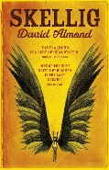
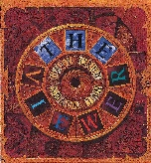
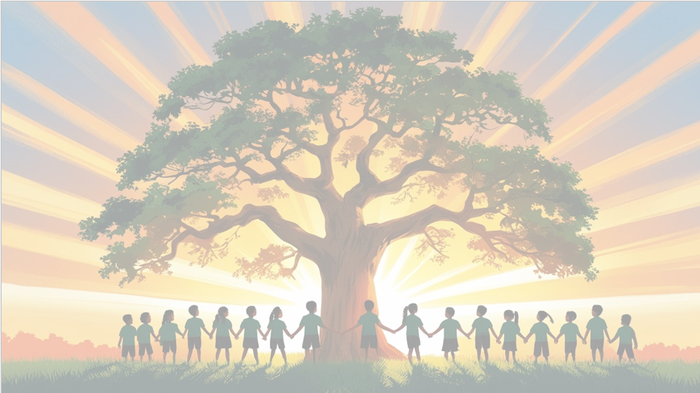
‘’Shine brightly in learning and life’
Maths
We will be developing our understanding of number and place value, including working with numbers up to ten million and using decimals in different contexts, such as money and measures. We will also practise a range of methods for addition, subtraction, multiplication and division, to become more confident and accurate when solving problems.
English
We will be using the texts ‘Skellig’ and ‘The Viewer’ as our focus books. We will be creating atmosphere in our writing. Our end unit pieces will be: Writing a Setting of Skellig’s garage and writing a diary entry.

PSHE: Healthy Me
In our six puzzle pieces this term, we will focus on ‘Being Me in My World’, thinking about rights and responsibilities and how we can make a positive contribution in Year 6.


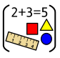
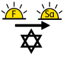
Movement: Pop art​
Art area: Drawing​
Artist: Warhol​
We will be creating self-portraits in Pop Art Style

RE

Our BIG question this term is: How do Christians show their belief that Jesus is God incarnate?

PE

In PE, Year 6 will be focusing on football and multi skills with our PE coach, Mr Kyd.

Year 6 Curriculum Overview
Term 1
2026-27
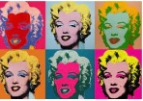

Geography
In Geography, we will be comparing our local area with London. Children will use maps and digital tools to explore similarities and differences, learning about London’s importance as the UK’s capital city.

Computing
We will be focusing on the strand Computer Science, learning about computing systems and networks, and how communication and collaboration happen online.
Science: Animals including Humans
We will be learning how the heart and circulatory system work, how our bodies transport nutrients and water, and how diet, exercise and lifestyle affect our health.




