
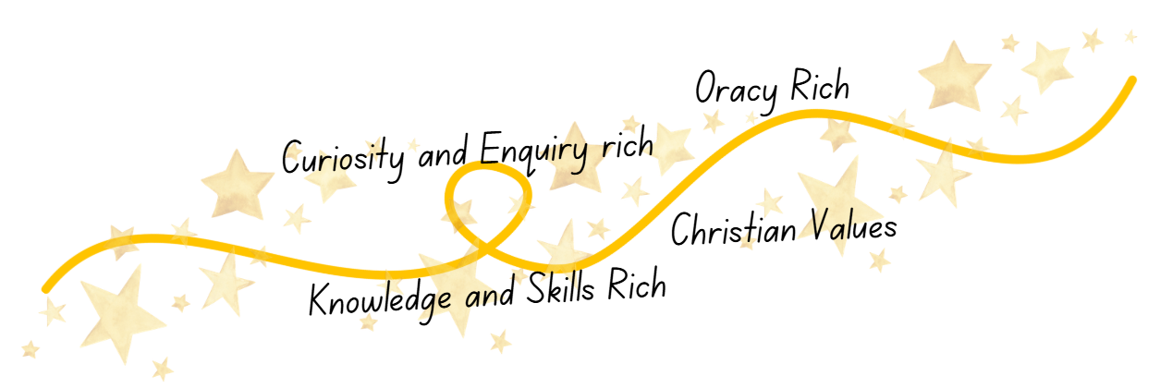
Science at
Shaw C of E Primary School
Curriculum Implementation
At Shaw C of E Primary School, our Science teaching follows a carefully sequenced and purposeful progression that enables children to build secure and connected scientific understanding over time. Each unit is thoughtfully planned to be knowledge and skills rich, allowing pupils to revisit, apply and deepen prior learning while drawing meaningful links across biology, chemistry and physics, as well as with other curriculum areas when appropriate. This coherence supports children in developing expertise, confidence and the ability to transfer learning across contexts.
Oracy is woven intentionally into every lesson. Pupils are immersed in high‑quality scientific vocabulary that is explicitly taught, modelled and used to structure thinking and communication. Both subject‑specific language and the vocabulary of Working Scientifically are embedded to help pupils articulate predictions, explain processes, discuss outcomes and reason with clarity. Through purposeful talk, children learn to communicate like scientists—listening carefully, questioning thoughtfully and collaborating effectively.
Curiosity and enquiry drive our approach to teaching Science. Children are encouraged to investigate, explore and think deeply through hands‑on experiences, problem‑solving and the observation of real‑world phenomena. Our model of teaching ensures regular opportunities to revisit key concepts and scientific behaviours, helping pupils to embed understanding, strengthen independence and develop the habits of inquisitive, reflective and motivated young scientists. Throughout this learning, our Christian values of aspiration, courage, respect and community shape the ethos of our classrooms and guide children to use their scientific knowledge with integrity and purpose.
Curriculum Intent
At Shaw C of E Primary School, our Science curriculum is rooted in our Christian vision and Golden Threads, aiming to develop knowledgeable, articulate and inquisitive learners. We provide a purposeful and ambitious curriculum that builds secure scientific understanding from EYFS through to Year 6. Through carefully sequenced learning in biology, chemistry and physics, pupils gain powerful knowledge and essential scientific skills that prepare them for future learning and help them make meaningful connections across concepts.
Talk is central to learning at Shaw, and our Science curriculum is intentionally oracy rich. Children are taught key vocabulary, encouraged to articulate predictions and reasoning, and engage in shared enquiry where ideas can be explored, questioned and refined. This develops confident communicators who can explain their thinking clearly, collaborate effectively and use scientific language with precision and purpose.
Curiosity and Christian values underpin every element of Science at Shaw. Through hands‑on investigations, problem‑solving and real‑world exploration, children develop independence, critical thinking and a love of discovery. Our values of aspiration, courage, respect and community guide pupils to act with integrity, care for God’s creation, and use their scientific understanding to make a positive difference in their school, community and the wider world.
Curriculum Impact
The implementation of our Science curriculum ensures that when children leave Shaw C of E Primary School, they do so with a rich, secure and connected understanding of primary Science that prepares them for the next stage of their learning. They develop both the powerful knowledge and the scientific skills needed to make sense of the world, drawing confidently on prior learning and applying it across new contexts. Our Golden Threads—knowledge and skills rich learning, oracy, curiosity and enquiry, and our Christian values—run through every aspect of this development.
As a result, pupils at Shaw are able to think and behave like scientists, showing independence, curiosity and confidence. They are equipped to find different ways to answer questions, generate their own ideas for investigating scientific enquiries, and gather, record and interpret evidence through hands-on exploration and practical investigations. Through our oracy-rich approach, pupils can articulate their thinking clearly, use scientific vocabulary with accuracy, and engage in meaningful discussion that deepens their understanding.
By the time they leave us, Shaw pupils demonstrate an inquisitive mindset and a strong moral purpose rooted in our Christian vision. They ask thoughtful, purposeful questions that extend their learning, show respect for the natural world, and understand their role as responsible stewards of God’s creation. Our children shine as young scientists—curious, thoughtful, reflective and ready to build on their scientific learning in the years ahead.

