Curriculum Implementation
Our Art curriculum is built around four key components—knowledge, skills, understanding and vocabulary—all mapped to the National Curriculum. Learning is sequenced across each year group to ensure clear progression and well-defined end points. Objectives are ambitious and cover the core disciplines of drawing, painting, sculpture and a range of media, including opportunities for digital art.
These disciplines develop pupils’ techniques, creative expression and critical evaluation. Children learn to use materials with purpose, communicate ideas and emotions, and reflect on their own work and that of artists from different times and cultures.
Through our progression framework, pupils revisit and build on prior learning, applying skills to increasingly complex concepts with growing confidence and originality. Lessons follow a consistent structure, including retrieval of previous learning, exploration of artists, explicit teaching of objectives and vocabulary, and clear summaries of progress. Cross-curricular links enrich learning and deepen cultural understanding.

Curriculum Intent
Our Art and Design curriculum is built around four key components—knowledge, skills, understanding and vocabulary—all aligned to the National Curriculum. Learning is carefully sequenced in each year group to ensure clear progression and well-defined end points for all pupils.
Objectives are ambitious and cover the core disciplines of drawing, painting, sculpture and a range of artistic media, including digital art where appropriate. These areas develop pupils’ artistic techniques, creative expression and critical evaluation. Children learn to use materials purposefully, explore their ideas and emotions, and reflect on their own work and that of a diverse range of artists and designers.
Our progression framework ensures pupils revisit and deepen prior learning, applying skills to new contexts with growing confidence, originality and perseverance. Lessons follow a consistent structure, including retrieval of previous learning, exploration of artists, explicit teaching of objectives and vocabulary, and clear summaries of the skills and knowledge developed. Cross-curricular links enrich pupils’ wider learning and build cultural understanding.

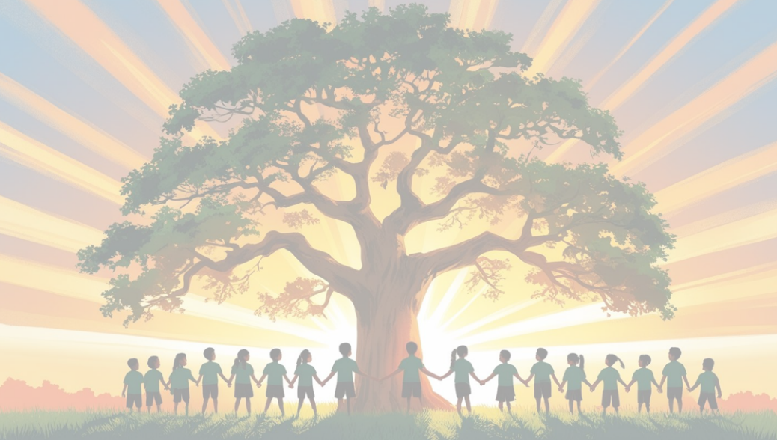

Art and Design at
Shaw C of E Primary School

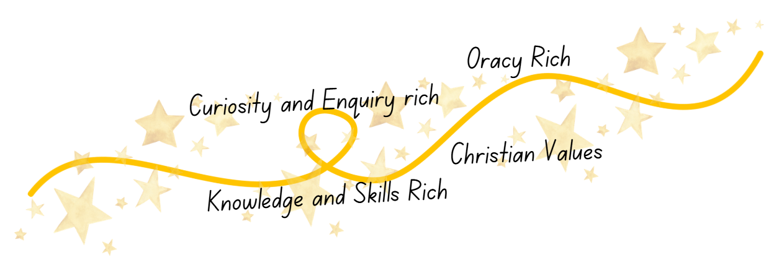
Curriculum Impact
By the end of their time at Shaw, pupils will leave as confident, capable and enthusiastic young artists who understand that creativity has an important place in both their education and their future lives.
- Express themselves confidently through a range of artistic techniques and media, showing creativity, originality, and increasing mastery of skills.
- Use key artistic vocabulary accurately to describe, evaluate and discuss their own work and the work of significant artists, craftspeople and designers.
- Demonstrate a secure understanding of artistic concepts, such as colour, line, texture, form and composition, and apply these effectively in their own creations.
- Show appreciation and curiosity for art in its many forms, recognising its value in culture, history and society, and understanding how art reflects diverse experiences and viewpoints.
- Reflect on and evaluate their work thoughtfully, identifying strengths, areas for development and the steps needed to improve—demonstrating resilience and pride in their achievements.

