PSED

- JIGSAW- Piece 3- Dreams and Goals
- I will play co-operatively in groups and develop role-play activities
- I will be trying out new activities independently and select resources independently.
- I will be learning routines of the school day.

Mathematical Development

- I will be developing an understanding of 4 and 5 and how they are represented in the environment.
- I will be able to show ‘finger numbers’ up to 5.
- I will be exploring 2D shapes that have four sides.
- I will gain an understanding of time by talking about daily routines and describing a sequence of events.

Physical Development

- I will practice good self-care routines by regular handwashing.
- I will be developing my independence, putting on my own coat, scarf, hat.
- I will be changing my clothes for PE sessions.
- I will be developing my balance when participating in dinosaur yoga.

Expressive Arts Development

- I will be experimenting with different ways of moving by pretending to be different dinosaurs.
- I will use junk modelling and other construction materials to create dinosaurs.
- I will be recreating stories in the role-play and small-world, including Dinosaurs Love Underpants.

Where Have the Dinosaurs Gone?

Communication, Language and Literacy

- I will use talk to connect ideas, explain what is happening during experiments with our ‘magic potion’ and dinosaur eggs.
- I will retell what happened during our ‘dinosaur break-in’.
- I will be taking part in Letters and Sounds activities. Aspect 5- Alliteration.
- I will develop an understanding of the way stories are structured and suggest how the story might end.

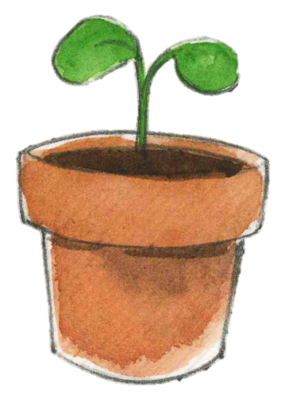


Knowledge and Understanding

- I will be developing an understanding of growth, decay and changes over time.
- I will talk about some things I have observed, including fossils.
- I will be exploring Chinese New Year
- I will begin to understand that information can be retrieved from computers by searching for facts about dinosaurs

Our focus British band – Coldplay

