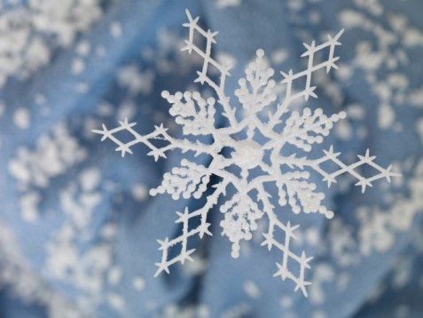
Personal, Social and Emotional Development
- Look at ways to keep warm in winter – clothes/eating/moving around/warm drinks.
- How do people keep warm?
- Talk about the ways that animals keep warm.
- Discuss the dangers of snow and ice – look at pictures of avalanches/taking care on slippery ice/why we don’t walk on frozen ponds
- Look at pictures of snowflakes close up and talk about how they are all different.
Communication & Language/
- Small world play with Arctic/Antarctic animals
- Role Play area – Igloo – using white sheets/boxes/make icicles and snowflakes with children/soft toy and small world arctic animals/glitter/arctic animal masks
Mathematics
- Create a repeating patterned scarf
- Order snowmen.
- Number recognition
- More or less (practical) Using arctic animals
- Practical addition/subtraction using winter objects/arctic animals
- Number ordering
- Number formation
- Data handling- our favourite type of penguin
Literacy
- Read fiction and non-fiction books and poems
- Sound out and attempt to write snow and ice words using phonic knowledge
- Blending and segmenting activities (practical)
- Phonics (continue to learn Phase 2/3 sounds)
- Write simple sentences

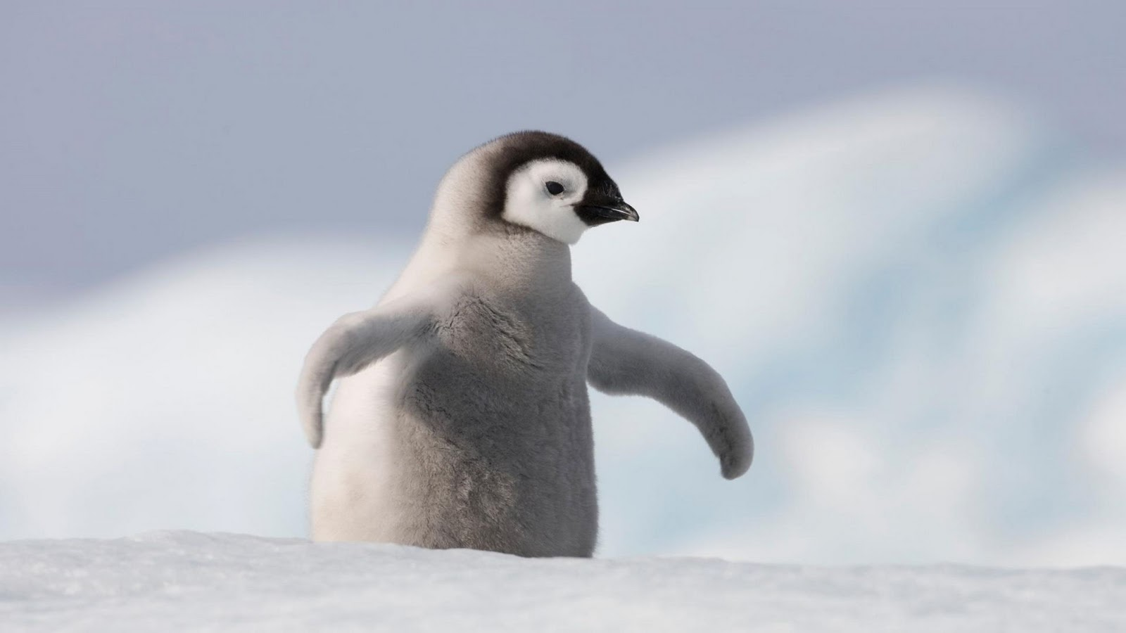
Winter Wonderland
F2- spring 2023

Expressive Arts & Designs
- Paint penguin pictures
- Paint with ‘cold’ colours (white, blue, silver, purple)
- Make icicles and snowflakes for the winter wonderland and role play area
- Use instruments to make spiky, frosty sounds
- Create a ‘snowy’ scene.
- Small world winter wonderland

Understanding of the World
- Melting and Freezing – make some ice cubes and salt half of them. Which melt first? What do they feel like?
- Use ice and small world arctic animals to make an arctic scene in the water tray
- Use a globe to talk about the North and South Poles
- Look at books about the Inuit people
- Find out about penguins.
- Why are polar bears white?
- Make igloos using sugar cubes
- Investigate materials that keep things warm
- Hot and cold climates
- Snowflake cookies
Physical Development
- Snowman dance activity based on “The Snowman”
- Do some running and jumping exercises outside on a cold day
- Listen to some lively staccato music and make spiky, frosty movements
- Move like various Arctic/Antarctic animals
- Make paper snowflakes to practice cutting skills
.
Vocabulary
Arctic, Antarctic, regurgitate, melting, freezing, thawing, investigate, avalanche, insulate

