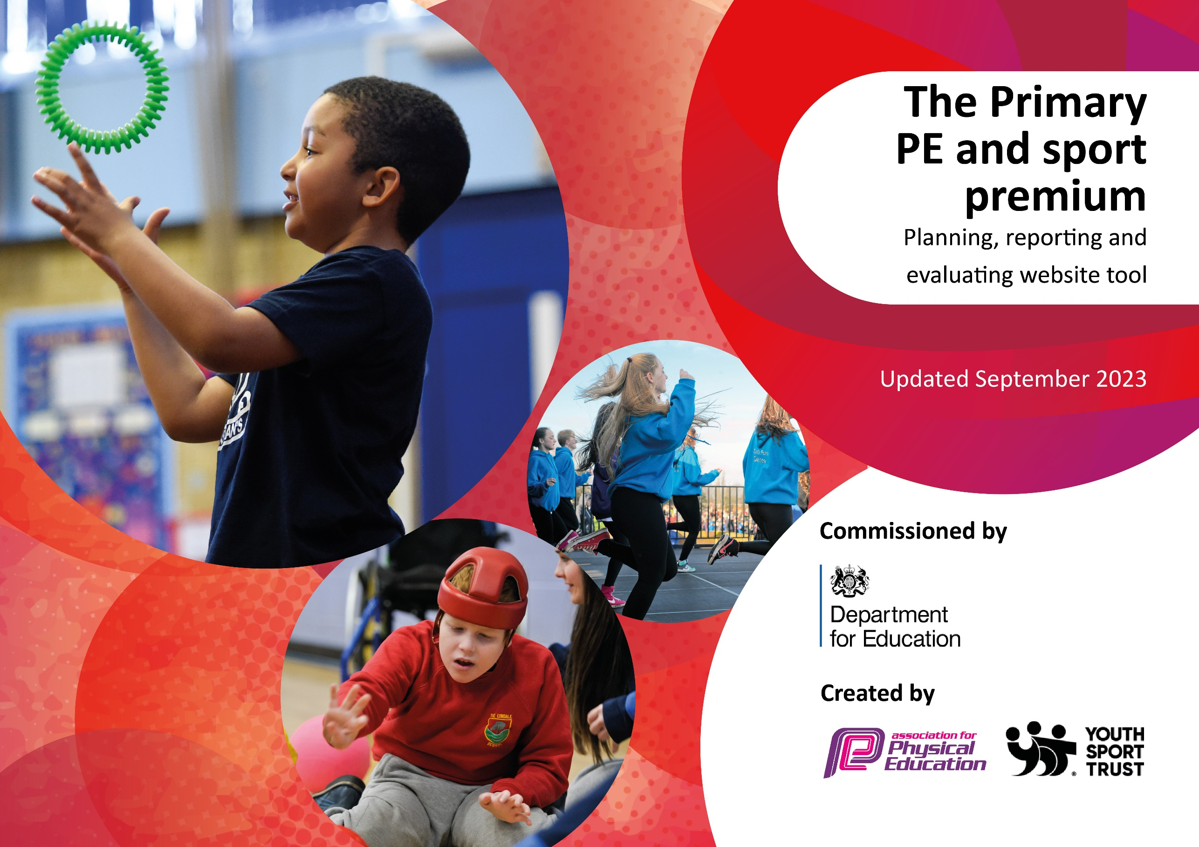

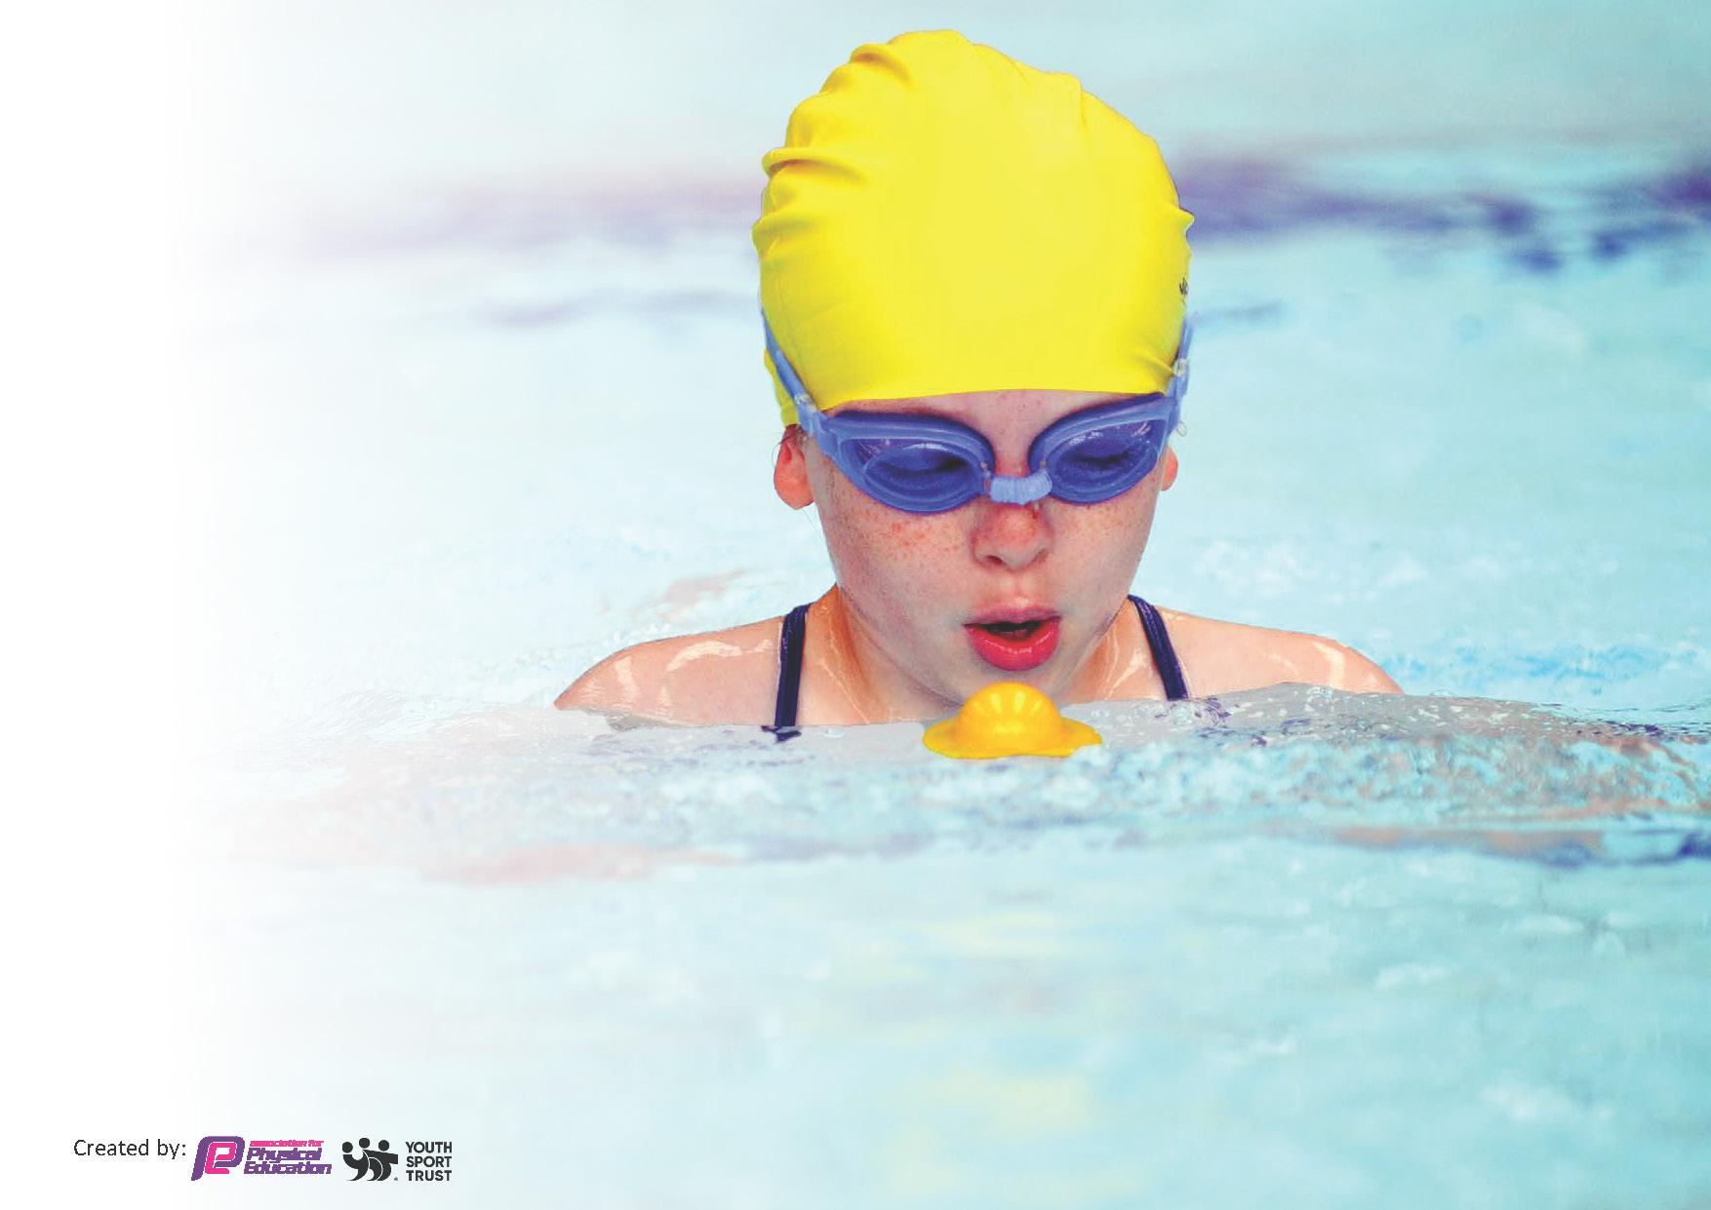
This template can be used for multiple purposes:
by:
- It enables schools to effectively plan their use of the Primary PE and sport premium
- It helps schools to meet the requirements (as set out in guidance) to publish information on their Primary PE and sport premium
- It will be an effective document to support Ofsted inspections enabling schools to evidence progress in Physical Education (PE) and evidence swimming attainment, which forms part of the PE National Curriculum. We would recommend schools consider
the Intent, Implementation and Impact of any spend, as examined within the Education Inspection Framework.

It is important that your grant is used effectively and based on school need.

Schools must use the funding to make additional and sustainable
improvements to the quality of the PE, School Sport and Physical Activity (PESSPA)
they offer. This means that you should use the Primary PE and sport premium to:

- Build capacity and capability within the school to ensure that improvements made now will benefit pupils joining the school in future years
- Develop or add to the PESSPA activities that your school already offers.

The Primary PE and sport premium should not be used to fund capital spend projects; the school’s core budget should fund these. Further detail on capital expenditure can be found in the updated Primary PE and sport premium guidance.

The Primary PE and sport premium guidance, outlines 5 key priorities that funding should be used towards. It is not

necessary that spending has to meet all the key priorities, you should select the priorities that you aim to use any funding towards.

Although completing this template is not a requirement for schools, schools are required to publish details of how they spend this funding. Schools must also outline what the impact this funding has had on pupils’ PE and sport participation and attainment and how any spending will be sustainable in the future. All funding must be spent by 31st July 2024.

The Department for Education has worked closely with the Association for Physical Education (afPE) and the Youth Sport Trust (YST) to develop this template and encourages schools to use it. This template is an effective way of meeting the reporting requirements of the Primary PE and sport premium.
Review of last year’s spend and key achievements (2024/2025)

We recommend you start by reflecting on the impact of current provision and reviewing your previous spend.

Activity/Action | Impact | Comments
Employ Fortius sports coach for the academic year 2024/25  Run a variety of sports clubs over the year.  Subscribe to PE Hub  Provide swimming sessions as a catch up for those children in Years 4,5 and 6 who are unable to swim the recommended distance of 25 metres through Pools for Schools.  Provide children with experiences in PE and sport beyond what can be delivered through quality first teaching. | Sports coaches were able to work with year groups from across the whole school from reception through to Year 6 with the exception of year 1. Teachers and Tas were able to work alongside the coaches to uplevel their own understanding. Coaches used PE Hub planning so that the sessions they led supported the learning of the school.  Coaches also led after school clubs in multi-sports and rounders.  Running, netball, football, cricket, rounders and multi-sports clubs were held for children from year 1 to year 6. Priority was given for children in receipt of PP. Taster sessions for younger children were available for football.  The school football team won the West Swindon league.  Subscription has continued providing good quality teaching resources. This has included videos to demonstrate good practice. The curriculum planner facility means that a range of PE activities are followed and that there is progression between year groups.  Top up sessions provided for children in Years 5 and 6 who were unable to swim the requisite 25 metres. 68 children who previously were unable to swim 25 metres were offered daily sessions for a week including a child who had never been in a swimming pool before. 61 chose to take part. Of these, 45 met the standard expected. 87% of our Year 6s will leave Shaw Ridge able to swim the required distance of 25 metres.  After school clubs in Kwik cricket and in football for beginners provided. | Next year we need to find a way to encourage more children in receipt of PP to engage with after school sports.

Key priorities and Planning
This planning template will allow schools to accurately plan their spending.

Action – what are you planning to do | Who does this action impact? | Key indicator to meet | Impacts and how sustainability will be achieved? | Cost linked to the action
Staff to continue working alongside Fortius sports coach for the academic year 2025/26  Run a variety of sports clubs over the year and increase engagement/participation for Pupil Premium students.  Increase participation in Swindon school competitions and a wider range of inter-school sporting events.  Subscribe to PE Hub  Provide cultural enrichment through sporting and active engagement opportunities,  e.g. Dance workshops  Provide Y5 and Y6 with the opportunities to meet goal of swimming 25 metres unaided through topup swimming | Teachers and Tas  All students including PP.  All students.  Children and teachers  Class teachers and children  Children in Y5 | Sports coach to continue to work with students across the entire school, from Reception to Year 6. Teachers and TAs to collaborate with the coach, enhancing their own knowledge and skills. The coach to continue following PE Hub planning to ensure their sessions align with the school’s learning objectives. Additionally, coach to run after-school clubs focused on multi-sports and football.  Deliver a broad and varied programme of extra-curricular sports clubs throughout the academic year, offering a range of activities that appeal to different interests and skill levels. A key focus will be on increasing engagement and participation among Pupil Premium (PP) students, by identifying and addressing potential barriers to involvement and ensuring access to all opportunities.  Actively broaden the school’s involvement in Swindon-wide inter-school competitions and sporting events by taking part in a greater number and wider variety of tournaments and fixtures throughout the academic year. This increased participation will provide pupils with more opportunities to represent the school, develop their athletic skills, and experience competitive sport in a supportive and structured environment.  Key Indicator 1: Increased confidence, knowledge and skills of all staff in teaching PE and sport  Key indicator 3: The profile of PE and sport should be raised across the school as a tool for improvement. Key indicator 4: Broader experience of a range of sports and activities offered to all pupils | Improved Quality of PE Lessons- Coaches bring specialist knowledge and experience, ensuring high-quality, engaging lessons.  Professional Development for Teachers and Tas-Teachers and TAs working alongside coaches gain hands-on experience and new strategies, increasing their confidence and competence in delivering PE independently.  Increased Pupil Engagement and Skill Development- High-quality, varied activities delivered by skilled coaches help pupils enjoy PE more, stay active, and develop fundamental movement and sport-specific skills.  Regular participation in sports helps children stay physically active, promoting health and wellbeing. By offering a wide range of clubs, more pupils especially those who may not typically engage are encouraged to take part.  Sports clubs offer valuable opportunities for social interaction outside the classroom. Through structured games and teamwork-based activities, pupils learn cooperation, communication, and respect.  Development of Key Personal and Social Skills Competitive sport nurtures teamwork, resilience, leadership, communication, and discipline. Pupils experience working as part of a team, coping with winning and losing, and setting personal or team goals during events.  Raised Aspirations and Confidence. Representing the school gives pupils a sense of pride, achievement, and belonging. Being selected to participate in competitions builds self-belief and raises aspirations, particularly for those who may not excel academically.  Teachers have access to, and make use of high quality plans  Workshops provided by external experts.  Children to be safe when in water | £13,440  Cover for teachers attending events £1000  £525  £1500  Top up sessions plus transport - £1000

Key achievements 2024-2025
This template will be completed at the end of the academic year and will showcase the key achievements schools have made with their Primary PE and sport premium spending.

Activity/Action | Impact | Comments

Swimming Data
Meeting National Curriculum requirements for swimming and water safety.
Priority should always be given to ensuring that pupils can perform safe self-rescue even if they do not fully meet the first two requirements of the National Curriculum programme of study

Question | Stats: | Further context  Relative to local challenges
What percentage of your current Year 6 cohort can swim competently, confidently and proficiently over a distance of at least 25 metres? | 87 % | Without Pools for Schools, this would have been lower – This figure was at 60% at the start of the year.
What percentage of your current Year 6 cohort can use a range of strokes effectively [for example, front crawl, backstroke, and breaststroke]? | 75%

What percentage of your current Year 6 cohort are able to perform safe self-rescue in different water-based situations? | 88%
If your schools swimming data is below national expectation, you can choose to use the Primary PE and sport premium to provide additional top-up sessions for those pupils that did not meet National Curriculum  requirements after the completion of core lessons. Have you done this? | Yes | Pools for Schools
Have you provided CPD to improve the knowledge and confidence of staff to be able to teach swimming and water safety? | No

Signed off by:

Head Teacher: | Sally Cowell
Subject Leader or the individual responsible for the Primary PE and sport premium: | Joe Lee (PE subject lead)
Governor: | Neil Linsell
Date: | 1st July 2025

