**Term Dates 2024-2025**

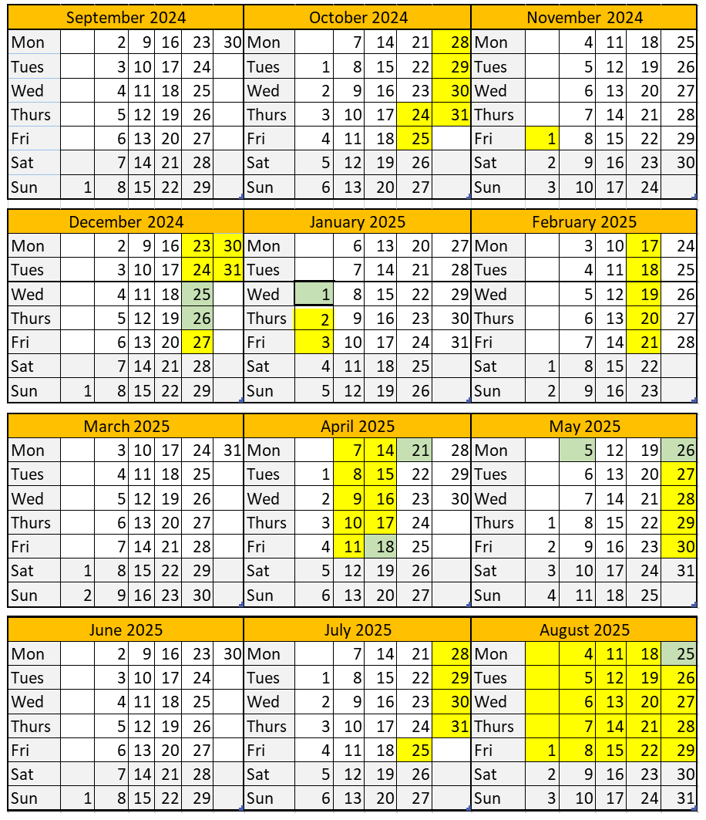

|  |  |  |  |  |  |  |  |  |  |  |  |  |  |  |
| --- | --- | --- | --- | --- | --- | --- | --- | --- | --- | --- | --- | --- | --- | --- |
| |  | | --- | | **Term Dates**  **Term 1** 02 September to 23 October 2024 38 days  **Term 2** 04 November to 20 December 2024 35 days  **Term** **3** 06 January to 14 February 2025 30 days **Term 4** 24 February to 04 April 2025 30 days  **Term 5** 22 April to 23 May 2025 23 days  **Term 6** 02 June to 24 July 2025 39 days  **TOTAL** 195 Days |   **Training Days**  Monday 2nd September  Friday 27th September  Monday 4th November  Monday 2nd June  Thursday 24th July | |  |  |  | | --- | --- | --- | |  | | | | Key | |  | |  | School Holiday | |  | Bank Holiday | |  | Term Time | |