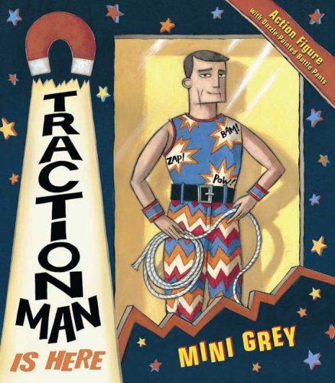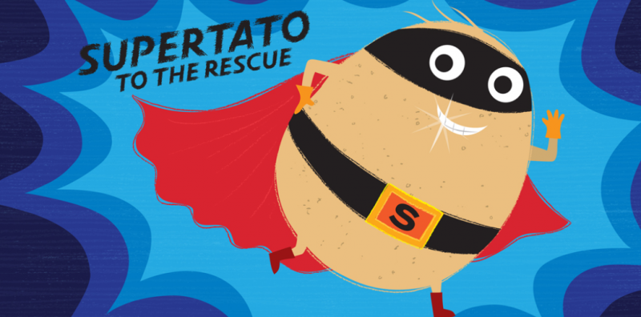

**Music:** Developing the use of vocal sounds. Developing pitch shape and duration. Performing songs with instruments.

**Art:** Designing and then printing our own superhero logo onto cape for our teddy.

**Geography:**

Identifying human and physical features in our local area.

Countries that make up the UK

Recap continents

**Vocabulary:**

partition, half, quarter, escape, distress, healthy, pitch, envelop, submerge, ferocious, design, predator, enraged, colossal

**DT:** Discussing where food comes from.

Designing our own healthy smoothies, based on our own likes and dislikes. Follow design criteria, prepare, make and evaluate.

**Computing: Logging on/ off**

IT in school

IT at home

Benefits of IT

Using IT safely

Using IT in different ways

Fractions: 1/4, 1/3 and 3/4 of a shape and a quantity. 2D and 3D shapes

Problem solving and Money.

Measuring length, capacity and mass.

Telling the time (nearest 15 minutes),

**History**:

Real life superheroes from the past and present.

Using a range of sources to gather information about Mary Seacole and creating a fact file about her.

**English:** Supertato, Traction Man, Superworm, Super Hotel stories

Daily Phonics

Handwriting practice

Whole class/ Individual Reading

Developing our writing stamina

Year 1/ 2 common exception words.

Non-fiction leaflet

Basic sentence structure and punctuation

Adding adjectives to make work more interesting.

**Science:** Animals including Humans: Basic needs of humans and how to keep healthy through exercise and hygiene.

Food groups

Human lifecycle looking at changes from baby to child.

**Year 2 Autumn 2022 – Term 1 Topic Web**

**Superheroes**

**Maths:** Number of the Day (how many different ways can you make the number, odd/even, tally).

Maths games. 2, 3, 5 and 10 times tables.

Using place value (tens and ones) and blank number lines to add and subtract 2-digit numbers.

Counting to 100 and back in ones and tens.

**PSHE:** Being Me in My World.

**RE:** How we should care for others and the world and why does it matter.