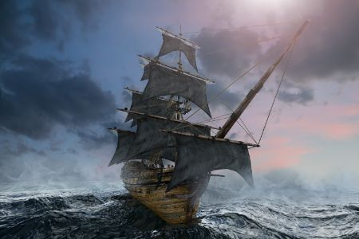

**Shiver me timbers! This term, we will be learning all about pirates!**

**English**

* Reading ‘The Pirates Next Door’.
* Character descriptions
* Identifying and using verbs.
* Letter writing
* Innovating a pirate story.
* Using more exciting vocabulary in our writing.
* Using our phonics knowledge to help us read and spell.
* Finger spaces, capital letter and full stops in sentences.
* Fine motor activities, and continuing to develop pre-cursive handwriting.
* Learning new sounds in phonics.
* Learning to read longer words.

**Music**

We will be exploring music through the theme of ‘water’.

**RE**

We will be learning all about what makes some places sacred.

**PSHE**

We will be learning how to tackle a challenge and set goals for achievement.

**Maths**

* Addition and subtraction using objects and a number line.
* Solve one-step problems that involve using addition and subtraction.
* Reading and writing numbers.
* Developing an understanding of numbers to 50 and then to 100.
* Developing an understanding of place value using the language ‘tens’ and ‘ones’.
* Measures including weight, length/ height and capacity.

**PE**

* Jumping in different ways
* Dismounting from apparatus and landing on our feet
* Different games teaching us how to attack and defend.
* Working as a team

**Computing**

* Creating media- digital writing.
* Developing an understanding of using a computer to create and manipulate text.

**History**

* Understanding the meaning of a ‘pirate’.
* Types of pirate ships and their features.
* Famous pirates throughout history.
* Food that pirates ate.

**Art**

* Making a primary colour collage.
* Colouring mixing to make secondary colours.
* Experimenting with shades and tints.
* Creating paintings in the style of Jackson Pollock.

**Science – Materials**

* Carrying out simple tests involving materials.
* Investigating absorbent and waterproof materials and their uses.
* Using our knowledge of materials to build a raft.

**Term 3**