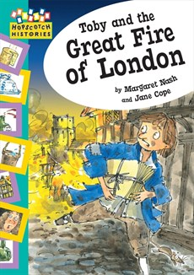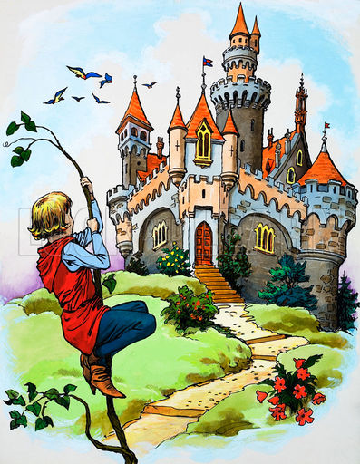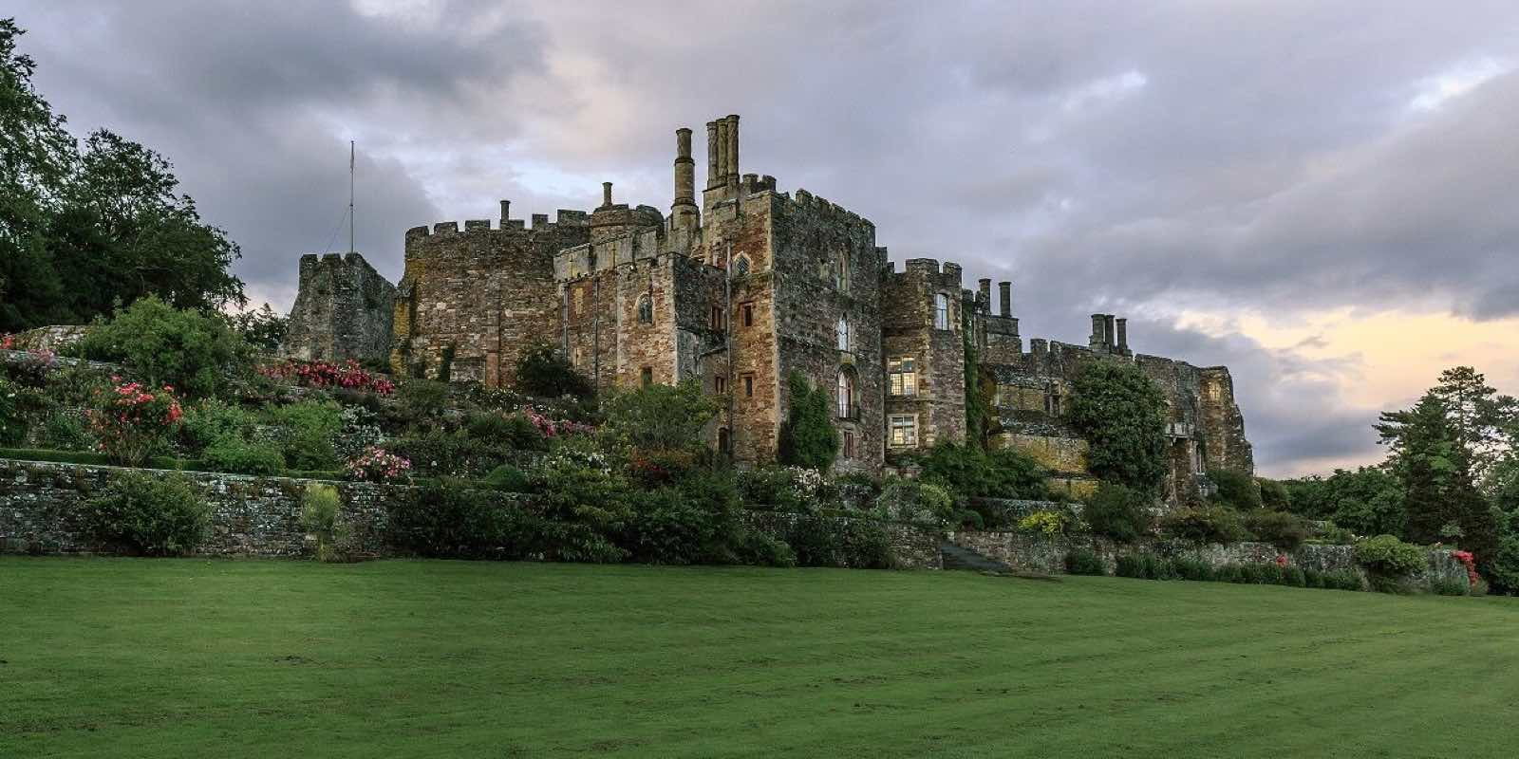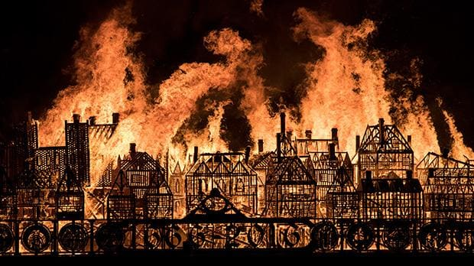

Computing: Safer internet day.

Music

Pictograms

Geography:

Covered in Term 5 and 6 topics.

PSHE: Dreams and Goals

Music: Linked with computing this term.

PE: Indoor - Gymnastics

Outdoor - Sports coach

English:

Fire of London: Fire safety instructions. Recounts of the Great Fire of London. Making own news report. Fire Cat story, writing a letter to the Mayor of London during 1666. Non Fiction texts about

Castles. Narrative based on traditional Stories (Jack and the Beanstalk), Poetry. David Melling a study of different stories by the same author.

Maths: Number of the Day

Maths games. 2, 3, 5 and 10 times tables.

Multiplication using arrays and Division

Money

Using place value (tens and ones) and blank number lines to add and subtract 2-digit numbers.

Identifying missing numbers in addition and subtraction number sentences.

Measuring length, capacity and mass.

Fractions: 1/4, 1/3 and 3/4 of a shape and a quantity.

Statistics (bar charts, tallies).

Science:

Naming and describing different materials.

Which material is best for which purpose and why.

Materials Investigation: Best material for a purpose. Writing up results and conclusion.

History:

The Great Fire of London – a significant event.

Castles

Naming and labelling parts of a castle.

Life in a castle

DT: Investigating vehicles

Looking at types of vehicles and features.

Focusing on wheels and axels.

Making a cart.

Art: Making coil pots out of clay.

Multimedia fire pictures.

**Year 2 Spring 2023 Topic Web: From Fires to Forts`**

Term 4: Castles

Term 3: The Great Fire of London