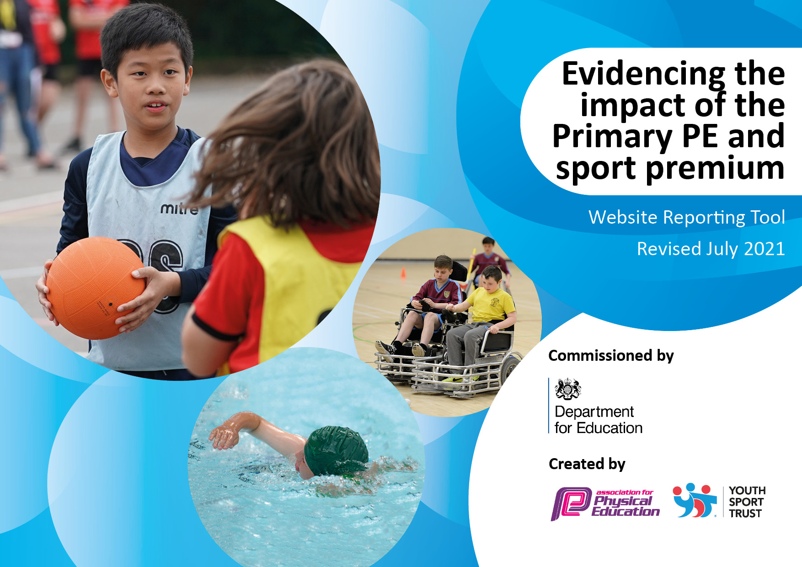
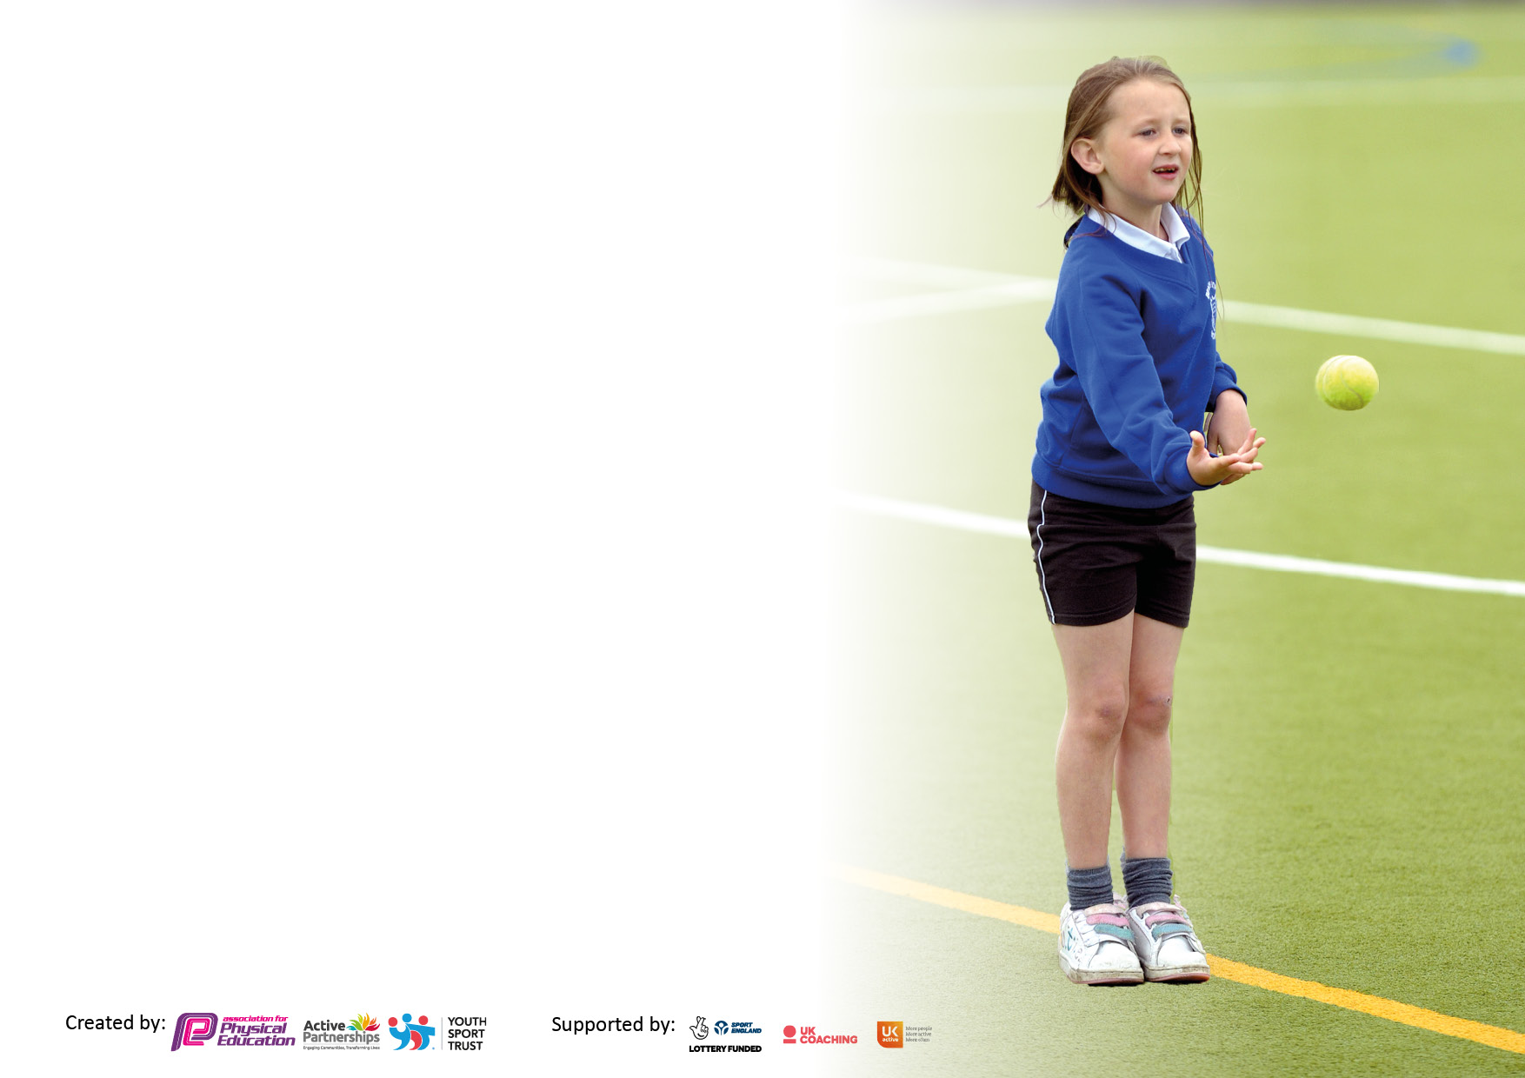

It is important that your grant is used effectively and based on school need. The Education Inspection Framework makes clear there will be a focus on ‘whether leaders and those responsible for governors all understand their respective roles and perform these in a way that enhances the effectiveness of the school’.

Under the Quality of Education Ofsted inspectors consider:
Intent - Curriculum design, coverage and appropriateness
Implementation - Curriculum delivery, Teaching (pedagogy) and Assessment
Impact - Attainment and progress

To assist schools with common transferable language this template has been developed to utilise the same three headings which should make your plans easily transferable between working documents.

Schools must use the funding to make additional and sustainable improvements to the quality of Physical Education, School Sport and Physical Activity (PESSPA) they offer. This means that you should use the Primary PE and sport premium to:

- Develop or add to the PESSPA activities that your school already offer
- Build capacity and capability within the school to ensure that improvements made now will benefit pupils joining the school in future years
- The Primary PE and sport premium should not be used to fund capital spend projects; the school’s budget should fund these.

Pleasevisitgov.ukfortherevisedDfEguidanceincludingthe5keyindicatorsacrosswhichschoolsshoulddemonstrate animprovement.Thisdocumentwillhelpyoutoreviewyourprovisionandtoreportyourspend.DfEencouragesschools to use this template as an effective way of meeting the reporting requirements of the Primary PE and sport premium.

We recommend you start by reflecting on the impact of current provision and reviewing the previous spend.

Schools are required to publish details of how they spend this funding, including any under-spend from 2019/2020, as well as on the impact it has on pupils’ PE and sport participation and attainment. All funding must be spent by 31st July 2022.

We recommend regularly updating the table and publishing it on your website throughout the year. This evidences your ongoing self-evaluation of how you are using the funding to secure maximum, sustainable impact. Final copy must be posted on your website by the end of the academic year and no later than the 31st July 2021. To see an example of how to complete the table please click HERE.
Created by: Supported by:

Details with regard to funding
Please complete the table below.

Total amount carried over from 2019/20 | £0
Total amount allocated for 2020/21 | £19,580
How much (if any) do you intend to carry over from this total fund into 2021/22? | £0
Total amount allocated for 2021/22 | £19,563
Total amount of funding for 2021/22. To be spent and reported on by 31st July 2022. | £19,563
Swimming Data
Please report on your Swimming Data below.

Meeting national curriculum requirements for swimming and water safety.

N.B. Complete this section to your best ability. For example you might have practised safe self-rescue techniques on dry land which you can then transfer to the pool when school swimming restarts.
Due to exceptional circumstances priority should be given to ensuring that pupils can perform safe self rescue even if they do not fully meet the first two requirements of the NC programme of study
What percentage of your current Year 6 cohort swim competently, confidently and proficiently over a distance of at least 25 metres?  N.B. Even though your pupils may swim in another year please report on their attainment on leaving primary school at the end of the summer term 2020.  Please see note above | 96%
What percentage of your current Year 6 cohort use a range of strokes effectively [for example, front crawl, backstroke and breaststroke]?  Please see note above | 96%
What percentage of your current Year 6 cohort perform safe self-rescue in different water-based situations? | 96%
Schools can choose to use the Primary PE and sport premium to provide additional provision for swimming but this must be for activity over and above the national curriculum requirements. Have you used it in this way? | Yes. £1000 for catch up with reduced group sizes who are at non-swimming level.

Action Plan and Budget Tracking
Capture your intended annual spend against the 5 key indicators. Clarify the success criteria and evidence of impact that you intend to measure to evaluate for pupils today and for the future.

Academic Year: 2020/21 | Total fund allocated: | Date Updated:
Key indicator 1: The engagement of all pupils in regular physical activity – Chief Medical Officers guidelines recommend that primary school pupils undertake at least 30 minutes of physical activity a day in school |  |  |  | Percentage of total allocation:
 |  |  |  | 18%
Intent | Implementation |  | Impact
Your school focus should be clear what you want the pupils to know and be able to do and about  what they need to learn and to  consolidate through practice: | Make sure your actions to achieve are linked to your intentions: | Funding allocated: | Evidence of impact: what do pupils now know and what can they now do? What has changed? | Sustainability and suggested next steps:
Children experience a range of sport and activity. | Purchase and maintain a range of PE equipment. | £1,700.00 | Children experience a range of sport and activity to begin to instil a love of physical activity.
Children experience a range of sport and activity. | Purchase playground equipment for each cohort. | £2,000.00 | Children experience a range of sport and activity to begin to instil a love of physical activity.  Equipment provided allowed safe accommodation for ‘bubbles’ of children during COVID-19 restrictions.
Key indicator 2: The profile of PESSPA being raised across the school as a tool for whole school improvement |  |  |  | Percentage of total allocation:
 |  |  |  | 2%
Intent | Implementation |  | Impact
Your school focus should be clear what you want the pupils to know and be able to do and about  what they need to learn and to  consolidate through practice: | Make sure your actions to achieve are linked to your intentions: | Funding allocated: | Evidence of impact: what do pupils now know and what can they now do? What has changed? | Sustainability and suggested next steps:
Have access to current CPD information and local competitive sports events. | Provide competitive sports and CPD through Fortius organisation. | £250.00 | Access to current CPD and events gained. Staff training to improve practice. | Continued subscription for next year.

Key indicator 3: Increased confidence, knowledge and skills of all staff in teaching PE and sport |  |  |  | Percentage of total allocation:
 |  |  |  | 59%
Intent | Implementation |  | Impact
Your school focus should be clear | Make sure your actions to | Funding | Evidence of impact: what do | Sustainability and suggested
what you want the pupils to know | achieve are linked to your | allocated: | pupils now know and what | next steps:
and be able to do and about | intentions: |  | can they now do? What has
what they need to learn and to |  |  | changed?:
consolidate through practice:
Provide high quality special sports leader to work alongside teachers delivering sport and PE lessons. | Sports leader to work with KS1 to deliver sport and PE lessons with teacher. | £8,457.00 | Consistent teaching of concepts and skills across KS1. | To assess the impact of standard of PE teaching in KS1 compared to KS2 to address any areas of improvement.
Provide high quality sports leader during playtimes to work alongside MDSA’s. | Sports leader to work alongside MDSA’s to support structured games and activities for children to play at lunchtimes. | £2,688,00 | Children are exposed to different sports and activities, which have been missed during PE lessons due to COVID lockdowns. | Support MDSA’s in leading these games themselves.
PE Hub subscription | Teachers have access to an extensive amount of content: lesson plans, medium term plans and home learning tools. | £455.00 | Teachers have structured planning to follow to match our skills progression ladder. | Renewed subscription.
Key indicator 4: Broader experience of a range of sports and activities offered to all pupils |  |  |  | Percentage of total allocation:
 |  |  |  | 19%
Intent | Implementation |  | Impact
Your school focus should be clear | Make sure your actions to | Funding | Evidence of impact: what do | Sustainability and suggested
what you want the pupils to know | achieve are linked to your | allocated: | pupils now know and what | next steps:
and be able to do and about | intentions: |  | can they now do? What has
what they need to learn and to |  |  | changed?:
consolidate through practice:
Swimming pool hire for swimming lessons (Year 4). | Swimming pool hire for Year 4 cohort of children to be confident swimmers. | £1,000.00 | Increased number of children can swim.
Running track instillation. | A running track installed on the field to ensure children have access to a daily mile, and to be used during sports days and PE lessons. | £2,800.00 | Children have access to a running track in all seasons to improve their physical activity levels.

Key indicator 5: Increased participation in competitive sport |  |  |  | Percentage of total allocation:
 |  |  |  | 2%
Intent | Implementation |  | Impact
Your school focus should be clear | Make sure your actions to | Funding | Evidence of impact: what do | Sustainability and suggested
what you want the pupils to know | achieve are linked to your | allocated: | pupils now know and what | next steps:
and be able to do and about | intentions: |  | can they now do? What has
what they need to learn and to |  |  | changed?:
consolidate through practice:
Sports Week - 100% participation in competitive sport and activity. | Week of timetabled events. |  | All children experience competitive sport, including individual and team sport. Raised awareness of benefits of sport and exercise. | Continue to build on the success of Sports Day/Week next year.
Line marking of pitches and running track. |  | £120.00 | Children engaged in structured activity during break and lunchtime.
Football Association subscription for children to have access to a competitive league. | A range of children have access to play in a competitive league against other local schools. | £110.00 | Children represent the school on a competitive platform. | Subscription continued next year.

Signed off by
Head Teacher:
Date:
Subject Leader: | Matthew Parsons
Date: | 22/07/21
Governor:
Date:

