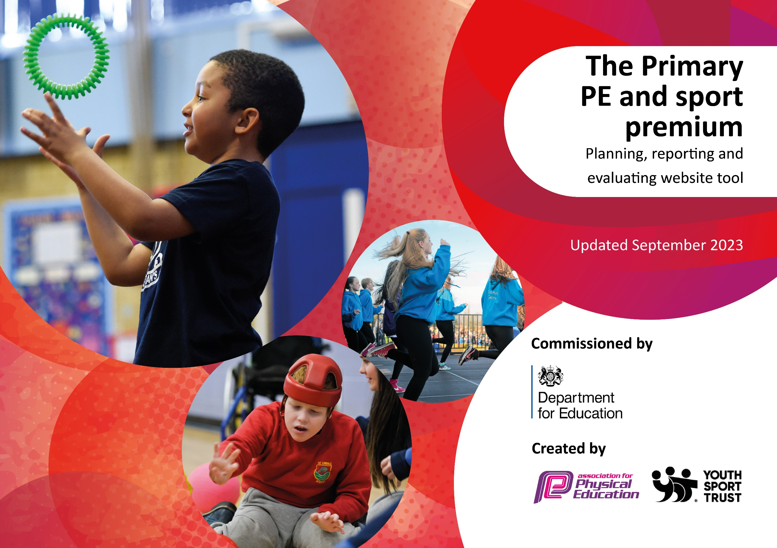

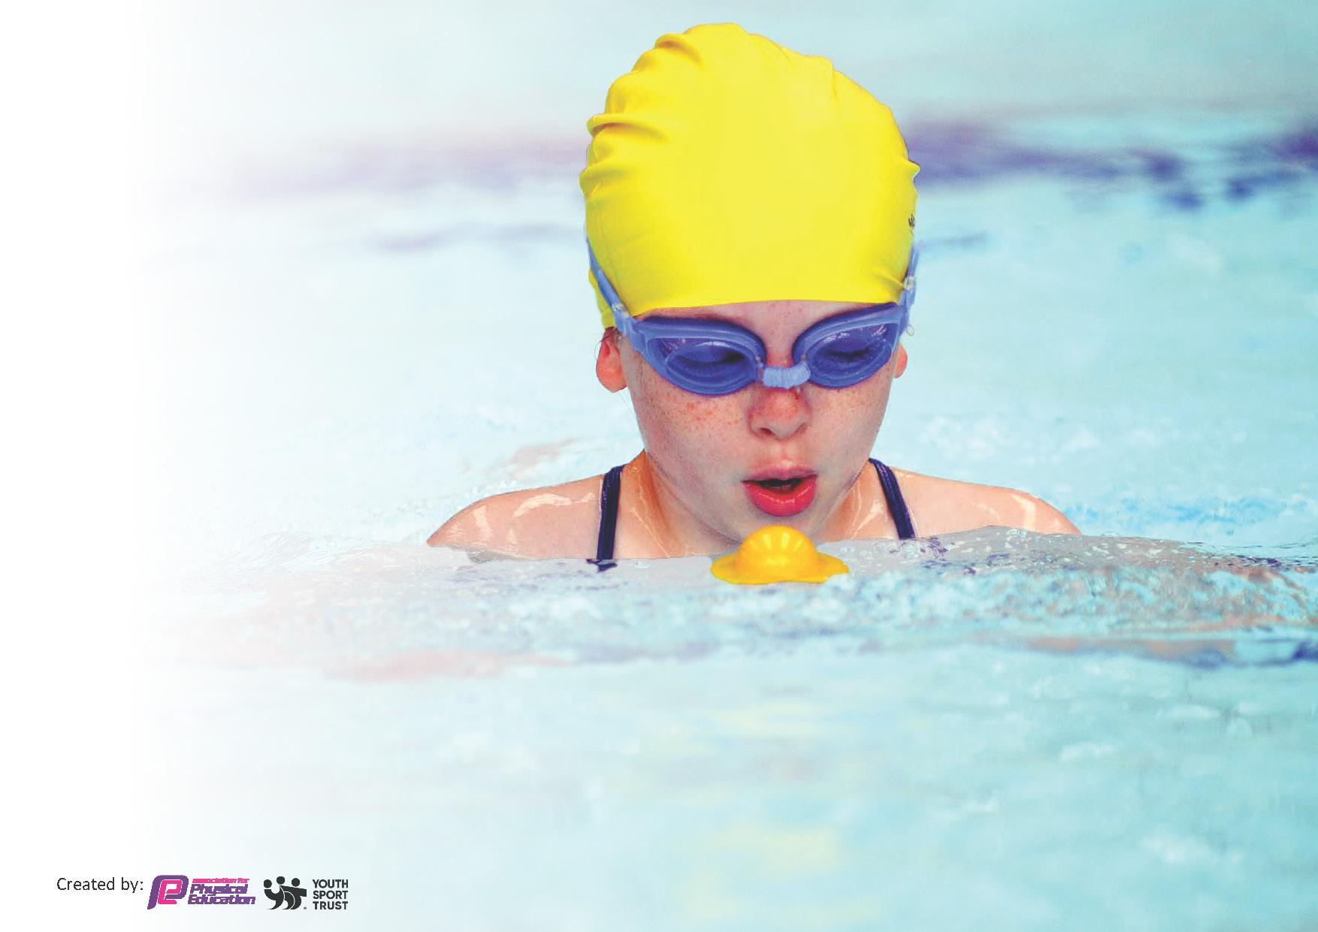
This template can be used for multiple purposes:
by:
- It enables schools to effectively plan their use of the Primary PE and sport premium
- It helps schools to meet the requirements (as set out in guidance) to publish information on their Primary PE and sport premium
- It will be an effective document to support Ofsted inspections enabling schools to evidence progress in Physical Education (PE) and evidence swimming attainment, which forms part of the PE National Curriculum. We would recommend schools consider
the Intent, Implementation and Impact of any spend, as examined within the Education Inspection Framework.

It is important that your grant is used effectively and based on school need.

Schools must use the funding to make additional and sustainable
improvements to the quality of the PE, School Sport and Physical Activity (PESSPA)
they offer. This means that you should use the Primary PE and sport premium to:

- Build capacity and capability within the school to ensure that improvements made now will benefit pupils joining the school in future years
- Develop or add to the PESSPA activities that your school already offers.

The Primary PE and sport premium should not be used to fund capital spend projects; the school’s core budget should fund these. Further detail on capital expenditure can be found in the updated Primary PE and sport premium guidance.

The Primary PE and sport premium guidance, outlines 5 key priorities that funding should be used towards. It is not

necessary that spending has to meet all the key priorities, you should select the priorities that you aim to use any funding towards.

Although completing this template is not a requirement for schools, schools are required to publish details of how they spend this funding. Schools must also outline what the impact this funding has had on pupils’ PE and sport participation and attainment and how any spending will be sustainable in the future. All funding must be spent by 31st July 2024.

The Department for Education has worked closely with the Association for Physical Education (afPE) and the Youth Sport Trust (YST) to develop this template and encourages schools to use it. This template is an effective way of meeting the reporting requirements of the Primary PE and sport premium.
Review of last year’s spend and key achievements (2023/2024)

We recommend you start by reflecting on the impact of current provision and reviewing your previous spend.

Activity/Action | Impact | Comments
Sports Coach funded to work with all year groups over the academic year.  Extra-Curricular sports opportunities provided by school staff and external specialists.  PE Hub subscribed to in order to provide comprehensive planning for all areas of PE.  Promoting healthy lifestyles through inspirational coaching.  Installation of orienteering course and experience days. | Every year group were able to experience PE teaching from a PE specialist in enjoyable activities covering a broad range of the PE curriculum. Teachers were able to learn from the sports coach to apply ideas to their own teaching and learning in PE.  Children were offered a range of extra curricular opportunities; running, football, multi-sports, netball, rugby, rounders and athletics over the year.  Teachers made access to this resource which included a curriculum planner ensuring full coverage.  All children enjoyed a Zumba session which promoted health and fitness.  Orienteering course was installed and used throughout the year. | All cohorts including F2 had time with the sports coach with the exception of Year 4 who had ukulele sessions on Wednesday afternoons. All teachers gave positive feedback and were able to take on board activites etc delivered.  Running, football, multi-sports, netball, rugby and rounders clubs have all been offered. Teams have been entered for netball, athletics, football and rugby competitions, including B team and years 1 -4.  49% of disadvantaged children took part in a sports club or represented the school at sport.  Feedback from children and staff was incredibly positive about this experience – definitely worth us repeating in the future or providing something similar.

Key priorities and Planning
This planning template will allow schools to accurately plan their spending.

Action – what are you planning to do | Who does this action impact? | Key indicator to meet | Impacts and how sustainability will be achieved? | Cost linked to the action
Employ Fortius sports coach for the academic year 2024/25.  Run a variety of sports clubs over the year.  Subscribe to PE Hub  Provide swimming sessions as a catch up for those children in Years 4,5 and 6 who are unable to swim the recommended distance of 25 metres through Pools for Schools.  Provide children with experiences in PE and sport beyond what can be delivered through quality first teaching. | Children and teachers.  Children  Children and teachers  Children  Children | Key Indicator 1: Increased confidence, knowledge and skills of all staff in teaching PE and sport  Key Indicator 2: Engagement of all pupils in regular physical activity  Key Indicator 4: Broader experience of a range of sports and activities offered to all pupils  Key Indicator 5: Increased participation in competitive sport  Key Indicator 1: Increased confidence, knowledge and skills of all staff in teaching PE and sport  Key Indicator 2 : Engagement of all pupils in regular physical activity  Key indicator 3: The profile of PE and sport should be raised across the school as a tool for improvement.  Key indicator 4: Broader experience of a range of sports and activities offered to all pupils | All children have access to high quality PE lessons taught by an expert over the period of a term. This coaching will serve as a model for classroom teachers to develop their own practice. which will be reflected in their teaching of PE.  Increased number of children taking up extra-curricular sport including those from disadvantaged backgrounds.  Teachers have access to, and make use of high quality plans.  Children who did not meet the expected requirement during their intensive sessions in year 4 will have another opportunity to achieve this in small groups with trained instructors.  Workshops to be investigated for whole school engagement. | £4000 for Fortius subscription.  £525  £3800 for pool + lifeguard + instructor  £#### for appropriate electrical adaptions  Orienteering workshop £750 + instructor travel  Dance workshop through Swindon dance.

Key achievements 2024-2025
This template will be completed at the end of the academic year and will showcase the key achievements schools have made with their Primary PE and sport premium spending.

Activity/Action | Impact | Comments
Employ Fortius sports coach for the academic year 2024/25.  Run a variety of sports clubs  PE Hub  Pools for Schools  Wider experiences | Sports coaches were able to work with year groups from across the whole school from reception through to Year 6 with the exception of year 1. Teachers and Tas were able to work alongside the coaches to uplevel their own understanding. Coaches used PE Hub planning so that the sessions they led supported the learning of the school.  Coaches also led after school clubs in multi-sports and rounders.  Running, netball, football, cricket, rounders and multi-sports clubs were held for children from year 1 to year 6. Priority was given for children in receipt of PP. Taster sessions for younger children were available for football.  The school football team won the West Swindon league.  Subscription has continued providing good quality teaching resources. This has included videos to demonstrate good practice. The curriculum planner facility means that a range of PE activities are followed and that there is progression between year groups.  Top up sessions provided for children in Years 5 and 6 who were unable to swim the requisite 25 metres. 68 children who previously were unable to swim 25 metres were offered daily sessions for a week including a child who had never been in a swimming pool before. 61 chose to take part. Of these, 45 met the standard expected. 87% of our Year 6s will leave Shaw Ridge able to swim the required distance of 25 metres.  After school clubs in Kwik cricket and in football for beginners provided. | Next year we need to find a way to encourage more children in receipt of PP to engage with after school sports.

Swimming Data
Meeting National Curriculum requirements for swimming and water safety.
Priority should always be given to ensuring that pupils can perform safe self-rescue even if they do not fully meet the first two requirements of the National Curriculum programme of study

Question | Stats: | Further context  Relative to local challenges
What percentage of your current Year 6 cohort can swim competently, confidently and proficiently over a distance of at least 25 metres? | 87 % | Without Pools for Schools, this would have been lower – This figure was at 60% at the start of the year.
What percentage of your current Year 6 cohort can use a range of strokes effectively [for example, front crawl, backstroke, and breaststroke]? | 75%

What percentage of your current Year 6 cohort are able to perform safe self-rescue in different water-based situations? | 88%
If your schools swimming data is below national expectation, you can choose to use the Primary PE and sport premium to provide additional top-up sessions for those pupils that did not meet National Curriculum  requirements after the completion of core lessons. Have you done this? | Yes | Pools for Schools
Have you provided CPD to improve the knowledge and confidence of staff to be able to teach swimming and water safety? | No

Signed off by:

Head Teacher: | Sally Cowell
Subject Leader or the individual responsible for the Primary PE and sport premium: | Joe Lee (PE subject lead)
Governor: | Neil Linsell
Date: | 1st July 2025

