Daily phonics 1
Good morning everyone.
In school we practise our phonics every day. These help us with reading and spelling. We need to make sure we say pure sounds.
- Every day we need to recap the set 1 sounds.
Have a go saying the sounds quickly. You could use the youtube link below to help.
https://www.youtube.com/watch?v=HYuzt5qv1ZI

- Every day we need to have a quick practise at the set 2 sounds. These sounds are made of 2 letters which are special friends. The 2 letters that make 1 sound are called a digraph.
Have a practise of set 2 sounds. You could use the video to help.

https://www.youtube.com/watch?v=WnkgOJjg0T8

- Now we have learnt the set 1 and 2 sounds we are going to learn the set 3 sounds. Each day we will learn 1 sound.
Today’s sound is ea. You can use the video clip to help.
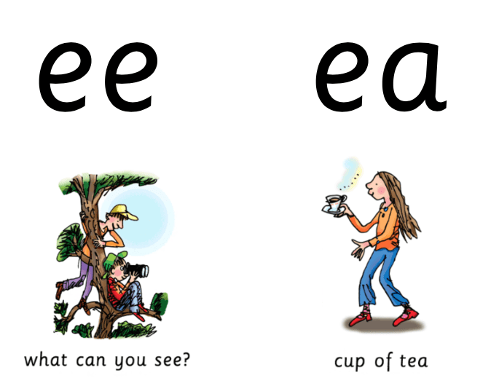
We already know ee – what can you see? There are other special friend letters that make the same sound. ea – cup of tea
Practise saying ea cup of tea

These green words have the ea sound, use fred talk to say the sounds, then say the whole word.

https://www.youtube.com/watch?v=UHzu7dkn3sY

- Spelling practise
Have a go at spelling the green words. Read the word, cover it up, have a go at writing then check it. Give yourself a tick for the right sounds and spelling.

- Red words
These are the tricky words that are not that easy to sound out – they have a grotty grapheme. We have been practising them in school.
How many red words can you read at speed?
Challenge someone in your house to have a go.

I | the | you | your | said | was
are | of | want | what | they | to
he | me | we | she | be | no
so | go | old | her
do | does | all | call | tall | small
many | any | one | anyone | some | come
watch | who | where | there | here | were
brother | other | mother | father | love | above
two | once | buy | worse | walk | talk
bought | caught | through | thought | whole | wear
could | would | should | great | saw | why
now | how | down | over
my | by | son | water | school | ball
everyone | their | people

If you can read all these words, have a go at spelling them.

Grown ups
Here are some helpful links to help with the phonics sessions and reading at home.
Parent Video- an example of how you could do the phonics at home.
https://www.youtube.com/watch?v=2o2b7nL1jrg-reading
https://www.youtube.com/watch?v=dftlTCNWlMQ-spelling
Oxford Owl Link for Parents – sign up for free
https://home.oxfordowl.co.uk/reading/learn-to-read-phonics/

Free e-book library from Oxford Owl – sign up for free for access to a range of e-books
https://www.oxfordowl.co.uk/library-page?view=image&query=&type=book&age_group=Age+4-7&level=&level_select=&book_type=&series=Read+Write+Inc.#

