Daily phonics 4
Good morning everyone.
In school we practise our phonics every day. These help us with reading and spelling. We need to make sure we say pure sounds.
- Every day we need to recap the set 1 sounds.
Have a go saying the sounds quickly. You could use the youtube link below to help.
https://www.youtube.com/watch?v=HYuzt5qv1ZI

- Every day we need to have a quick practise at the set 2 sounds. These sounds are made of 2 letters which are special friends. The 2 letters that make 1 sound are called a digraph.
Have a practise of set 2 sounds. You could use the video to help.

https://www.youtube.com/watch?v=WnkgOJjg0T8

- So far we have learnt and practised ea
Practise these green words
clean dream seat scream real please

Practise these green words
join coin voice choice noise

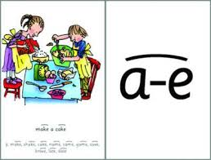

Practise these green words
make cake name same late date

Today’s new sound is i-e. These special friend letters, have a different letter in the middle of them. It is called a split digraph. We already know the sound igh.
Practise saying the sound and these words. You can use the youtube link to help.
https://www.youtube.com/watch?v=SFW1vnaXZBI

- Spelling practise
Have a go at spelling the green words. Read the word, cover it up, have a go at writing then check it. Give yourself a tick for the right sounds and spelling.

- Red words – play roll and read
Roll the dice. Choose a word from the row that matches that number. If you can read it cover it up.
 | I | the | you | your | said
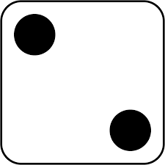 | are | of | want | what | they
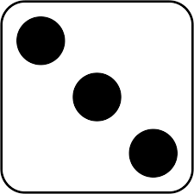 | he | me | we | she | be
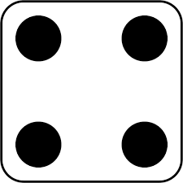 | so | go | old | her | was
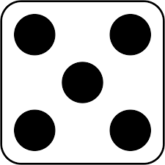 | do | does | all | call | tall
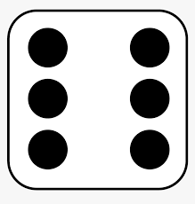 | to | no | small | many | any

If you can read them all, you could play again and spell the words instead.

Grown ups
Here are some helpful links to help with the phonics sessions and reading at home.
Parent Video- an example of how you could do the phonics at home.
https://www.youtube.com/watch?v=2o2b7nL1jrg-reading
https://www.youtube.com/watch?v=dftlTCNWlMQ-spelling
Oxford Owl Link for Parents – sign up for free
https://home.oxfordowl.co.uk/reading/learn-to-read-phonics/

Free e-book library from Oxford Owl – sign up for free for access to a range of e-books
https://www.oxfordowl.co.uk/library-page?view=image&query=&type=book&age_group=Age+4-7&level=&level_select=&book_type=&series=Read+Write+Inc.#

